**Chemical Reactions & Properties of Matter Hyperdoc**

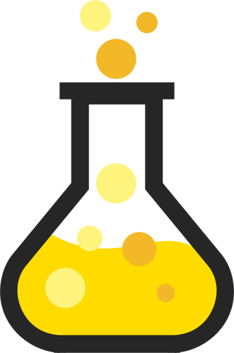

**Directions:** Click on each activity link in order, and then respond to each question within that activity.

| **Skill** | **Activity & Questions** | **Response** |
| --- | --- | --- |
| [**Explore**](https://www.generationgenius.com/properties-of-matter-for-kids/) | Explore this website about the properties of matter. Take the quiz. Write three questions and answers you got correct in the response column to the right. | WHat is matter?: Matter is anything that takes up weight or space.  What can matter be identified as?: Matter can be identified through its properties like magnetism, density, and solubility.  Which is more dense: sulfur hexafluoride or helium? How do you know?: Sulfur hexafluoride is more dense because when they put helium in a balloon it goes right up to the ceiling and when they put sulfur hexafluoride in a balloon it sunk to the ground. |
| [**Examine**](https://www3.epa.gov/acidrain/education/site_students/lucy1.html) | Examine this animation, “The Tale of Lucy Lake.” Identify the author’s purpose. Use details from the animation to support your claim. | I think that the author's purpose for this animation is to let readers learn about acid rain and where it comes from. |
| [**Watch**](https://www.pbslearningmedia.org/resource/phy03.sci.phys.mfw.zrocket/acids-and-bases-testing-rockets/#.XZAjE-dKg_U) | Watch this video about acids and bases. Summarize the key ideas and details. What new information did you learn? | I learned that if you mix up an acid |
| [**Learn**](http://studyjams.scholastic.com/studyjams/jams/science/matter/solids-liquids-gases.htm) | Learn about solids, liquids, and gases. Click the Play Video icon you see below when you get to the site.    Then, answer these questions:   * What does the state of matter depend on? * Describe the speed of molecules in solids, liquids, and gases. * How does heat impact matter changing states? |  |
| [**Compare**](https://www.ducksters.com/science/chemistry/chemical_mixtures.php) | Visit this site about solutions and mixtures. What is the difference between heterogeneous and homogeneous mixture. Give an example of each. What is the difference between a solution and a mixture? |  |
| [**Read**](http://www.lovemyscience.com/cat_reaction.html) | Read about fun chemical reactions kids can try at home! Then, answer these questions:   * Which three experiments excite you the most? Why? * What causes the chemical reactions in the experiments you chose? |  |
| **Infer** | Is a chemical reaction taking place in this photo? If so, how do you know? What can you infer based on this image? Use evidence from the image to support your answer. |  |
| **Analyze**  Analyze this image. Then, answer these questions:     * How much time has passed between photos? * What are some changes you observe? * How has acid rain impacted this statue? | |  |
| **Apply** | Write a one paragraph persuasive piece on one of the following topics:   * Why we should protect our planet from acid rain / stop pollution so acid rain doesn’t happen * Why chemical reactions are important for our planet |  |
| **Share** | Share your biggest takeaway from this hyperdoc. What did you learn? What are you still curious about? What do you wonder? |  |