Energy Flow in Ecosystems

Engage | Watch this Video on Energy Flow in Ecosystems  ?  Write three sentences explaining Energy Flow seen in Kalahari Desert Ecosystem (Where do the Sand People get their energy? The Kudu? The Organisms the Kudu eat?)  -------The Sand people get their energy by using the ancient hunting technique, the Persistence hunt.  A animal that lives in the Kalahari.  They eat wide variety of leaves, herbs, fruits, and etc.
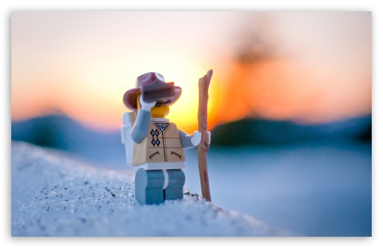  Explore | - Download this copy of the Vocabulary Slides  - Create each slide with the correct definition  - Include a picture on each which helps in your understanding of the word  - Use slide #1 as an example  - When you are done place a Link to it Below  --Copy of Energy Flow Vocabulary–  - Read this National Geographic Article  ?  What is the difference between primary, secondary, tertiary consumers?  (include a quote from the article to support your explanation)  “Primary consumers are herbivores, secondary consumers eat herbivores,  And the tertiary consumers eat the secondary consumer.”  “  - Watch these 3 videos on Food Webs  Fabulous Food Chains the Dirt on Decomposers Home Sweet Habitat  - Check out this Food Chain Example:  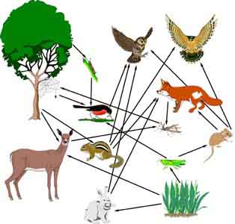  - Complete the Food Chain Games (Select 2)  - Watch this video on Energy Pyramids  ?  Why is the Energy Pyramid shaped like a pyramid?  Energy Pyramid are a important concept in ecology .  Why does the energy ”go down” at each level?  Energy decrases as it moves up trophic levels because energy is lost as metabolic heat.
  Explain | - Create a Food Web from the following images  -Post a Link to your Food Web here-  Copy of Food Web  - Create an Energy Pyramid on the following document  (this should match what your food pyramid shows)  Copy of Energy Pyramid
  Elaborate | ?  Using your Food Web and Energy Pyramid describe the flow of energy through your ecosystem.  - Start with the sun and end at your top predators.  - Include the trophic levels  - Describe what happens to energy as it moves through different organisms  Answer in at least 4 sentences  The Producer (Berries) gets eaten by the Primary consumer (Bunny). The Primary consumer gets eaten by the Secondary consumer (Snake). The Secondary consumer gets eaten by the Tertiary consumer (Bird). The Tertiary consumer dies and turns into a Decomposer (mushroom) .  You are done, Submit this Doc. through Classroom

