Energy Flow in Ecosystems

Engage | Watch this Video on Energy Flow in Ecosystems  ?  Write three sentences explaining Energy Flow seen in Kalahari Desert Ecosystem (Where do the Sand People get their energy? The Kudu? The Organisms the Kudu eat?)  The sand people get their energy from the Kudu. The organisms they eat from the Kudu are the horns and the bodys.
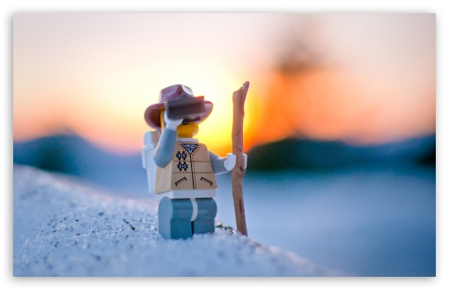  Explore | - Download this copy of the Vocabulary Slides  - Create each slide with the correct definition  - Include a picture on each which helps in your understanding of the word  - Use slide #1 as an example  - When you are done place a Link to it Below  https://docs.google.com/presentation/d/1a9IIWdZWWArfI6uTXK1uxbFHn_3zh3DOzVR1eImvQ6Y/edit?usp=sharing  - Read this National Geographic Article  ?  What is the difference between primary, secondary, tertiary consumers?  (include a quote from the article to support your explanation)  The difference between Primary, Secondary, and Tertiary consumers is that Primary are herbivores and are the 2nd trophic level, Secondary eat the Primary and are the 3rd trophic level and the Tertiary eat the secondary consumer and are 4thin the trophic level. “ Primary consumers are herbivores”.  - Watch these 3 videos on Food Webs  Fabulous Food Chains the Dirt on Decomposers Home Sweet Habitat  - Check out this Food Chain Example:  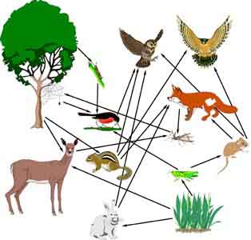  - Complete the Food Chain Games (Select 2)  - Watch this video on Energy Pyramids  ?  Why is the Energy Pyramid shaped like a pyramid?  Why does the energy ”go down” at each level?  The energy goes down because it has to decrease 10 percent going up and it has to reproduce and escape. The energy pyramid is shaped as a pyramid because it shows how small it is going to get and the less energy.
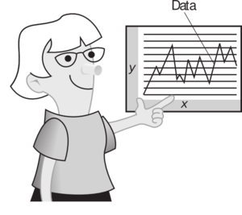  Explain | - Create a Food Web from the following images  https://docs.google.com/drawings/d/1lrky0nqz2jUoKPdSy9xzDf4ZiAJHkOputzcDp59X2Pw/edit?usp=sharing  - Create an Energy Pyramid on the following document  (this should match what your food pyramid shows)  https://docs.google.com/drawings/d/1oM9ukxu8ebTcU-BaNu6_oIvzTtu9XUQCpFsqZBjrM7g/edit?usp=sharing
  Elaborate | ?  Using your Food Web and Energy Pyramid describe the flow of energy through your ecosystem.  - Start with the sun and end at your top predators.  - Include the trophic levels  - Describe what happens to energy as it moves through different organisms  As the energy moves through the different orgasims it decreases 10%. There are 4 different trophic levels: 1st, 2nd, 3rd, 4th.  You are done, Submit this Doc. through Classroom

