Energy Flow in Ecosystems

Engage | Watch this Video on Energy Flow in Ecosystems  ?  Write three sentences explaining Energy Flow seen in Kalahari Desert Ecosystem (Where do the Sand People get their energy? The Kudu? The Organisms the Kudu eat?)  The energy flow seen in the Kalahari Desert is sand, dead trees, animals-for example the Kudu, and dried grass everywhere, The sand people get their energy from the Kudu’s water and taking small rests. The Kudu, however, gets its energy from resting in the shade.
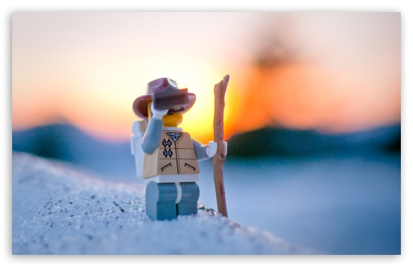  Explore | - Download this copy of the Vocabulary Slides  - Create each slide with the correct definition  - Include a picture on each which helps in your understanding of the word  - Use slide #1 as an example  - When you are done place a Link to it Below  Copy of Energy Flow Vocabulary  - Read this National Geographic Article  ?  What is the difference between primary, secondary, tertiary consumers?  (include a quote from the article to support your explanation)  The difference between primary, secondary and tertiary consumers is that the primary consumers are herbivores as in they eat plants and other kinds of producers, while the secondary consumers eat the herbivores. For example, it said, “A secondary consumer may be a snake that eats a mouse.” Finally, tertiary consumers eat the secondary consumers meaning that they are at the fourth trophic level.  - Watch these 3 videos on Food Webs  Fabulous Food Chains the Dirt on Decomposers Home Sweet Habitat  - Check out this Food Chain Example:  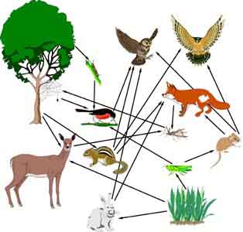  - Complete the Food Chain Games (Select 2)  - Watch this video on Energy Pyramids  ?  Why is the Energy Pyramid shaped like a pyramid?  ?  Why does the energy ”go down” at each level?  The energy pyramid is shaped like a pyramid because the base has to have the largest amount of biomass so it can support the energy requirements of the organisms at higher levels and the reason why the energy goes down is because it decreases as it moves up and because energy is lost at metabolic heat.
  Explain | - Create a Food Web from the following images  Copy of Food Web  - Create an Energy Pyramid on the following document  (this should match what your food pyramid shows)  Copy of Energy Pyramid
  Elaborate | ?  Using your Food Web and Energy Pyramid describe the flow of energy through your ecosystem.  - Start with the sun and end at your top predators.  - Include the trophic levels  - Describe what happens to energy as it moves through different organisms  Answer in at least 4 sentences  The flow of energy of the pyramid starts from a pant and starts to go up to a predicator, an example of one is a wolf or a hawk. First the sun makes the soil sprout plants to help the animals eat and then a rabbit or rat will start to eat that plant which will give them half the energy that the plant already had. Then after that, a snake or bird will most likely eat the rabbit or rat and will get a bit of their energy that they had gotten from the plant. After that a hawk and wolf will eat the snake and bird and will only gain 10% of the energy the bird and snake has gotten from the rabbit/rat. The energy starts to get lower by 10% when it moves from different organisms which in most cases the last animal to eat the other animal only gains 10^ of the energy that the animal got from the plant or the other animal that they had eaten already.  You are done, Submit this Doc. through Classroom

