Energy Flow in Ecosystems

Engage | Watch this Video on Energy Flow in Ecosystems  ?  Write three sentences explaining Energy Flow seen in Kalahari Desert Ecosystem (Where do the Sand People get their energy? The Kudu? The Organisms the Kudu eat?)  The Sand people get their energy from the animal that was killed by using its saliva to heal it’s burning muscles and its body to feed his family.
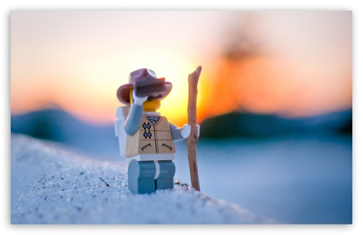  Explore | - Download this copy of the Vocabulary Slides  - Create each slide with the correct definition  - Include a picture on each which helps in your understanding of the word  - Use slide #1 as an example  - When you are done place a Link to it Below  https://docs.google.com/presentation/d/1gqLCcJ6iyeqAjWbgX2oMO8RDLyJSNl43PgN_4WZbrOI/edit?usp=sharing  - Read this National Geographic Article  ?  What is the difference between primary, secondary, tertiary consumers?  (include a quote from the article to support your explanation)  Primary and secondary consumers are usually carnivores, which apart from that tertiary consumers are carnivores that eat other carnivores  - Watch these 3 videos on Food Webs  Fabulous Food Chains the Dirt on Decomposers Home Sweet Habitat  - Check out this Food Chain Example:  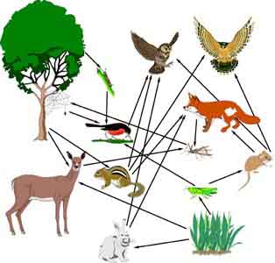  - Complete the Food Chain Games (Select 2)  - Watch this video on Energy Pyramids  ?  Why is the Energy Pyramid shaped like a pyramid?  As you move up the pyramid there isn't enough biomass as  there is on the bottom of the pyramid  Why does the energy ”go down” at each level?  They are escaping to go gain energy for themselves
  Explain | - Create a Food Web from the following images  Copy of Food Web  - Create an Energy Pyramid on the following document  (this should match what your food pyramid shows)  Copy of Energy Pyramid
  Elaborate | ?  Using your Food Web and Energy Pyramid describe the flow of energy through your ecosystem.  - Start with the sun and end at your top predators.  - Include the trophic levels  - Describe what happens to energy as it moves through different organisms  Answer in at least 4 sentences  The berries plant gets its energy from water and sunlight, the rabbit then eats the berries, the rabbit is then eaten by a Snake and the Snake is eaten by a Wolf.After the wolf eats the snake, it ends up dying and the decomposer comes in to decompose the wolf into organic materials.Everytime a consumer,consumes another animal it does not get 100% energy it only gains 10% energy.To gain 100% energy the consumer would need to eat 10 animals.  You are done, Submit this Doc. through Classroom

