Energy Flow in Ecosystems

Engage | Watch this Video on Energy Flow in Ecosystems  ?  Write three sentences explaining Energy Flow seen in Kalahari Desert Ecosystem (Where do the Sand People get their energy? The Kudu? The Organisms the Kudu eat?)  -------Delete this and Write the answer HERE------
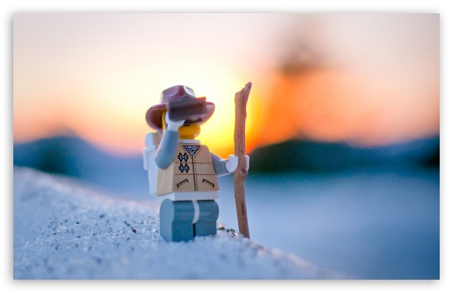  Explore | - Download this copy of the Vocabulary Slides  - Create each slide with the correct definition  - Include a picture on each which helps in your understanding of the word  - Use slide #1 as an example  - When you are done place a Link to it Below  --Copy of Energy Flow Vocabulary–  - Read this National Geographic Article  ?  What is the difference between primary, secondary, tertiary consumers?  (include a quote from the article to support your explanation)  There is quite a difference between them, A primary consumer is the start of a food chain. It’s an autotroph, or producer. This means it makes its own food. The secondary consumer is usually an omnivore or herbivore. It eats plants and animals, or just plants. The tertiary consumer is the last of a food change. It’s usually a carnivore, who eats mostly meat. That is the “the fourth trophic level”  - Watch these 3 videos on Food Webs  Fabulous Food Chains the Dirt on Decomposers Home Sweet Habitat  - Check out this Food Chain Example:  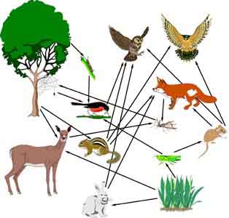  - Complete the Food Chain Games (Select 2)  - Watch this video on Energy Pyramids  ?  Why is the Energy Pyramid shaped like a pyramid?  ?  Why does the energy ”go down” at each level?  -------The Energy Pyramid is shaped as a pyramid because the energy gets to be less as it goes on, like a pyramid that gets smaller as it goes on. ------
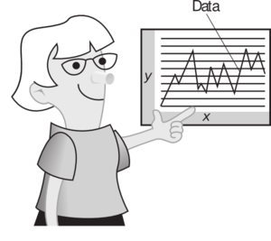  Explain | - Create a Food Web from the following images  Copy of Food Web  - Create an Energy Pyramid on the following document  (this should match what your food pyramid shows)  Copy of Energy Pyramid
  Elaborate | ?  Using your Food Web and Energy Pyramid describe the flow of energy through your ecosystem.  - Start with the sun and end at your top predators.  - Include the trophic levels  - Describe what happens to energy as it moves through different organisms  Answer in at least 4 sentences  -------Delete this and Write the answer HERE------  You are done, Submit this Doc. through Classroom

