Energy Flow in Ecosystems

Engage | Watch this Video on Energy Flow in Ecosystems  ?  Write three sentences explaining Energy Flow seen in Kalahari Desert Ecosystem (Where do the Sand People get their energy? The Kudu? The Organisms the Kudu eat?)  The sand people get their energy from hunting in silence. The Kudu is a group of animals that live in the Kalahari Desert. The organisms that the kudus eat are plants.
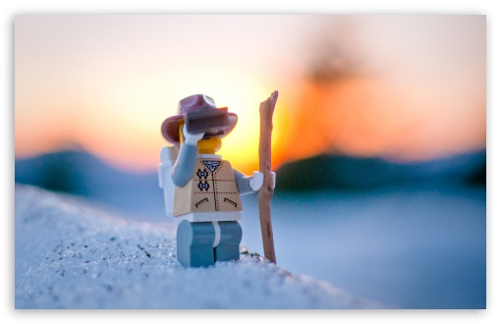  Explore | - Download this copy of the Vocabulary Slides  - Create each slide with the correct definition  - Include a picture on each which helps in your understanding of the word  - Use slide #1 as an example  - When you are done place a Link to it Below  Copy of Energy Flow Vocabulary  - Read this National Geographic Article  What is the difference between primary, secondary, tertiary consumers?  (include a quote from the article to support your explanation)  The “primary consumers are herbivores” and herbivores eat plants so they are at the second trophic level. The secondary consumers “eat herbivores” and they are at the third trophic level. The tertiary consumers “eat the secondary consumers” so they are at the fourth trophic level.  - Watch these 3 videos on Food Webs  Fabulous Food Chains the Dirt on Decomposers Home Sweet Habitat  - Check out this Food Chain Example:  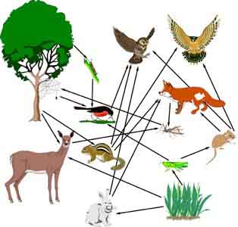  - Complete the Food Chain Games (Select 2)  - Watch this video on Energy Pyramids  Why is the Energy Pyramid shaped like a pyramid?  The energy pyramid is shaped like a pyramid because energy is lost at each trophic level.  Why does the energy ”go down” at each level?  Every level that you raise the energy goes down by 10 percent.
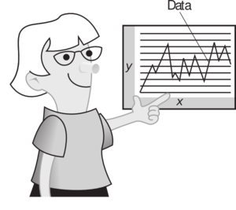  Explain | - Create a Food Web from the following images  -Post a Link to your Food Web here-  Copy of Food Web  - Create an Energy Pyramid on the following document  (this should match what your food pyramid shows)  Copy of Energy Pyramid
  Elaborate | Using your Food Web and Energy Pyramid describe the flow of energy through your ecosystem.  - Start with the sun and end at your top predators.  - Include the trophic levels  - Describe what happens to energy as it moves through different organisms  Answer in at least 4 sentences  The sun makes its way to the producers then will make their own food which starts off as the first trophic level. As the producers make their own food the primary consumer eats the producers as it is now in the second trophic level. Then the secondary consumer eats the primary consumer as it is now in the third trophic level which will lead to the tertiary consumers eating the secondary consumers and it now ends at the fourth trophic level. That energy becomes to be less energy because once the trophic level begin to rise the less energy it has.  You are done, Submit this Doc. through Classroom

