Energy Flow in Ecosystems

Engage | Watch this Video on Energy Flow in Ecosystems  ?  Write three sentences explaining Energy Flow seen in Kalahari Desert Ecosystem (Where do the Sand People get their energy? The Kudu? The Organisms the Kudu eat?)  The sand people get their energy from killing animals. the kudus do this thing with their hands so they can track down the animal. The organisms the hudu eats is the animal.
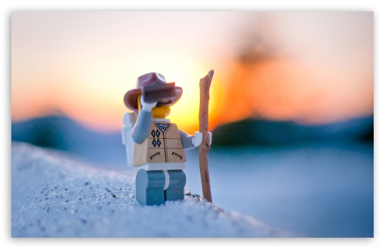  Explore | - Download this copy of the Vocabulary Slides  - Create each slide with the correct definition  - Include a picture on each which helps in your understanding of the word  - Use slide #1 as an example  - When you are done place a Link to it Below  https://docs.google.com/presentation/d/1ybqLzV8cdUD1E2wG4O5h8zN-ENyjMbtl4muxartMM-w/edit?usp=sharing  - Read this National Geographic Article  ?  What is the difference between primary, secondary, tertiary consumers?  (include a quote from the article to support your explanation)  The difference between primary,secondary,and tertiary consumers is that primary consumers are herbivores and secondary consumers eat herbivores and tertiary consumers eat the secondary consumer and are at the fourth trophic level.  - Watch these 3 videos on Food Webs  Fabulous Food Chains the Dirt on Decomposers Home Sweet Habitat  - Check out this Food Chain Example:  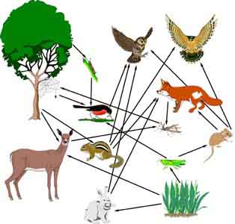  - Complete the Food Chain Games (Select 2)  - Watch this video on Energy Pyramids  ?  Why is the Energy Pyramid shaped like a pyramid?  Its shaped like a pyramid because as the food chain goes up the energy goes down  Why does the energy ”go down” at each level?  Because there getting eaten by the animals on top of them and the energy decreases.
  Explain | - Create a Food Web from the following images  https://docs.google.com/drawings/d/1mrzwvMSaTsxcpSIoI9m-Z1TOBlvxm34t1it0WOednTk/edit?usp=sharing  - Create an Energy Pyramid on the following document  (this should match what your food pyramid shows)  https://docs.google.com/drawings/d/1P1jAwckU5vAUG_nNXaXIHBDCoFLNiwEkuNu2D6QgPUY/edit?usp=sharing
  Elaborate | ?  Using your Food Web and Energy Pyramid describe the flow of energy through your ecosystem.  - Start with the sun and end at your top predators.  - Include the trophic levels  - Describe what happens to energy as it moves through different organisms  Answer in at least 4 sentences  First the sun gives energy to the primary producer the the primary consumer eats the primary producer then the primary consumer gets eaten by the secondary consumer after that the tertiary consumer eats the secondary consumer.  You are done, Submit this Doc. through Classroom

