Energy Flow in Ecosystems

Engage | Watch this Video on Energy Flow in Ecosystems  ?  Write three sentences explaining Energy Flow seen in Kalahari Desert Ecosystem (Where do the Sand People get their energy? The Kudu? The Organisms the Kudu eat?)  They use their hand signs to indicate one of them found a track of a group of kudu. an African antelope that has a grayish or brownish coat with white vertical stripes, and a short bushy tail. The male has long spirally curved horns. Leave, grass, and flowers.
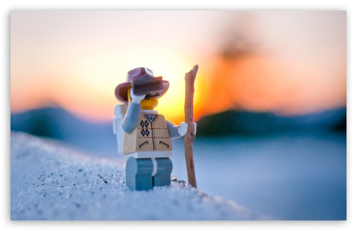  Explore | - Download this copy of the Vocabulary Slides  - Create each slide with the correct definition  - Include a picture on each which helps in your understanding of the word  - Use slide #1 as an example  - When you are done place a Link to it Below  Copy of Energy Flow Vocabulary  - Read this National Geographic Article  ?  What is the difference between primary, secondary, tertiary consumers?  (include a quote from the article to support your explanation)  Primary consumers are herbivores, Secondary consumers eat herbivores, Tertiary consumers eat secondary consumers.Tertiary consumers eat the secondary consumers and are at the fourth trophic level.  - Watch these 3 videos on Food Webs  Fabulous Food Chains the Dirt on Decomposers Home Sweet Habitat  - Check out this Food Chain Example:  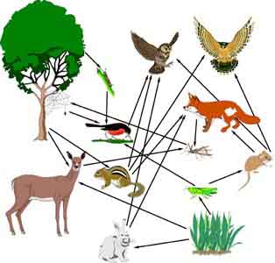  - Complete the Food Chain Games (Select 2)  - Watch this video on Energy Pyramids  ?  Why is the Energy Pyramid shaped like a pyramid?  ?  Why does the energy ”go down” at each level?  The pyramid shape is used to represent the flow of energy because of the way that energy is used up and lost throughout the system. The amount of energy at each trophic level decreases as it moves through an ecosystem.
  Explain | - Create a Food Web from the following images  Copy of Food Web  - Create an Energy Pyramid on the following document  (this should match what your food pyramid shows)  Copy of Energy Pyramid
  Elaborate | ?  Using your Food Web and Energy Pyramid describe the flow of energy through your ecosystem.  - Start with the sun and end at your top predators.  - Include the trophic levels  - Describe what happens to energy as it moves through different organisms  Answer in at least 4 sentences  Sun gives plant energy then a primary consumer eats the plants. A primary consumer such as a rabbit or bunny gets eaten by a secondary consumer. A secondary consumer such as a snake gets eaten by a tertiary consumer such as a hawk tertiary consumer are the top and producers are at the bottom.  You are done, Submit this Doc. through Classroom

