Energy Flow in Ecosystems

Engage | Watch this Video on Energy Flow in Ecosystems  ?  Write three sentences explaining Energy Flow seen in Kalahari Desert Ecosystem (Where do the Sand People get their energy? The Kudu? The Organisms the Kudu eat?)  -------Delete this and Write the answer HERE------
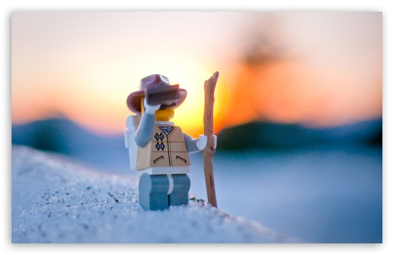  Explore | - Download this copy of the Vocabulary Slides  - Create each slide with the correct definition  - Include a picture on each which helps in your understanding of the word  - Use slide #1 as an example  - When you are done place a Link to it Below  - https://docs.google.com/presentation/d/1IBxBw6NuSCdOY1LkKuU-C6Ivn0HqgrOT5e1eWwKNiNs/edit#slide=id.g1c758eb772_1_46  - https://docs.google.com/presentation/d/1IBxBw6NuSCdOY1LkKuU-C6Ivn0HqgrOT5e1eWwKNiNs/edit?usp=sharing  --Create a Link to your Completed SLIDESHOW here–  - Read this National Geographic Article  ?  What is the difference between primary, secondary, tertiary consumers?  (include a quote from the article to support your explanation)  -------Delete this and Write the answer HERE------  - Watch these 3 videos on Food Webs  Fabulous Food Chains the Dirt on Decomposers Home Sweet Habitat  - Check out this Food Chain Example:  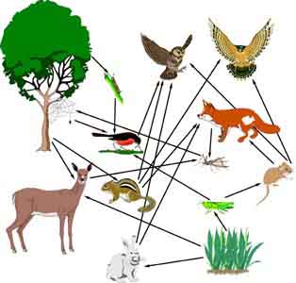  - Complete the Food Chain Games (Select 2)  - Watch this video on Energy Pyramids  ?  Why is the Energy Pyramid shaped like a pyramid?  ?  Why does the energy ”go down” at each level?  -------Delete this and Write the answer HERE------
  Explain | - Create a Food Web from the following images  -Post a Link to your Food Web here-  - Create an Energy Pyramid on the following document  (this should match what your food pyramid shows)  -Post a Link to your Energy Pyramid here-
  Elaborate | ?  Using your Food Web and Energy Pyramid describe the flow of energy through your ecosystem.  - Start with the sun and end at your top predators.  - Include the trophic levels  - Describe what happens to energy as it moves through different organisms  Answer in at least 4 sentences  -------Delete this and Write the answer HERE------  You are done, Submit this Doc. through Classroom

