Energy Flow in Ecosystems

Engage | Watch this Video on Energy Flow in Ecosystems  ?  Write three sentences explaining Energy Flow seen in Kalahari Desert Ecosystem (Where do the Sand People get their energy? The Kudu? The Organisms the Kudu eat?)  They get their energy from eating animals that they hunt .  The kudu is an animal that looks like a deer but way bigger.  The kudu eat plants and grass.
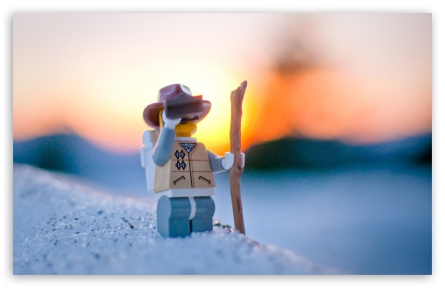  Explore | - Download this copy of the Vocabulary Slides  - Create each slide with the correct definition  - Include a picture on each which helps in your understanding of the word  - Use slide #1 as an example  - When you are done place a Link to it Below  Copy of Energy Flow Vocabulary  - Read this National Geographic Article  ?  the primary consumers. Secondary consumers are usually carnivores that eat the primary consumers. Tertiary consumers are animal that eats another animal  - Watch these 3 videos on Food Webs  Fabulous Food Chains the Dirt on Decomposers Home Sweet Habitat  - Check out this Food Chain Example:  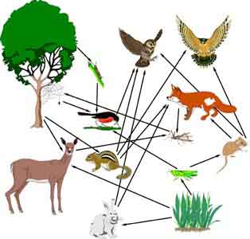  - Complete the Food Chain Games (Select 2)  - Watch this video on Energy Pyramids  ?  Why is the Energy Pyramid shaped like a pyramid?  ?  Why does the energy ”go down” at each level?  energy is lost at each trophic level when organisms use it up.  Energy decreases as it moves up trophic levels because energy loses strength
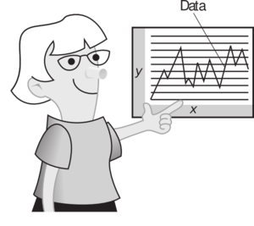  Explain | - Create a Food Web from the following images  Copy of Food Web  - Create an Energy Pyramid on the following document  (this should match what your food pyramid shows)  Copy of Energy Pyramid
  Elaborate | ?  Using your Food Web and Energy Pyramid describe the flow of energy through your ecosystem.  - Start with the sun and end at your top predators.  - Include the trophic levels  - Describe what happens to energy as it moves through different organisms  Answer in at least 4 sentences  The sun helps the grass grow . Then the rabbits eat the grass but a snake eats the rabbit .The hawk comes and eats the owl . most likely nothing is going to eat the owl so the owl dies and fungi will grow . If a animal eats another animals the energy get less and less.  You are done, Submit this Doc. through Classroom

