Energy Flow in Ecosystems

Engage | Watch this Video on Energy Flow in Ecosystems  ?  Write three sentences explaining Energy Flow seen in Kalahari Desert Ecosystem (Where do the Sand People get their energy? The Kudu? The Organisms the Kudu eat?)  They feel the rhythm of the animals movements. They will carry horns and move quickly.they separate them form the herd to kill them.
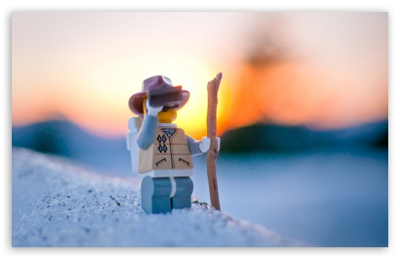  Explore | - Download this copy of the Vocabulary Slides  - Create each slide with the correct definition  - Include a picture on each which helps in your understanding of the word  - Use slide #1 as an example  - When you are done place a Link to it Below  https://docs.google.com/presentation/d/19M-0s0KrGKS1PfFFpZPAdWbAQPYACJT9vN7bD5WbU94/edit?usp=sharing  - Read this National Geographic Article  ?  What is the difference between primary, secondary, tertiary consumers?  (include a quote from the article to support your explanation)  The organisms that consume the primary producers are herbivores, the primary consumers. Secondary consumers are usually carnivores that eat the primary consumers. Tertiary consumers are carnivores that eat other carnivores.  - Watch these 3 videos on Food Webs  Fabulous Food Chains the Dirt on Decomposers Home Sweet Habitat  - Check out this Food Chain Example:  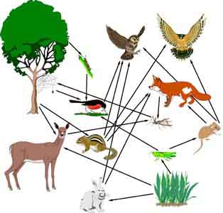  - Complete the Food Chain Games (Select 2)  - Watch this video on Energy Pyramids  ?  Why is the Energy Pyramid shaped like a pyramid?  ?  Why does the energy ”go down” at each level?  The energy pyramid is shaped like a pyramid because there is a lot of biomass energy.the energy goes down because there isn’t enough.
  Explain | - Create a Food Web from the following images  -Post a Link to your Food Web here-  https://docs.google.com/drawings/d/17EyPn4AX041dX3TOdAGqr6I2aIMLzcYq2_vCzqXOFvw/edit?usp=sharing  - Create an Energy Pyramid on the following document  (this should match what your food pyramid shows)  https://docs.google.com/drawings/d/10Co9C6ZzDvR2uEreORK0NpJA6sXRjU-zexvMLckoaJ4/edit?usp=sharing
  Elaborate | ?  Using your Food Web and Energy Pyramid describe the flow of energy through your ecosystem.  - Start with the sun and end at your top predators.  - Include the trophic levels  - Describe what happens to energy as it moves through different organisms  Answer in at least 4 sentences  They are far down the food chain, meaning that a large number of animals happily eat them. Large predators such as snakes may eat a whole rat in one go whereas smaller animals may eat them gradually a bit at a time.birds of prey feed on mice and rats. Raptors, including hawks, owls, eagles and falcons, are common predators. Red tail hawks, found across most of North America, and American kestrels, the smallest falcon in North America, will hunt rats by day.  You are done, Submit this Doc. through Classroom

