Energy Flow in Ecosystems

Engage | Watch this Video on Energy Flow in Ecosystems  ?  Write three sentences explaining Energy Flow seen in Kalahari Desert Ecosystem (Where do the Sand People get their energy? The Kudu? The Organisms the Kudu eat?)  The guy carries the horns and moves fast. They feel the rhythm of the animals' movement. The chase lasted for 8 hours and both the hunters were at the end of their strength neither can go any longer.
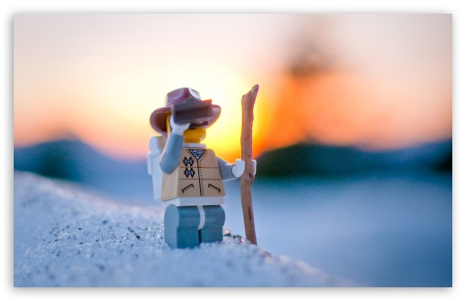  Explore | - Download this copy of the Vocabulary Slides  - Create each slide with the correct definition  - Include a picture on each which helps in your understanding of the word  - Use slide #1 as an example  - When you are done place a Link to it Below  https://docs.google.com/presentation/d/1G2kWyEUfInngNn64Zj3nTqfzCth3QhZeBG-ldoVdYWY/edit?usp=sharing  - Read this National Geographic Article  ?  What is the difference between primary, secondary, tertiary consumers?  (include a quote from the article to support your explanation)  “Herbivores: primary consumers Secondary consumer: carnivores that eat primary consumers Tertiary consumers: carnivores that eat other carnivores “primary consumers are herbivores” Secondary consumers eat herbivores”. “Tertiary consumers eat the secondary consumers”.  - Watch these 3 videos on Food Webs  Fabulous Food Chains the Dirt on Decomposers Home Sweet Habitat  - Check out this Food Chain Example:  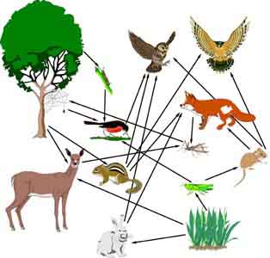  - Complete the Food Chain Games (Select 2)  - Watch this video on Energy Pyramids  ?  Why is the Energy Pyramid shaped like a pyramid?  ?  Why does the energy ”go down” at each level?  The energy pyramid is shaped like a pyramid because there is a lot of Biomass energy. The energy goes down because there isn’t enough energy.
  Explain | - Create a Food Web from the following images  -Post a Link to your Food Web here-  https://docs.google.com/drawings/d/1HG0k_HGFQpIAq5FgZ91_HwuTSZQ6NbeUv8BQML15wmc/edit?usp=sharing  - Create an Energy Pyramid on the following document  (this should match what your food pyramid shows)  -Post a Link to your Energy Pyramid here-  https://docs.google.com/drawings/d/1C2Uy7FQSajs5hcAf7CkkdU2iTqM0_gjVJ4M4i0IaK10/edit?usp=sharing
  Elaborate | ?  Using your Food Web and Energy Pyramid describe the flow of energy through your ecosystem.  - Start with the sun and end at your top predators.  - Include the trophic levels  - Describe what happens to energy as it moves through different organisms  Answer in at least 4 sentences  The sun gives energy to the plants which are the 1st trophic level, So when the plant is all grown a rabbit comes and eats it. The rabbit is the 2nd trophic level, while it eats nutritious plants, a snake comes and gobbles it up. The snake is the 3rd trophic level, eating the bunny and enjoying life, the snake is sure that he’s undefeatable. (Time lapse: 0.2 seconds later) A wolf the 4th trophic level shows up and eats the snake. Now that the wolf doesn’t have anything to eat he dies. The Mushroom decomposes it’s dead body and the cycle repeats itself. (It’s the circle of life, am I right Simba <3)  You are done, Submit this Doc. through Classroom

