Energy Flow in Ecosystems

Engage | Watch this Video on Energy Flow in Ecosystems  ?  Write three sentences explaining Energy Flow seen in Kalahari Desert Ecosystem (Where do the Sand People get their energy? The Kudu? The Organisms the Kudu eat?)  These sand people use one of the most ancient tracking systems because they believe it still works. They are one of the last tribes in the world that use this technique. If they lose the animal there hunting they try to put themselves in its position to keep tracking.
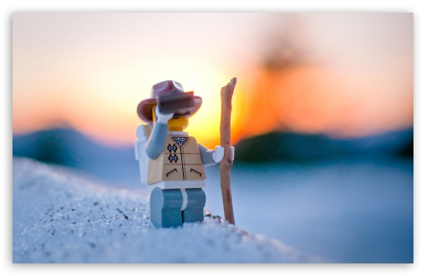  Explore | - Download this copy of the Vocabulary Slides  - Create each slide with the correct definition  - Include a picture on each which helps in your understanding of the word  - Use slide #1 as an example  - When you are done place a Link to it Below  https://docs.google.com/presentation/d/1emjB-7wxkMQdWEbCRpTqzFXuV0GLxzO8BqVm0s_KEtc/edit?usp=sharing  - Read this National Geographic Article  ?  What is the difference between primary, secondary, tertiary consumers?  (include a quote from the article to support your explanation)  The difference between them is they each get less energy the bigger the food chain the smaller the portions.  - Watch these 3 videos on Food Webs  Fabulous Food Chains the Dirt on Decomposers Home Sweet Habitat  - Check out this Food Chain Example:  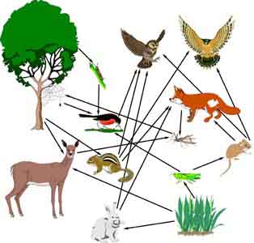  - Complete the Food Chain Games (Select 2)  - Watch this video on Energy Pyramids  ?  Why is the Energy Pyramid shaped like a pyramid?  ?  Why does the energy ”go down” at each level?  Because it resembles the food chain the higher up the deadlier  It goes down each animal because it's only used for growth
  Explain | - Create a Food Web from the following images  -Post a Link to your Food Web here-  - Create an Energy Pyramid on the following document  (this should match what your food pyramid shows)  -Post a Link to your Energy Pyramid here-
  Elaborate | ?  Using your Food Web and Energy Pyramid describe the flow of energy through your ecosystem.  - Start with the sun and end at your top predators.  - Include the trophic levels  - Describe what happens to energy as it moves through different organisms  Answer in at least 4 sentences  First the sun and water make photosynthesis and then the plants grow. After that a primary consumer like a grasshopper eats the grass then a frog eats the grasshopper. After that a snake will eat the frog. And then a hawk will swoop down and snatch the snake.  You are done, Submit this Doc. through Classroom

