Energy Flow in Ecosystems

Engage | Watch this Video on Energy Flow in Ecosystems  ?  Write three sentences explaining Energy Flow seen in Kalahari Desert Ecosystem (Where do the Sand People get their energy? The Kudu? The Organisms the Kudu eat?)  The Sand People get their energy from hunting the Kudu. The Kudu get their energy from plants. The plants get their energy from the sun and water.
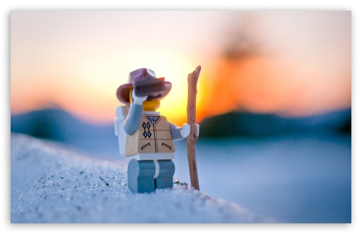  Explore | - Download this copy of the Vocabulary Slides  - Create each slide with the correct definition  - Include a picture on each which helps in your understanding of the word  - Use slide #1 as an example  - When you are done place a Link to it Below  Copy of Energy Flow Vocabulary  - Read this National Geographic Article  ?  What is the difference between primary, secondary, tertiary consumers?  (include a quote from the article to support your explanation)  Primary consumers eat the producers, secondary consumers eat the primary consumers, and tertiary consumers eat the secondary consumers.  - Watch these 3 videos on Food Webs  Fabulous Food Chains the Dirt on Decomposers Home Sweet Habitat  - Check out this Food Chain Example:  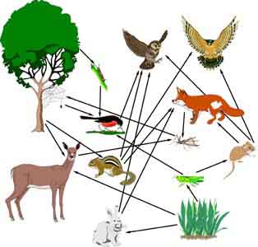  - Complete the Food Chain Games (Select 2)  - Watch this video on Energy Pyramids  ?  Why is the Energy Pyramid shaped like a pyramid?  ?  Why does the energy ”go down” at each level?  It is shaped like a pyramid because the energy obtained goes down as the food chain goes up. It “goes down” at each level because the other animals store it for growth.
  Explain | - Create a Food Web from the following images  -Post a Link to your Food Web here-  Copy of Food Web  - Create an Energy Pyramid on the following document  (this should match what your food pyramid shows)  Copy of Energy Pyramid
  Elaborate | ?  Using your Food Web and Energy Pyramid describe the flow of energy through your ecosystem.  - Start with the sun and end at your top predators.  - Include the trophic levels  - Describe what happens to energy as it moves through different organisms  Answer in at least 4 sentences  The sun provides energy for the producers so that they can grow and the primary consumers can eat the producers. The secondary consumers then eat the primary consumers, and then the tertiary consumers (top predators) will eat the secondary consumers. The tertiary consumer will die and the decomposer will break it down and restart the food chain. Energy “goes down” as the food chain “goes up”, and the tertiary consumer gets the least amount of energy while the primary consumer gets the most energy.  You are done, Submit this Doc. through Classroom

