Energy Flow in Ecosystems

Engage | Watch this Video on Energy Flow in Ecosystems  ?  Write three sentences explaining Energy Flow seen in Kalahari Desert Ecosystem (Where do the Sand People get their energy? The Kudu? The Organisms the Kudu eat?)  The Sand People start to feel the rhythm of the animals’ movements from the spacing of tracks. The Kudu eat a wide variety of food such as leaves, twigs, shrubs, herbs, vines, flowers, and grass.
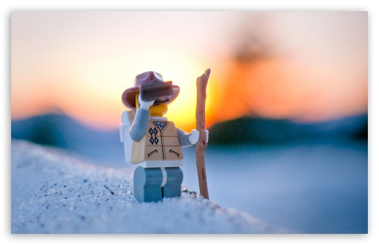  Explore | - Download this copy of the Vocabulary Slides  - Create each slide with the correct definition  - Include a picture on each which helps in your understanding of the word  - Use slide #1 as an example  - When you are done place a Link to it Below  https://docs.google.c om/presentation/d/1PON51XYzlbAmWKopwe99mMIyxk6o4bbqUp_y7Lw5Gr4/edit?usp=sharing  Read this National Geographic Article  ?  What is the difference between primary, secondary, tertiary consumers?  (include a quote from the article to support your explanation)  The difference between primary, secondary, and tertiary is that primary consumers are herbivores and they make up the second trophic level. Secondary consumers are usually carnivores that eat the primary consumers. Tertiary Consumers are carnivores that eat other carnivores. ------  - Watch these 3 videos on Food Webs  Fabulous Food Chains the Dirt on Decomposers Home Sweet Habitat  - Check out this Food Chain Example:  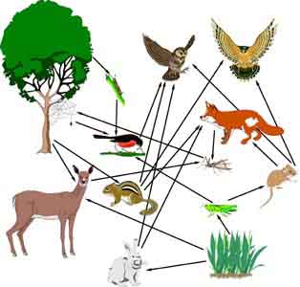  - Complete the Food Chain Games (Select 2)  - Watch this video on Energy Pyramids  ?  Why is the Energy Pyramid shaped like a pyramid?  ?  Why does the energy ”go down” at each level?  -------The energy pyramid is shaped the way it is, because there is enough biomass energy contained in the primary producers at the bottom to support the predators at the top. The energy goes down at each level because most energy gets lost when the animals try to run away from their predator or when they are trying to look for food themselves. ------
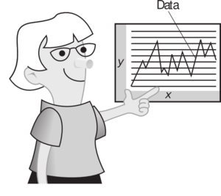  Explain | - Create a Food Web from the following images  -Post a Link to your Food Web here-  https://docs.google.com/drawings/d/1IsLCWgJOMjNJnXyuVS9BjGUjFwGu7GfYCXIsTPZkaNw/edit  - Create an Energy Pyramid on the following document  (this should match what your food pyramid shows)  -Post a Link to your Energy Pyramid here-  https://docs.google.com/drawings/d/1E_ieLcyuUMIEsDZyEJeGvaT9jCteUDNs4mLX7Zf2jrQ/edit
  Elaborate | ?  Using your Food Web and Energy Pyramid describe the flow of energy through your ecosystem.  - Start with the sun and end at your top predators.  - Include the trophic levels  - Describe what happens to energy as it moves through different organisms  Answer in at least 4 sentences  The Food Web starts with the plants which are the producers. They get a trophic level of 100%. Producers get the most amount of energy. Producers then get eaten by the primary consumers. Primary consumers get a trophic level of 10%. The primary consumers get eaten by the secondary consumers which get a trophic level of 1%. The secondary consumers get eaten by the tertiary consumers. The tertiary consumers get a trophic level of .01%. Therefore tertiary consumers get the least amount of energy.  You are done, Submit this Doc. through Classroom

