Energy Flow in Ecosystems

Engage | Watch this Video on Energy Flow in Ecosystems  ?  Write three sentences explaining Energy Flow seen in Kalahari Desert Ecosystem (Where do the Sand People get their energy? The Kudu? The Organisms the Kudu eat?)  -------Delete this and Write the answer HERE------
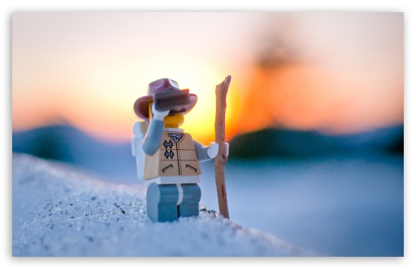  Explore | - Download this copy of the Vocabulary Slides  - Create each slide with the correct definition  - Include a picture on each which helps in your understanding of the word  - Use slide #1 as an example  - When you are done place a Link to it Below  --Create a Link to your Completed SLIDESHOW here–  - Read this National Geographic Article  ?  What is the difference between primary, secondary, tertiary consumers?  (include a quote from the article to support your explanation)  The difference between primary,secondary and tertiary consumers is that primary consumers are Herbivores which they eat plants and algae. In the article it says that “In the grassland ecosystem deer,mice and even elephants are herbivores.”A Secondary consumer eats herbivores.In the text it says that “they are the third trophic level.For an example in the desert ecosystem a secondary consumer can be a snake thats eats a mouse.”.Now the tertiary consumer eat the secondary consumer.They are the forth trophic level. For an example It can be an ow or eagle that eats a snake.  - Watch these 3 videos on Food Webs  Fabulous Food Chains the Dirt on Decomposers Home Sweet Habitat  - Check out this Food Chain Example:  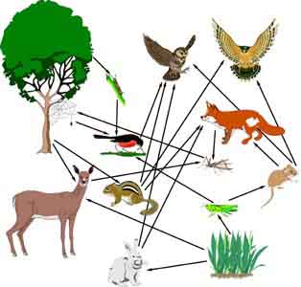  - Complete the Food Chain Games (Select 2)  - Watch this video on Energy Pyramids  ?  Why is the Energy Pyramid shaped like a pyramid?  ?  Why does the energy ”go down” at each level?  -------Delete this and Write the answer HERE------
  Explain | - Create a Food Web from the following images  -Post a Link to your Food Web here-  - Create an Energy Pyramid on the following document  (this should match what your food pyramid shows)  -Post a Link to your Energy Pyramid here-
  Elaborate | ?  Using your Food Web and Energy Pyramid describe the flow of energy through your ecosystem.  - Start with the sun and end at your top predators.  - Include the trophic levels  - Describe what happens to energy as it moves through different organisms  Answer in at least 4 sentences  -------Delete this and Write the answer HERE------  You are done, Submit this Doc. through Classroom

