Energy Flow in Ecosystems

Engage | Watch this Video on Energy Flow in Ecosystems  ?  Write three sentences explaining Energy Flow seen in Kalahari Desert Ecosystem (Where do the Sand People get their energy? The Kudu? The Organisms the Kudu eat?)  They feel the rhythm of the animals' movement. He will carry the horns and will move fast. They separate home from the herd to be able to do that.
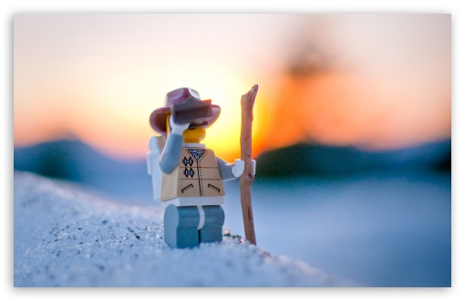  Explore | - Download this copy of the Vocabulary Slides  - Create each slide with the correct definition  - Include a picture on each which helps in your understanding of the word  - Use slide #1 as an example  - When you are done place a Link to it Below  Copy of Energy Flow Vocabulary  - Read this National Geographic Article  ?  What is the difference between primary, secondary, tertiary consumers?  (include a quote from the article to support your explanation)  Herbivores: primary consumers  Secondary consumer: carnivores that eat primary consumers  Tertiary consumers: carnivores that eat other carnivores  “primary consumers are herbivores” ``Secondary consumers eat herbivores”. “Tertiary consumers eat the secondary consumers”.  - Watch these 3 videos on Food Webs  Fabulous Food Chains the Dirt on Decomposers Home Sweet Habitat  - Check out this Food Chain Example:  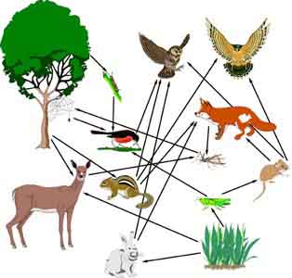  - Complete the Food Chain Games (Select 2)  - Watch this video on Energy Pyramids  ?  Why is the Energy Pyramid shaped like a pyramid?  ?  Why does the energy ”go down” at each level?  The energy pyramid is shaped like a pyramid because there is a lot of biomass energy. Their energy goes down because there is not enough.
  Explain | - Create a Food Web from the following images  Copy of Food Web  - Create an Energy Pyramid on the following document  (this should match what your food pyramid shows)  Copy of Energy Pyramid
  Elaborate | ?  Using your Food Web and Energy Pyramid describe the flow of energy through your ecosystem.  - Start with the sun and end at your top predators.  - Include the trophic levels  - Describe what happens to energy as it moves through different organisms  Answer in at least 4 sentences  Plants (first trophic level) get eaten by the mouse. Mouse (second trophic level) gets eaten by the snake. Snake (third trophic level) gets eaten by the bird. When the trophic levels go up the energy gets less.  You are done, Submit this Doc. through Classroom

