Biome Project
Below is all the information you need to include in your Biome project. You will have until October 22nd at Midnight to turn in this assignment. This assignment is worth 100 points.

Choose one Biome to research. For the Freshwater and Marine Biomes, you may only select one area.

Polar Region
Tundra
Taiga
Temperate Forest
Temperate Grasslands
Savanna
Desert
Tropical Rainforest
Marine (Pacific Ocean, Atlantic Ocean or Indian Ocean
Freshwater (Lakes and Ponds, Rivers , Wetlands)
Coral Reef

Once you have picked your Biome, you need to find the following information on your biome. Please make sure all the information is in complete sentences. If the information is not in complete sentences, you will lose points. Conduct your research through Google and copy and paste the addresses of all websites you use below the table.
5 points for each section
Biome Name: | Tropical Rainforest
What is your Biome like? ( Climate, average temperature, average rain amount, seasons if it has any) | Tropical Rainforests are closed canopy forests growing 28 degrees north or south of the equator. They are very wet places, temperatures are uniformly high -between 20 C and 35 C.
Any adaptations creatures need to survive in your biome | Many animals have adapted to the unique conditions of the tropical rainforests. The sloth uses camouflage and moves very slowly to make it difficult for predators to spot them.
Examples of Producers in your biome: | The producers in the Tropical rainforest are trees, vines, mosses, grasses, and tropical fruit trees.
Examples of Primary Consumers in your Biome | Primary consumers in the Tropical rainforest are the macaws, monkeys, agouti, taapir, butterflies, sloths, and toucans.
Examples of Secondary Consumers in your Biome: | Secondary consumers in the Tropical rainforest are tree frogs, the jaguar, and gaint spiders.
Examples of Tertiary Consumers in your Biome: | Tertiary consumers in the Tropical rainforest are pumas, crocodiles and dart frogs.
Examples of Decomposers in your Biome: | Decomposers in the Tropical forest are termites, slugs, scorpions, worms, and fungi.
Example of Mutualism in your Biome: | An example of mutualism in the Tropical forest are Monarch butterflies traveling in large groups to stay safe.
Example of Commensalism in your Biome: | Bugs actually live on and inside sloth fur; they benefit by getting shelter, and also benefit by eating algae that grows on the sloth's fur.
Example of Parasitism in your Biome: | One parasitism in the Tropical forest is the roundworm, some of these are notoriously parasitic and live their lives in the animal’s intestinal tract.
Recreate a food web found in your Biome: | A toucan at the bottom consumes the fruit produced by the tree, a primary producer such as a ficus tree, which produces leaves that monkeys eat, and then the monkey is eaten by the harpy eagle.

Copy and paste the web addresses of all resources below. These must be included in your presentation to receive full credit.
10 points
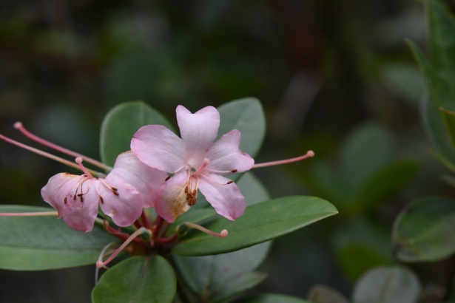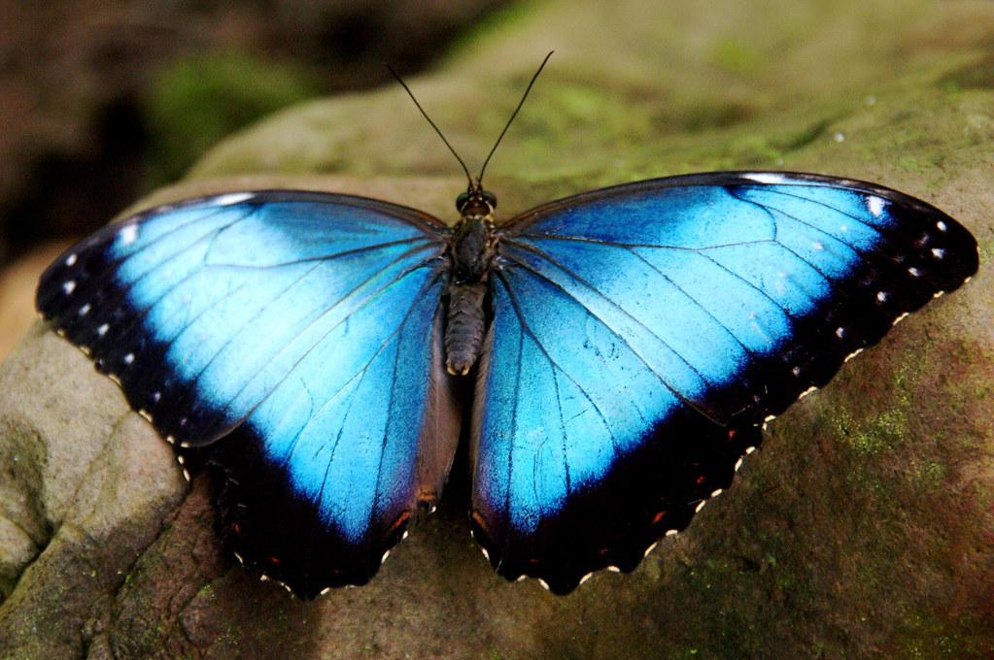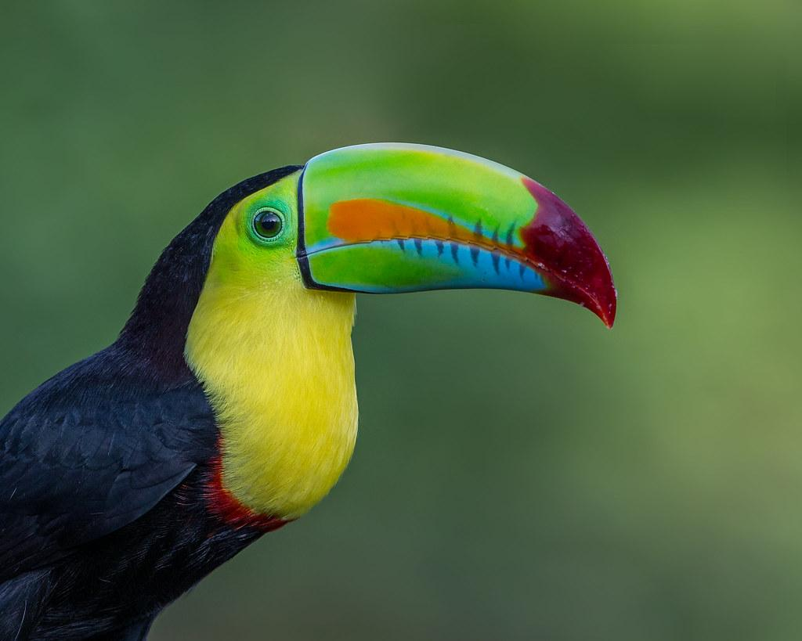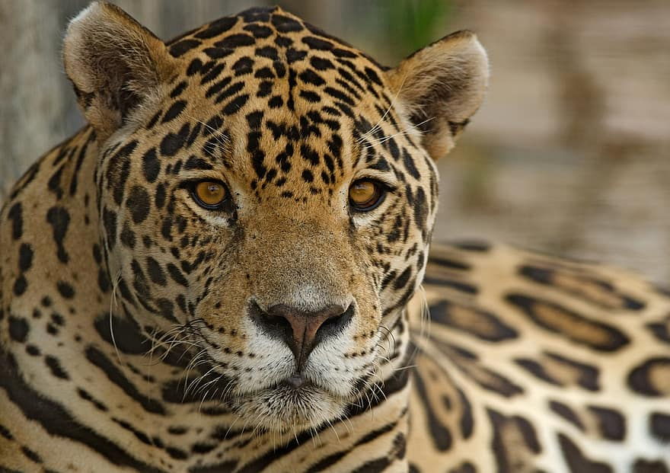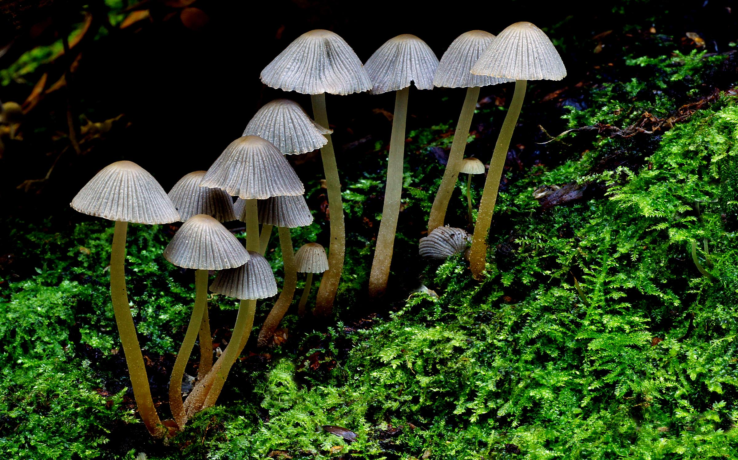
Flower
(Producer)
Butterfly
(Primary Consumer)

Toucan
(Secondary Consumer)
Jagur
(Tertiary Consumer)

Mushrooms (Decomposer)

Once you have collected all your information for your Biome and put the information in complete sentences, you will need to make a slideshow about your Biome. Each topic needs to be a slide in your slide show. Below are the requirements you have to include in each slide:

https://earthobservatory.nasa.gov/biome/biorainforest.php#:~:text=The%20tropical%20rainforest%20is%20a,that%20form%20three%20different%20layers.&text=They%20climb%20trees%20in%20the,trees%2C%20ferns%2C%20and%20palms.

https://www.bioexplorer.net/tropical-rainforest-animal-adaptations.html/

https://www.nationalgeographic.org/encyclopedia/rain-forest/#:~:text=Decomposers%2C%20such%20as%20termites%2C%20slugs,of%20predators%20consume%20the%20decomposers!

https://www.edtechlens.com/blog/rainforest-kids-science-me-ill-you-working-rainforest#:~:text=In%20the%20rainforest%2C%20there%20are,hunt%20together%20to%20find%20food.

30 points total

Each slide have a different background
Each slide have pictures
Each slide have transitions (information slides in, rotates, etc.)

Additionally, you will need to find a video on your biome from youtube and attach the link to your slide show

Extra Credit

Create a slide telling me if you would want to live in your biome
Create a slide telling me which countries you would find your biome

Please attach the link to your google slides right here:

