Biome Project
Below is all the information you need to include in your Biome project. You will have until October 22nd at Midnight to turn in this assignment. This assignment is worth 100 points.

Choose one Biome to research. For the Freshwater and Marine Biomes, you may only select one area.

Polar Region
Tundra
Taiga
Temperate Forest
Temperate Grasslands
Savanna
Desert
Tropical Rainforest
Marine (Pacific Ocean, Atlantic Ocean or Indian Ocean
Freshwater (Lakes and Ponds, Rivers , Wetlands)
Coral Reef

Once you have picked your Biome, you need to find the following information on your biome. Please make sure all the information is in complete sentences. If the information is not in complete sentences, you will lose points. Conduct your research through Google and copy and paste the addresses of all websites you use below the table.
5 points for each section
Biome Name: | Polar Region
What is your Biome like? ( Climate, average temperature, average rain amount, seasons if it has any) | The Polar Regions average temperature is less than 10 C/ 50 F. The climate lacks warm summers, it hardly ever rains and the only seasons are winter and summer.
Any adaptations creatures need to survive in your biome | The adaptations creatures need to survive in the polar region are “layers of fat and oily skin to stay warm. Also, a white appearance and a small platform area to reduce the heat.”
Examples of Producers in your biome: | Lichen is the only producer in the Polar Region.
Examples of Primary Consumers in your Biome | The Primary Consumers in the polar region are the Caribou and other grazing (grass eaters) animals.
Examples of Secondary Consumers in your Biome: | The Secondary Consumers in the polar region are beluga whales and seals.
Examples of Tertiary Consumers in your Biome: | The Tertiary Consumers are polar bears, eagles, and wolves.
Examples of Decomposers in your Biome: | The Decomposers are Bacteria and Fungi.
Example of Mutualism in your Biome: | One Mutualism Relationship is Caribou and the Arctic fox. The Caribou gets its food being safe from the fox while the fox also gets food at the same time.
Example of Commensalism in your Biome: | A Commensalism Relationship in the polar region is the Arctic fox, Caribou, and Reindeer. When the Caribou and Reindeer are eating the lichens and looking for food, the fox starts to follow them and eats the leftovers.
Example of Parasitism in your Biome: | A polar region Parasitism Relationship exists between the liver tapeworm cysts and wolves, caribou, polar bears, and moose. The tapeworm feeds on the animals and as a result the animals are malnourished. (lack of nutrients)
Recreate a food web found in your Biome: | 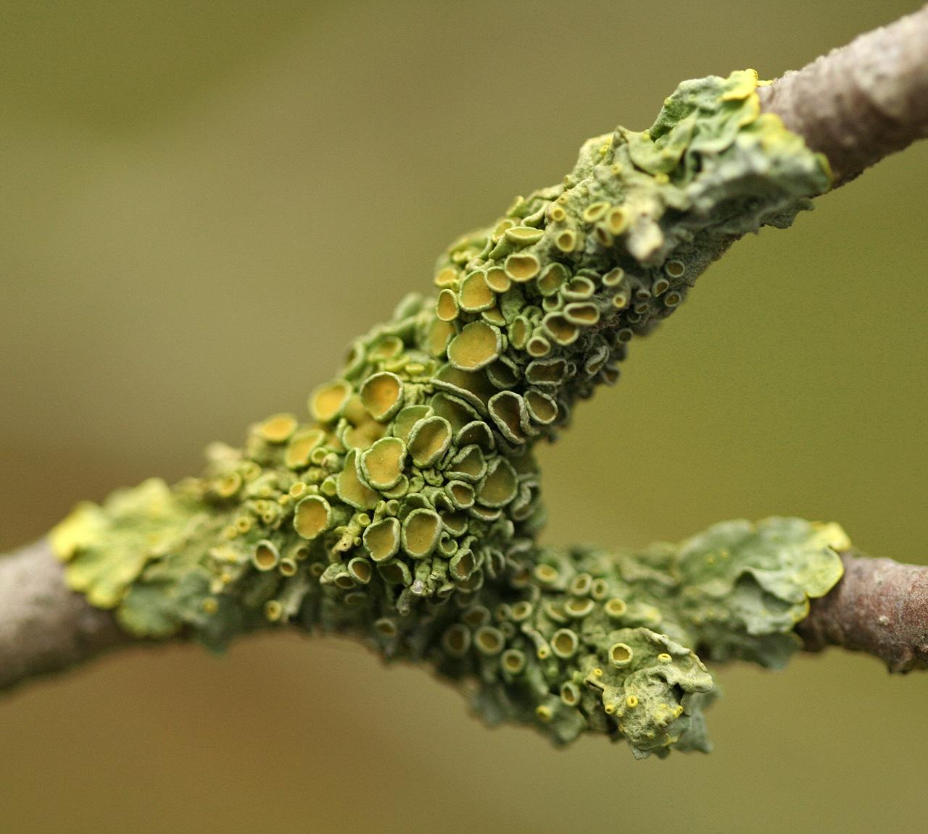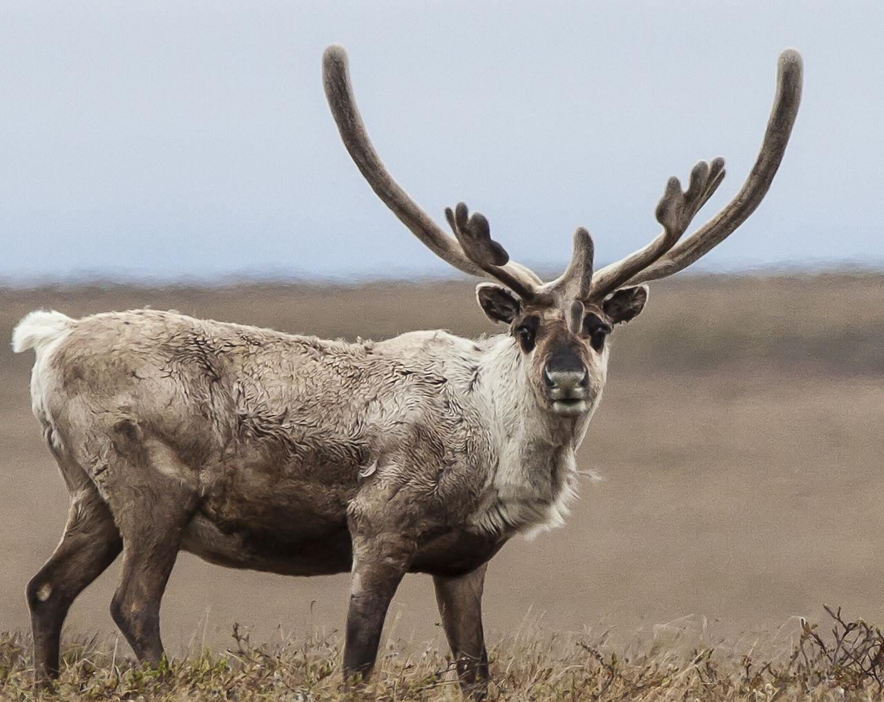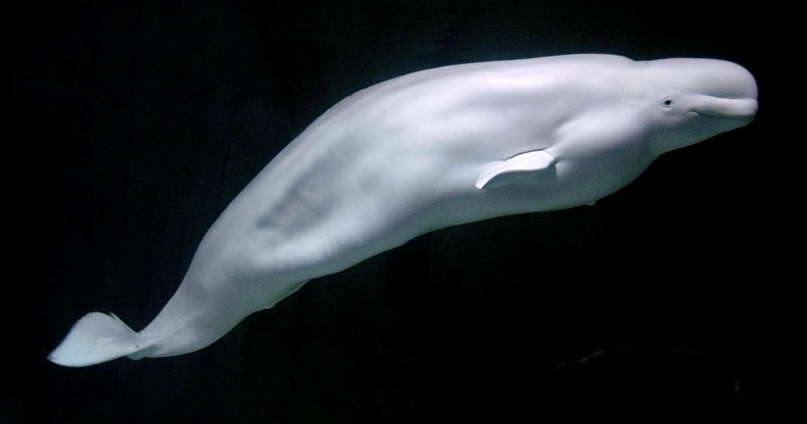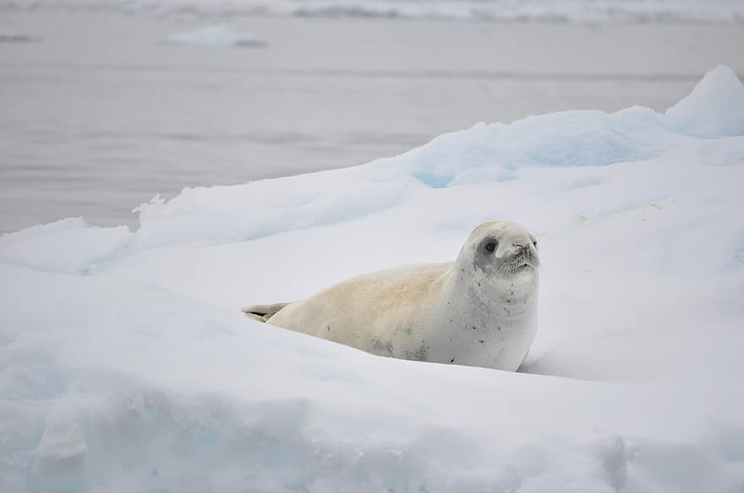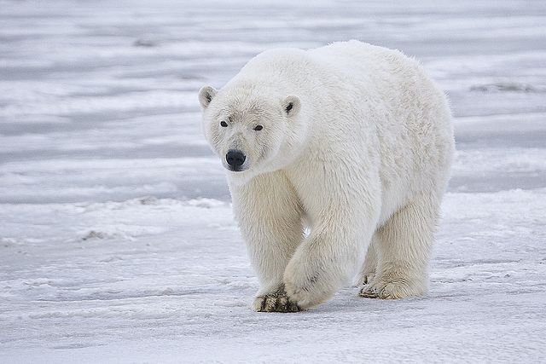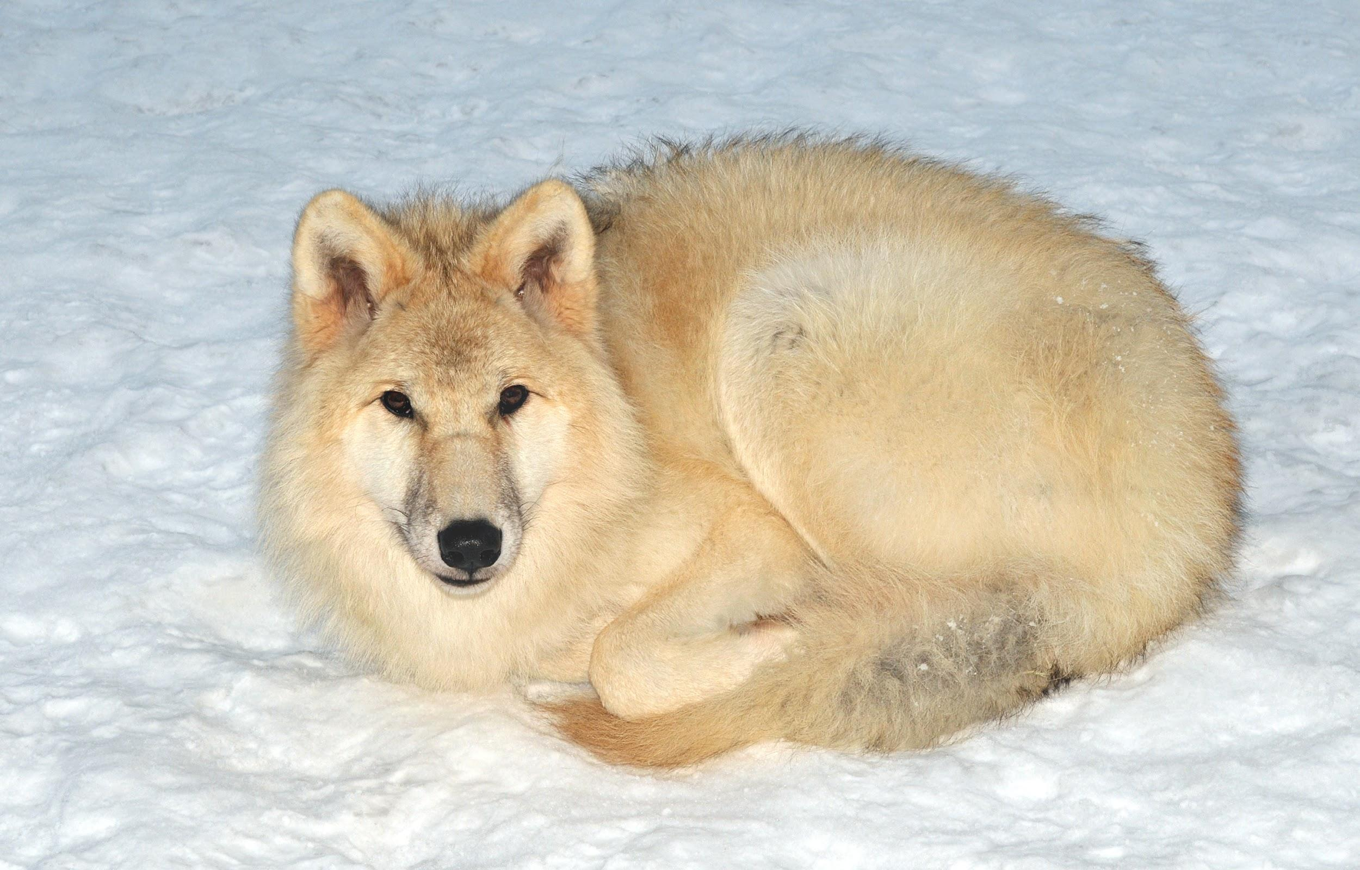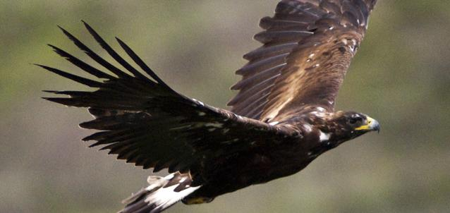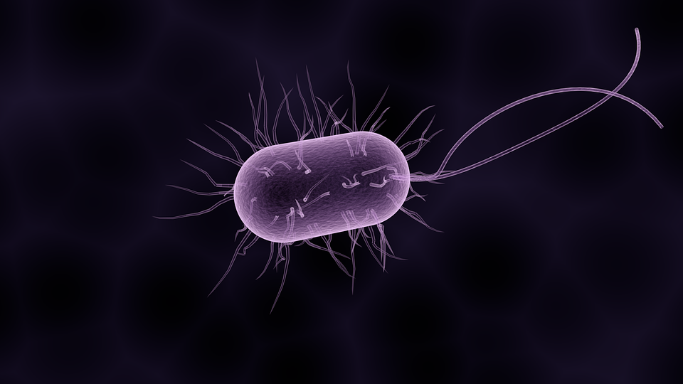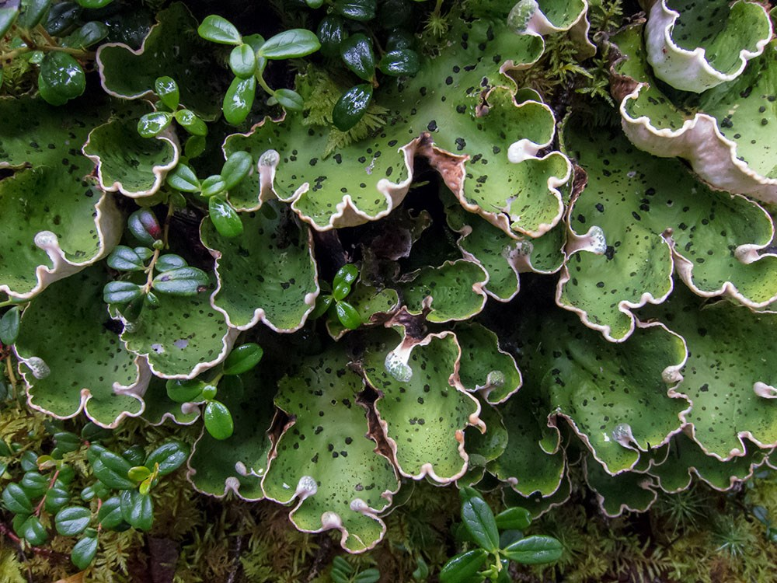  Lichen (producer)  Caribou (1st consumer)  beluga whales and seals (2nd consumer)  polar bears, wolves, and eagles ( Tertiary consumer)  Bacteria, and Fungi (Decomposers)

Copy and paste the web addresses of all resources below. These must be included in your presentation to receive full credit.
10 points
https://en.wikipedia.org https://divediscover.whoi.edu https://www.bbc.co.uk https://wonderopolis.org https://study.com https://articpolarecosystems2012.weebly.com

Once you have collected all your information for your Biome and put the information in complete sentences, you will need to make a slideshow about your Biome. Each topic needs to be a slide in your slide show. Below are the requirements you have to include in each slide:
30 points total

Each slide have a different background
Each slide have pictures
Each slide have transitions (information slides in, rotates, etc.)

Additionally, you will need to find a video on your biome from youtube and attach the link to your slide show

Extra Credit

Create a slide telling me if you would want to live in your biome
Create a slide telling me which countries you would find your biome

Please attach the link to your google slides right here:
America Estrada Alvarado - Biome Slides

