Biome Project
Below is all the information you need to include in your Biome project. You will have until October 22nd at Midnight to turn in this assignment. This assignment is worth 100 points.

Choose one Biome to research. For the Freshwater and Marine Biomes, you may only select one area.

Polar Region
Tundra
Taiga
Temperate Forest
Temperate Grasslands
Savanna
Desert
Tropical Rainforest
Marine (Pacific Ocean, Atlantic Ocean or Indian Ocean
Freshwater (Lakes and Ponds, Rivers , Wetlands)
Coral Reef

Once you have picked your Biome, you need to find the following information on your biome. Please make sure all the information is in complete sentences. If the information is not in complete sentences, you will lose points. Conduct your research through Google and copy and paste the addresses of all websites you use below the table.
5 points for each section
Biome Name: | Polar Region
What is your Biome like? ( Climate, average temperature, average rain amount, seasons if it has any) | The Polar Region climate has an average temperature every month of less than 10 C ( 50 F). The polar climate consists of cool summers and very cold winters, so when it's summer, there is a lack of warmth.
Any adaptations creatures need to survive in your biome | An example of an animal that has adaptations to survive in the polar region is the Polar Bear. Some adaptations that they have are that they have hair that's translucent which makes it seem white because it reflects the snow and they also have layers of thick fur and fat which help them keep warm.
Examples of Producers in your biome: | An example of a producer is algae living in the sea ice (ice algae). It is autotrophic single-celled algae.
Examples of Primary Consumers in your Biome | A couple of examples of primary consumers in my biome are phytoplanktons and crustaceans that consume the zoo plankton.
Examples of Secondary Consumers in your Biome: | Harp Seals are examples of secondary consumers in the Polar Region biome because they mainly eat fish.
Examples of Tertiary Consumers in your Biome: | Tertiary consumers consist of polar bears,orca whales, wolves, and eagles.
Examples of Decomposers in your Biome: | Some decomposers found in the Polar Region are bacteria, such as microorganisms and fungi. They work together to break down dead and decaying matter, digesting and absorbing the nutrients in the process.
Example of Mutualism in your Biome: | An example of mutualism in the polar region is, since lichen consists of green alga and fungus, the alga is naturally photosynthetic so they are able to transform carbon dioxide into sugar that fungus feeds on. Meanwhile, the fungus counterpart helps protect the alga by getting minerals substrate and retaining water.
Example of Commensalism in your Biome: | An example of commensalism in this biome is when the arctic fox follows behind the polar bear and scavenges on scraps of food, the polar bear isn't affected and the fox benefits from the food.
Example of Parasitism in your Biome: | Liver Tapeworm cyst is an example of parasitism because they are prone to live in animal bodies such as wolves, caribou, polar bears and moose; they feed on the food that the animals eat which leads to the animal getting malnutrition.
Recreate a food web found in your Biome: | 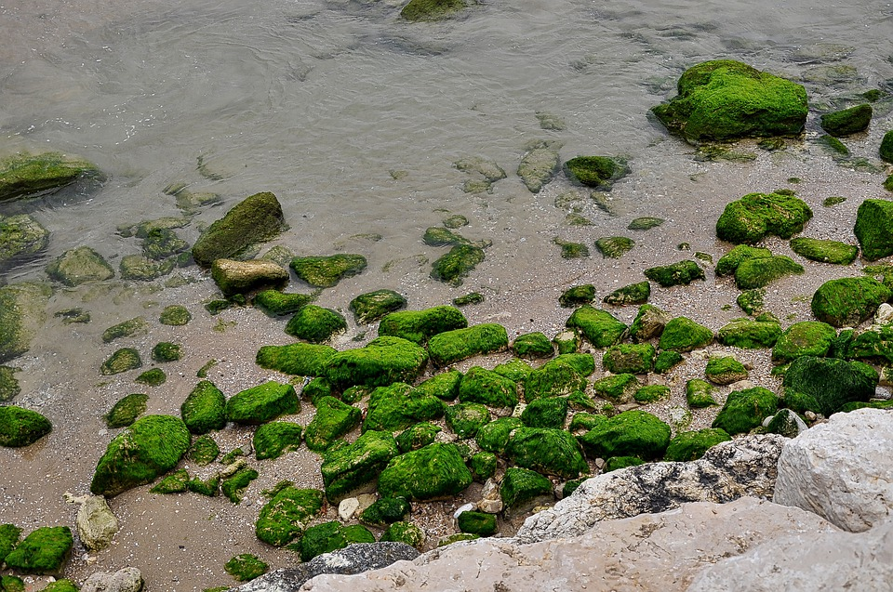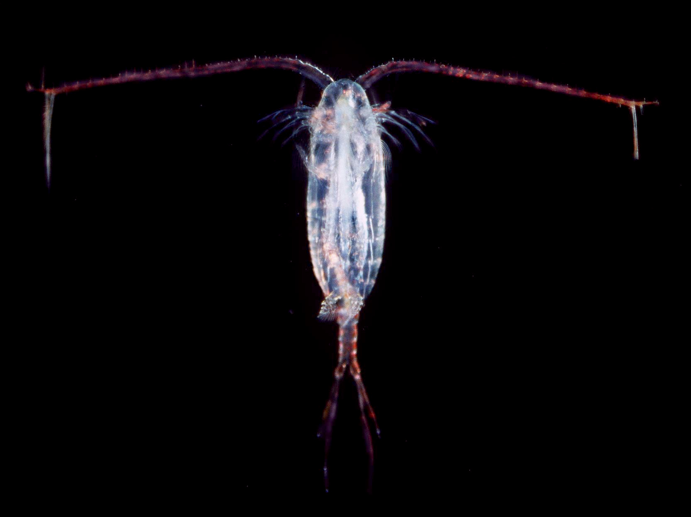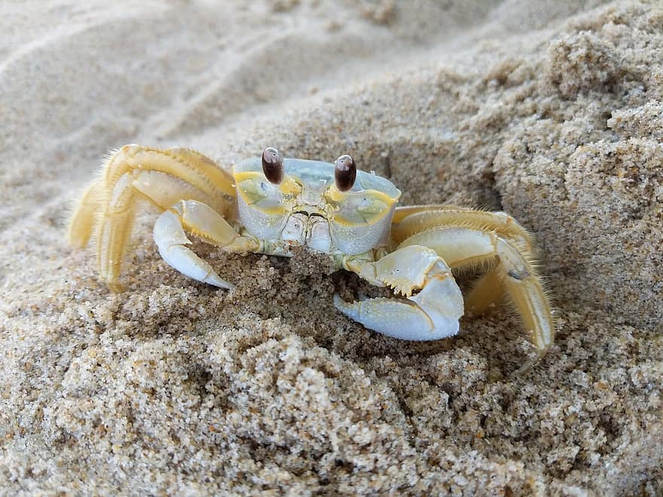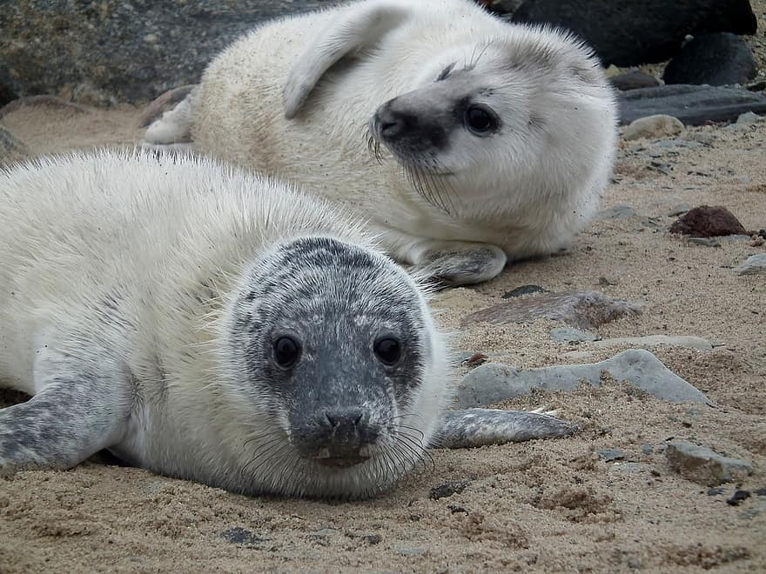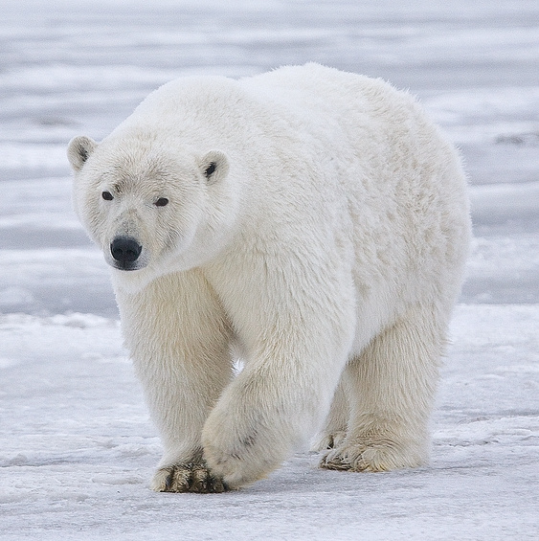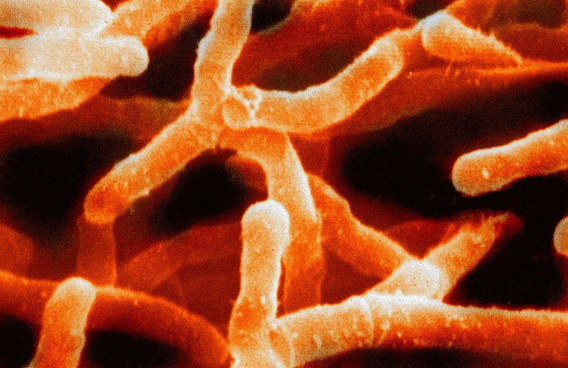  Ice Algae: Producers  Zooplankton: Primary consumer  Crustaceans: Secondary consumer  Seals: secondary consumer  Polar Bear: Tertiary consumer  Bacteria: decomposer

Copy and paste the web addresses of all resources below. These must be included in your presentation to receive full credit.
10 points
https://lisbdnet.com
https://www.bioexplorer.net
https://sciencing.com
https://kids.frontiersin.org
https://study.com
https://www.sps186.org
https://sites.google.com
https://www.sunnysports.com

Once you have collected all your information for your Biome and put the information in complete sentences, you will need to make a slideshow about your Biome. Each topic needs to be a slide in your slide show. Below are the requirements you have to include in each slide:
30 points total

Each slide have a different background
Each slide have pictures
Each slide have transitions (information slides in, rotates, etc.)

Additionally, you will need to find a video on your biome from youtube and attach the link to your slide show

Extra Credit

Create a slide telling me if you would want to live in your biome
Create a slide telling me which countries you would find your biome

Please attach the link to your google slides right here:
Dayanna Rivera - Biome Slides

