Biome Project
Below is all the information you need to include in your Biome project. You will have until October 22nd at Midnight to turn in this assignment. This assignment is worth 100 points.

Choose one Biome to research. For the Freshwater and Marine Biomes, you may only select one area.

Polar Region
Tundra
Taiga
Temperate Forest
Temperate Grasslands
Savanna
Desert
Tropical Rainforest
Marine (Pacific Ocean, Atlantic Ocean or Indian Ocean
Freshwater (Lakes and Ponds, Rivers , Wetlands)
Coral Reef

Once you have picked your Biome, you need to find the following information on your biome. Please make sure all the information is in complete sentences. If the information is not in complete sentences, you will lose points. Conduct your research through Google and copy and paste the addresses of all websites you use below the table.
5 points for each section
Biome Name: | Savanna
What is your Biome like? ( Climate, average temperature, average rain amount, seasons if it has any) | The savanna climate has a temperature range of 68° to 86° F (20° - 30° C). In the winter, it is usually about 68° to 78° F (20° - 25° C). In the summer the temperature ranges from 78° to 86° F (25° - 30° C). Rainfall?
Any adaptations creatures need to survive in your biome | The animals in the Savanna adapt to the shortage of water and food through various ways–to survive the shortage of water.
Examples of Producers in your biome: | Examples of producers in the Savanna are plants like star grass, lemon grass, acacia trees, red oat grass, and jackalberry trees.
Examples of Primary Consumers in your Biome | Examples of Primary Consumers in my biome are gazelles, giraffes, elephants, antelope, wildebeest, zebras, and impalas.
Examples of Secondary Consumers in your Biome: | Examples of Secondary consumers species in the Savanna are lions, leopards, cheetahs, hyenas, jackals, wild dogs, snakes, lizards, and birds of prey.
Examples of Tertiary Consumers in your Biome: | An example of Tertiary Consumers are Cheetahs and Lions The Cheetah consumes the leopard, hyena,the african wild dog and the jackal.
Examples of Decomposers in your Biome: | Examples of Decomposers in the savanna are bacteria, fungi, earthworms, and insects.
Example of Mutualism in your Biome: | One interesting example of mutualism in the east African savanna is the relationship between the whistling-thorn Acacia tree, large herbivores such as giraffes, and ant communities that live on the trees. Whistling-thorn Acacias reward ants that defend the trees from browsing herbivores.
Example of Commensalism in your Biome: | An example of a commensalism relationship in the savanna is the relationship between lions and hyenas. Lions kill and consume certain animals, then hyenas feed on the remains, enjoying the benefits of free food without harming the lions.
Example of Parasitism in your Biome: | A tick that is sucking blood from an elephant is an example of parasitism in the savanna. The tick is a parasite that is taking advantage of its host, and using its host for nutrients.
Recreate a food web found in your Biome: | 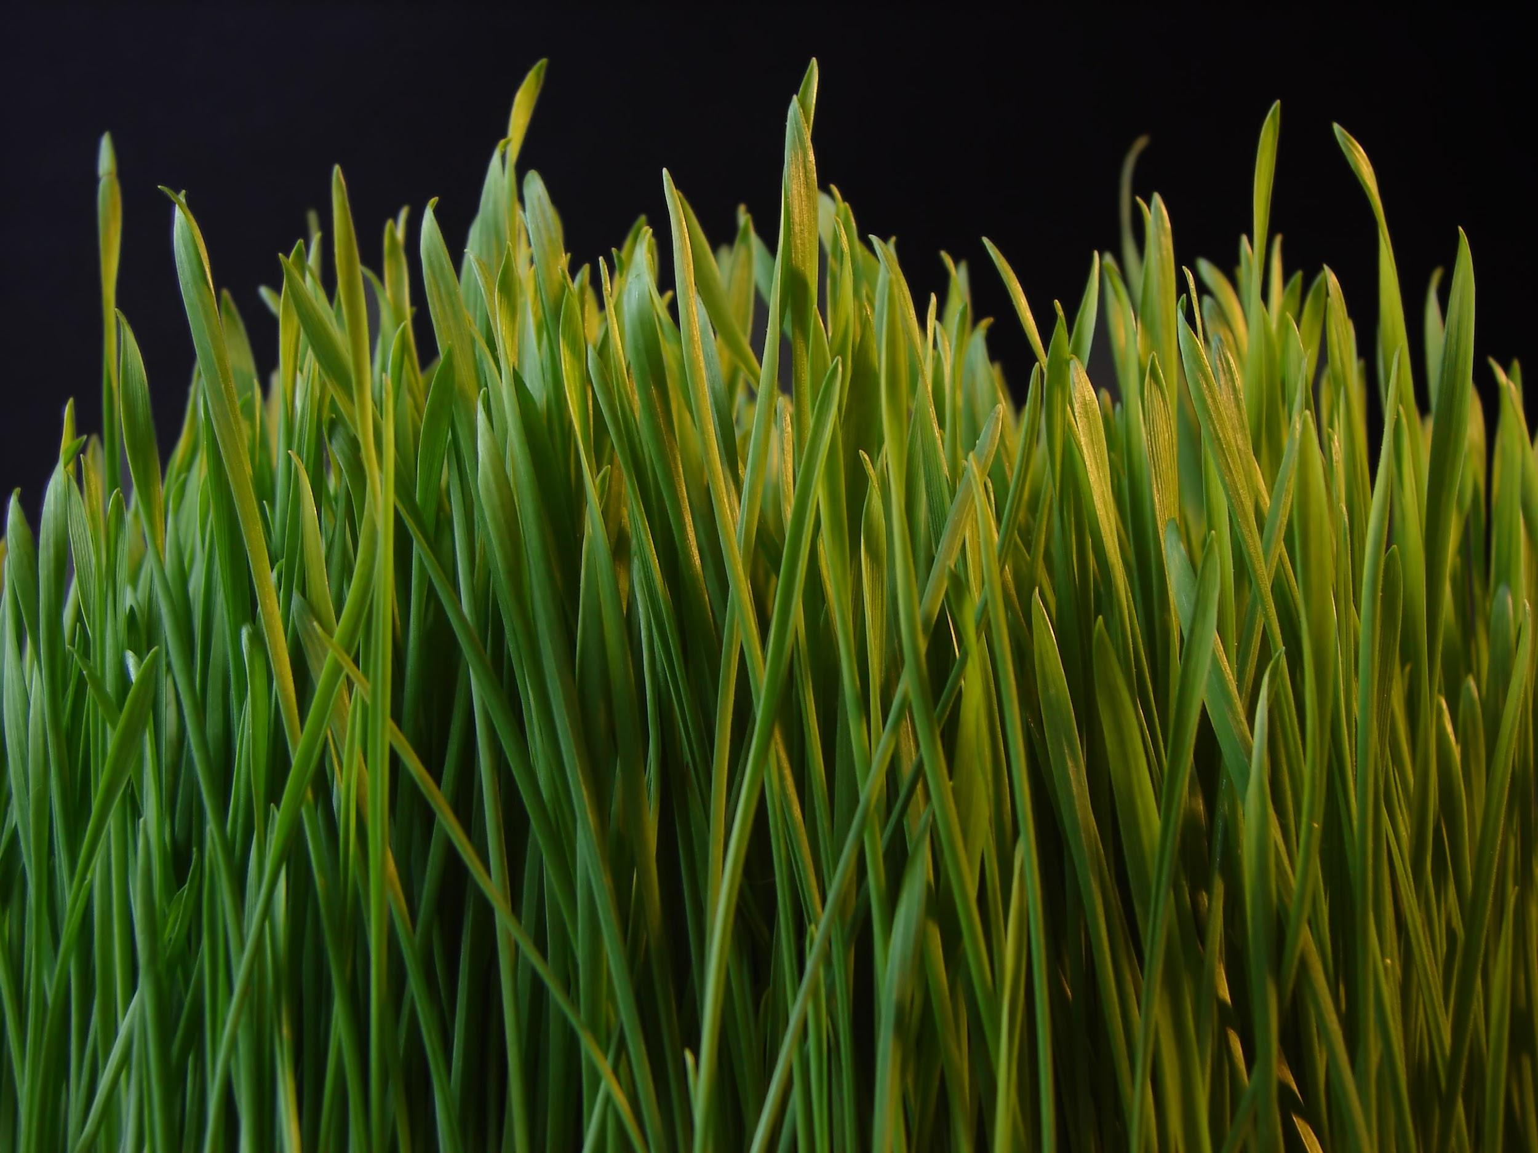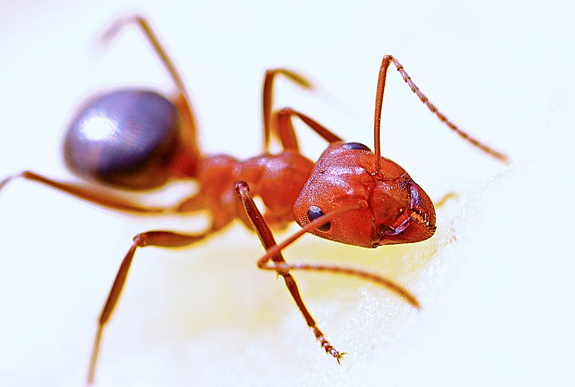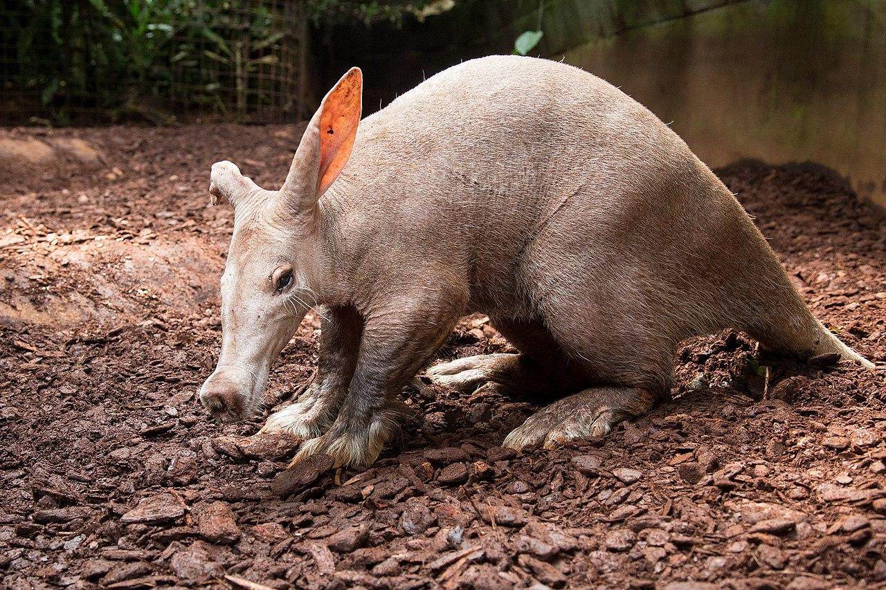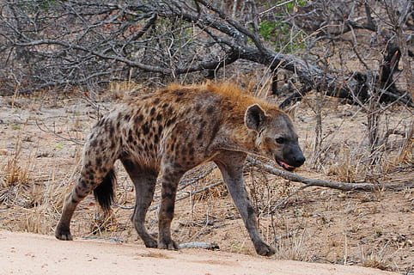  Grass  (producer)  Ant  (primary Consumer)  Aardvark  (Secondary Consumer)  Hyena (Tertiary Consumer)

Copy and paste the web addresses of all resources below. These must be included in your presentation to receive full credit.
10 points
Nature's Web of Life: Mutualism - Wild Nature Institute
What Is an Example of Parasitism in the Savanna https://www.reference.com › Science

Once you have collected all your information for your Biome and put the information in complete sentences, you will need to make a slideshow about your Biome. Each topic needs to be a slide in your slide show. Below are the requirements you have to include in each slide:
30 points total

Each slide have a different background
Each slide have pictures
Each slide have transitions (information slides in, rotates, etc.)

Additionally, you will need to find a video on your biome from youtube and attach the link to your slide show

Extra Credit

Create a slide telling me if you would want to live in your biome
Create a slide telling me which countries you would find your biome

Please attach the link to your google slides right here:

