Biome Project
Below is all the information you need to include in your Biome project. You will have until October 22nd at Midnight to turn in this assignment. This assignment is worth 100 points.

Choose one Biome to research. For the Freshwater and Marine Biomes, you may only select one area.

Polar Region
Tundra
Taiga
Temperate Forest
Temperate Grasslands
Savanna
Desert
Tropical Rainforest
Marine (Pacific Ocean, Atlantic Ocean or Indian Ocean
Freshwater (Lakes and Ponds, Rivers , Wetlands)
Coral Reef

Once you have picked your Biome, you need to find the following information on your biome. Please make sure all the information is in complete sentences. If the information is not in complete sentences, you will lose points. Conduct your research through Google and copy and paste the addresses of all websites you use below the table.
5 points for each section
Biome Name: | Taiga
What is your Biome like? ( Climate, average temperature, average rain amount, seasons if it has any) | The taiga biome is the largest terrestrial biome. It can also get up to −10 °C (14 °F) or more. Rain fall? Seasons??
Any adaptations creatures need to survive in your biome | Animals in taiga need a layer of insulating feathers or fur to protect them from the cold. Most animals migrate to warmer climates once the cold weather begins.
Examples of Producers in your biome: | Some examples of producers in taiga biome are trees, conifers, small shrubs, moss, and grass.
Examples of Primary Consumers in your Biome | Some examples of primary consumers in the taiga biome are rabbits, voles, mice, and shrews.
Examples of Secondary Consumers in your Biome: | Examples of secondary consumers in the taiga biome are shellfish, snails, beetles, and crustaceans.
Examples of Tertiary Consumers in your Biome: | Some examples of tertiary consumers in taiga are bears, owls, and eagles.
Examples of Decomposers in your Biome: | A few examples of decomposers in the taiga biome are snails, flies, slugs, fungi, bacteria, and earthworms.
Example of Mutualism in your Biome: | An example of mutualism in the taiga biome is when bees fly plant to plant. Then what happens?
Example of Commensalism in your Biome: | An example of commensalism in the taiga biome is when moss starts growing on trees. How is each benefited?
Example of Parasitism in your Biome: | An parasitism example in taiga is when a winter tick hitchhikes on a moose's back. Oh howso? Who is benefited?
Recreate a food web found in your Biome: | 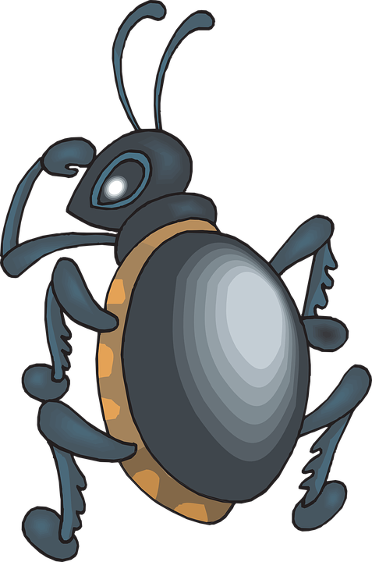  Tree  Beetle  Squirrel  Fox

Copy and paste the web addresses of all resources below. These must be included in your presentation to receive full credit.
10 points
Environmental conditions - taiga - Encyclopedia Britannica
Taiga Facts - MBGnet
Taiga Biome (Boreal Forest) - Earth Eclipse
Weather and Climate - Boreal Forest and Taiga

Once you have collected all your information for your Biome and put the information in complete sentences, you will need to make a slideshow about your Biome. Each topic needs to be a slide in your slide show. Below are the requirements you have to include in each slide:
30 points total

Each slide have a different background
Each slide have pictures
Each slide have transitions (information slides in, rotates, etc.)

Additionally, you will need to find a video on your biome from youtube and attach the link to your slide show

Extra Credit

Create a slide telling me if you would want to live in your biome
Create a slide telling me which countries you would find your biome

Please attach the link to your google slides right here:

