Biome Project
Below is all the information you need to include in your Biome project. You will have until October 22nd at Midnight to turn in this assignment. This assignment is worth 100 points.

Choose one Biome to research. For the Freshwater and Marine Biomes, you may only select one area.

Polar Region
Tundra
Taiga
Temperate Forest
Temperate Grasslands
Savanna
Desert
Tropical Rainforest
Marine (Pacific Ocean, Atlantic Ocean or Indian Ocean
Freshwater (Lakes and Ponds, Rivers , Wetlands)
Coral Reef

Once you have picked your Biome, you need to find the following information on your biome. Please make sure all the information is in complete sentences. If the information is not in complete sentences, you will lose points. Conduct your research through Google and copy and paste the addresses of all websites you use below the table.
5 points for each section
Biome Name: | Coral Reef
What is your Biome like? ( Climate, average temperature, average rain amount, seasons if it has any) | The Coral reef can reach between the temperatures of 73 to 84 degrees Fahrenheit. The coral reef Biome receives about an average yearly precipitation of 75-78inches of rain. This biome experiences summers and winters but the season temperatures can vary greatly.
Any adaptations creatures need to survive in your biome | The coral reefs have lots of cracks and crevices, the tiny bodies of some fish allow them to move quickly and make sharp turns to escape their predator.
Examples of Producers in your biome: | Some primary producers in the Coral Reef are Blue-green algae, phytoplankton, zooxanthellae, seagrass, and brown algae.
Examples of Primary Consumers in your Biome | The primary consumers in my biome are zooplankton, corals, sponges , atlantic blue tang, and queen conch.
Examples of Secondary Consumers in your Biome: | Examples of secondary consumers in my biome are sharks, dolphins, eels, sea horses, jellyfish, and starfish.
Examples of Tertiary Consumers in your Biome: | Tertiary consumers in this biome include sharks, barracuda, tuna, grouper, and snapper.
Examples of Decomposers in your Biome: | Decomposers in this biome include fan worms , sea cucumbers, snails , crabs , bristle worms, and bacteria.
Example of Mutualism in your Biome: | One example of mutualism in the coral reef is when the coral provides algae a place to live and in return the algae produces oxygen and helps the coral to remove waste.
Example of Commensalism in your Biome: | An example of commensalism in my biome might be a suckerfish who attaches itself to a shark and cleans up the waste after the shark eats. The doesn't feel anything while the suckerfish is getting a free meal.
Example of Parasitism in your Biome: | A parasite referred to as fish lice eats louse of the species Cymothoa exigua. In the coral an example might be??
Recreate a food web found in your Biome: | 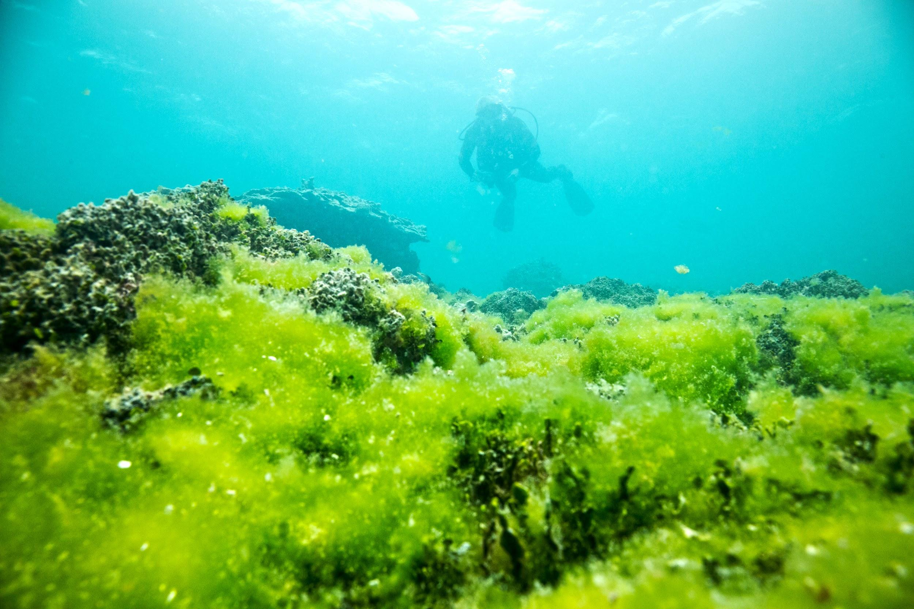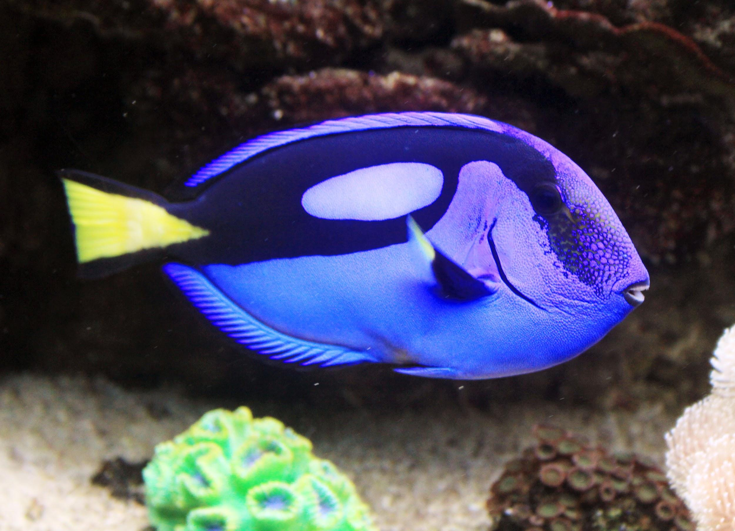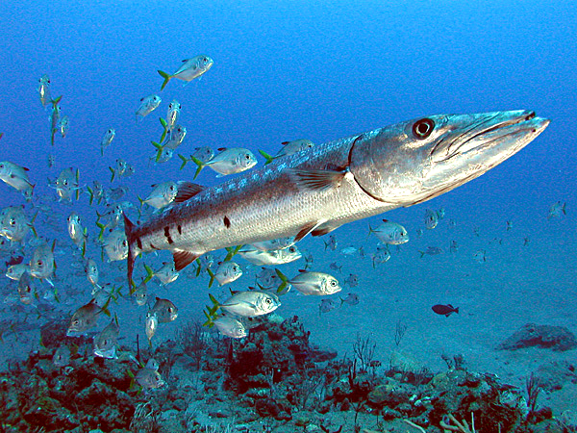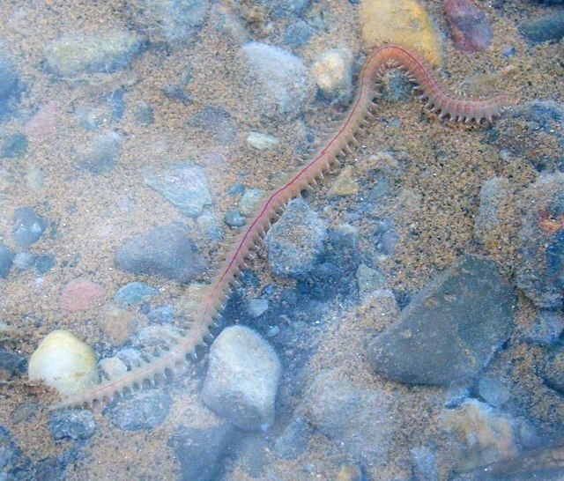  Algae  (Producer)  Atlantic Blue fish  (Primary Consumer  Dolphin  (Secondary Consumer)  Barracuda  (Tertiary Consumer)  Bristle Worms  (Decomposer)

Copy and paste the web addresses of all resources below. These must be included in your presentation to receive full credit.
10 points
Climate , Rainfall, Seasons , Adaptations , Producer and Primary consumer , Tertiary consumers and decomposers , Mutualism , Commensalism , Parasitism

Once you have collected all your information for your Biome and put the information in complete sentences, you will need to make a slideshow about your Biome. Each topic needs to be a slide in your slide show. Below are the requirements you have to include in each slide:
30 points total

Each slide have a different background
Each slide have pictures
Each slide have transitions (information slides in, rotates, etc.)

Additionally, you will need to find a video on your biome from youtube and attach the link to your slide show

Extra Credit

Create a slide telling me if you would want to live in your biome
Create a slide telling me which countries you would find your biome

Please attach the link to your google slides right here:

