Biome Project
Below is all the information you need to include in your Biome project. You will have until October 22nd at Midnight to turn in this assignment. This assignment is worth 100 points.

Choose one Biome to research. For the Freshwater and Marine Biomes, you may only select one area.

Polar Region
Tundra
Taiga
Temperate Forest
Temperate Grasslands
Savanna
Desert
Tropical Rainforest
Marine (Pacific Ocean, Atlantic Ocean or Indian Ocean
Freshwater (Lakes and Ponds, Rivers , Wetlands)
Coral Reef

Once you have picked your Biome, you need to find the following information on your biome. Please make sure all the information is in complete sentences. If the information is not in complete sentences, you will lose points. Conduct your research through Google and copy and paste the addresses of all websites you use below the table.
5 points for each section
Biome Name: | Savanna
What is your Biome like? ( Climate, average temperature, average rain amount, seasons if it has any) | In the savanna the temperature ranges from 68 F - 86 F and it has a wet and dry season. It rains 30-40 inches.
Any adaptations creatures need to survive in your biome | In my biome animals adapt to little water and food, so they find other ways to get food and water. Name one.
Examples of Producers in your biome: | Example of produces in my biome are Jackalberry Trees, Star grass, Lemongrass, and Jarrah trees.
Examples of Primary Consumers in your Biome | Examples of primary consumers in the savanna include Gazelles, Giraffe, Antelope, Zebras, and Elephants.
Examples of Secondary Consumers in your Biome: | Examples of secondary consumers in my biome include Wild dogs, hyenas, birds, and lizards.
Examples of Tertiary Consumers in your Biome: | Examples of tertiary consumers in my biome are lions, leopards, cheetahs, jackals, and snakes.
Examples of Decomposers in your Biome: | Examples of decomposers in the savanna are Insects, bacteria Fungi, and earthworms.
Example of Mutualism in your Biome: | One example of mutualism in the savanna might include ants and trees. The ants get a home with food and the tree gets protection.
Example of Commensalism in your Biome: | An example of commensalism in the savanna include the Lion who kills the animal to eat, and then hyenas will get the leftovers.
Example of Parasitism in your Biome: | An example of parasitism in the savanna is a tic and an elephant. The tic sucks blood from the elephant and the elephant gets ill
Recreate a food web found in your Biome: | 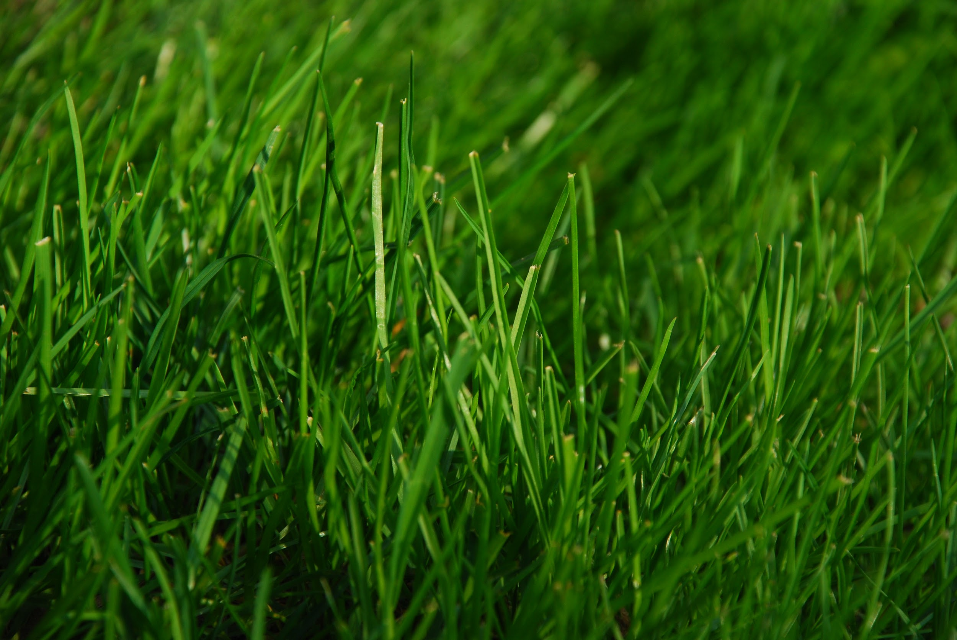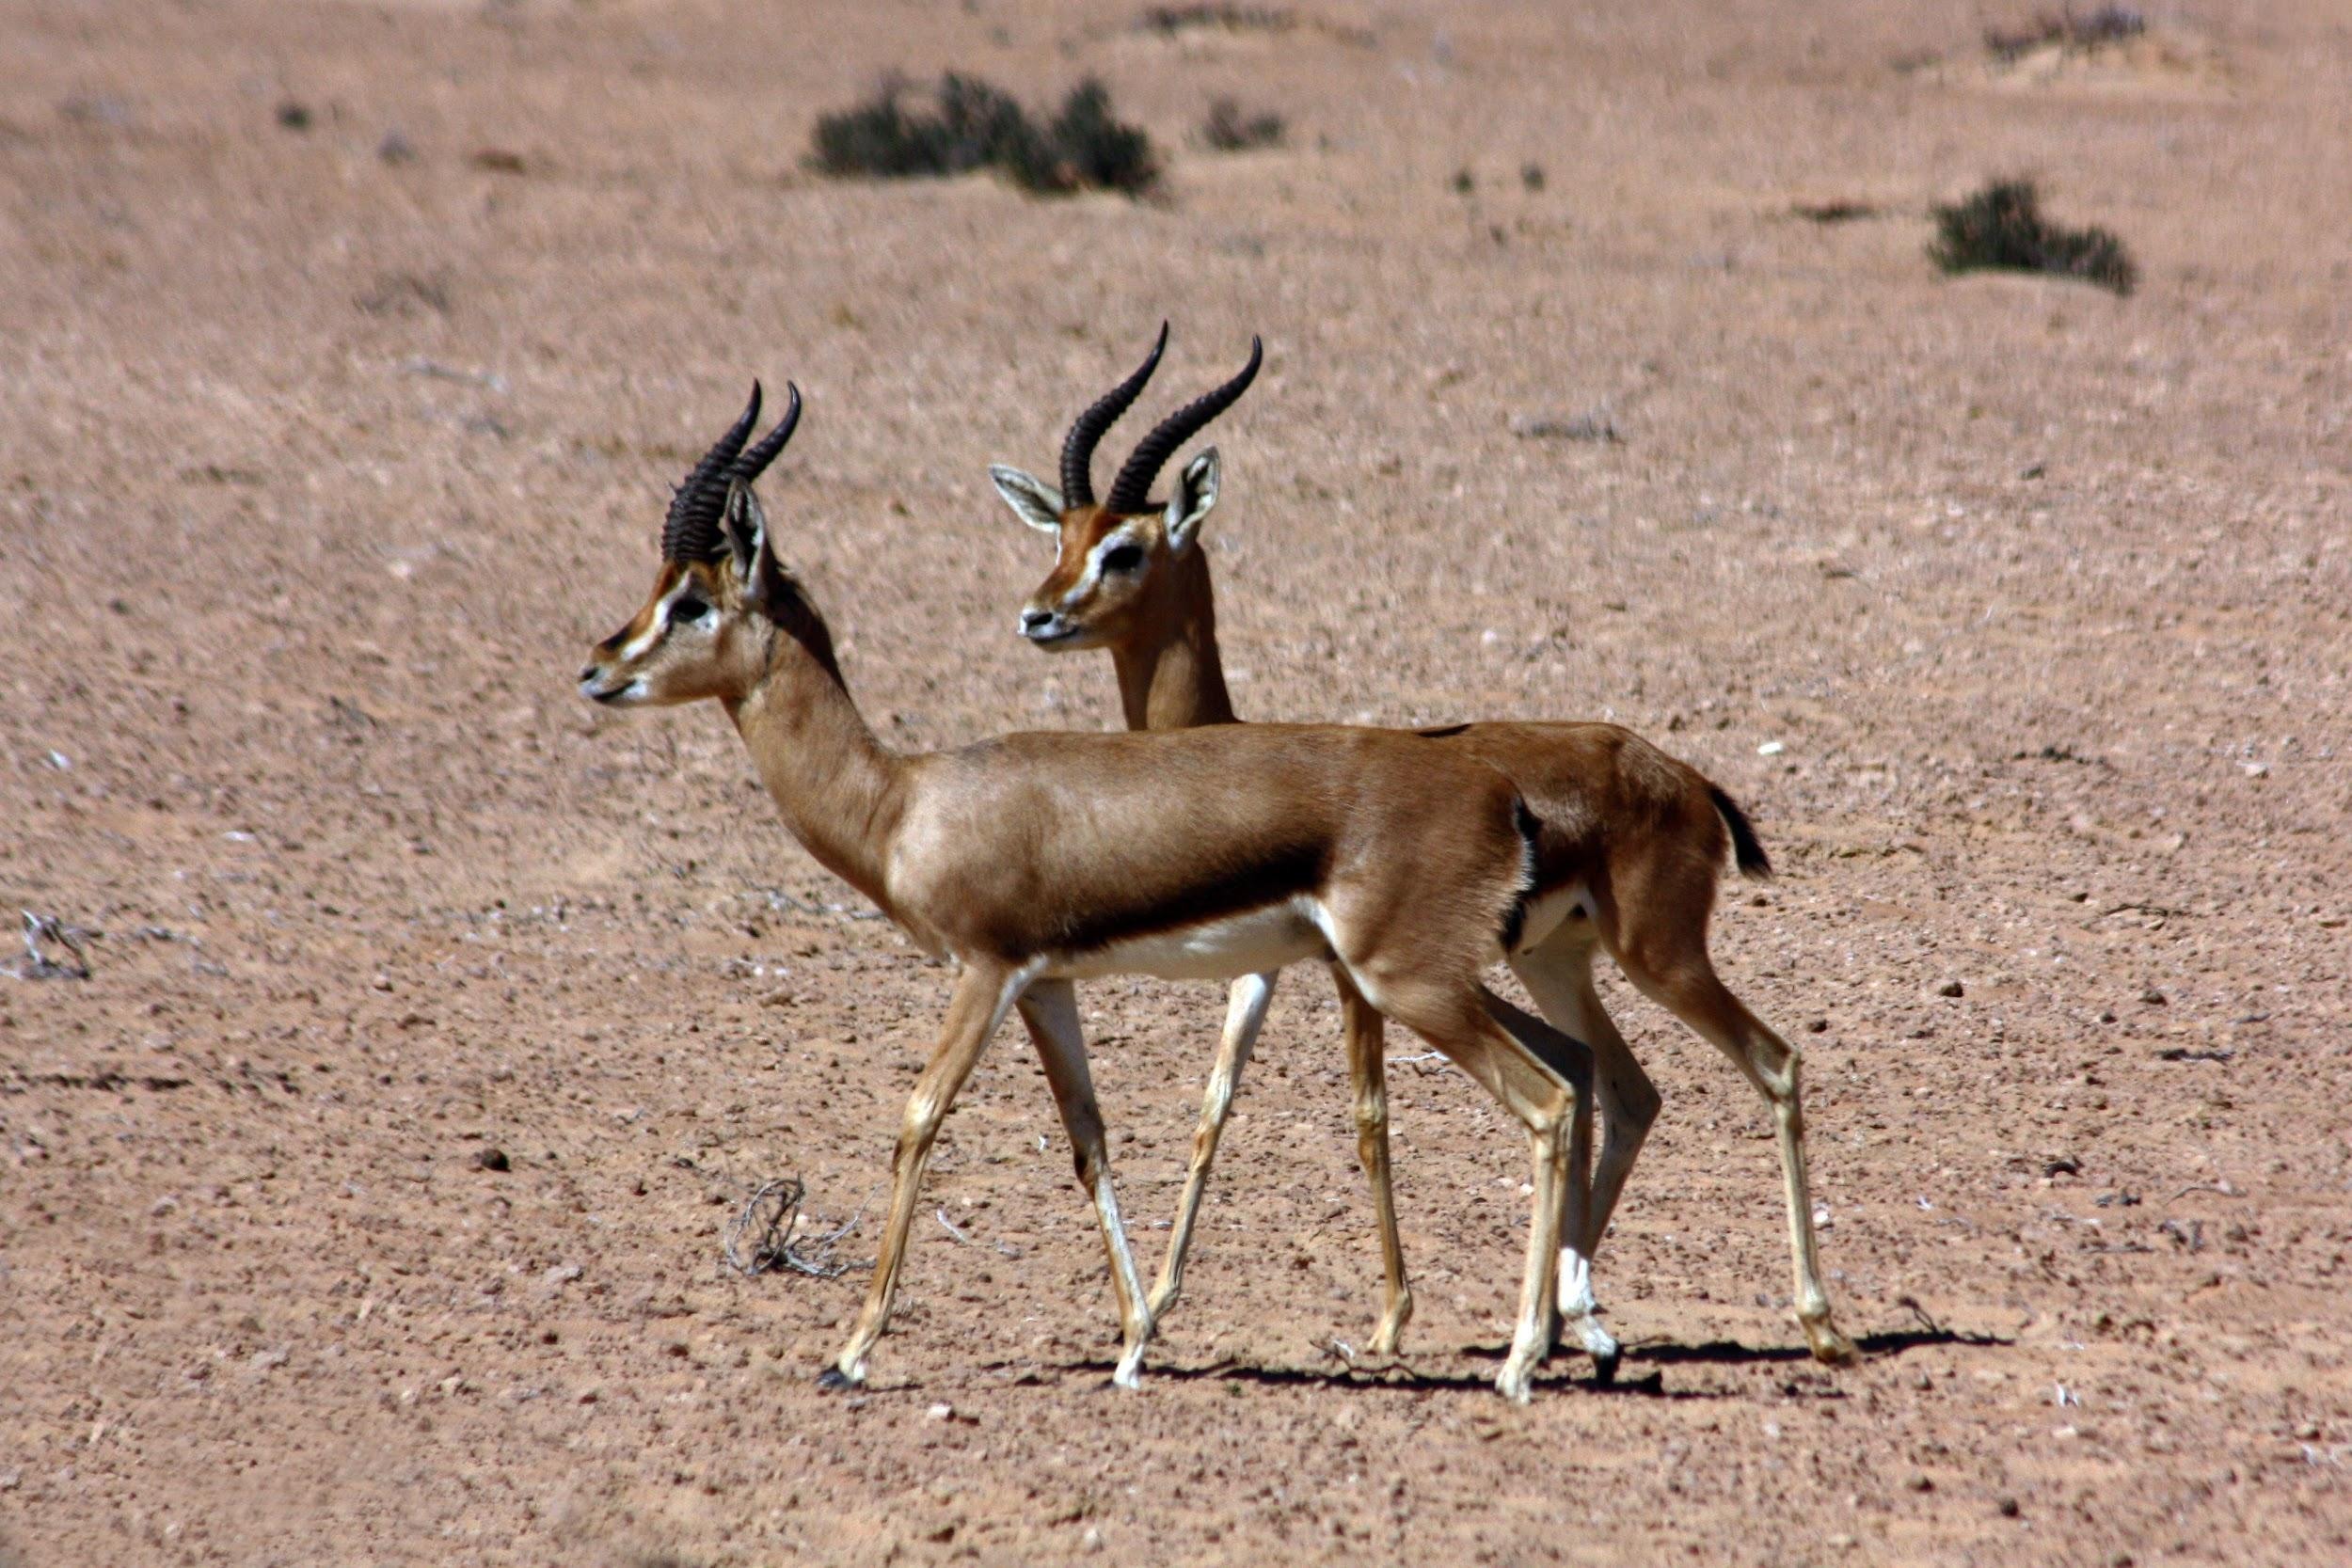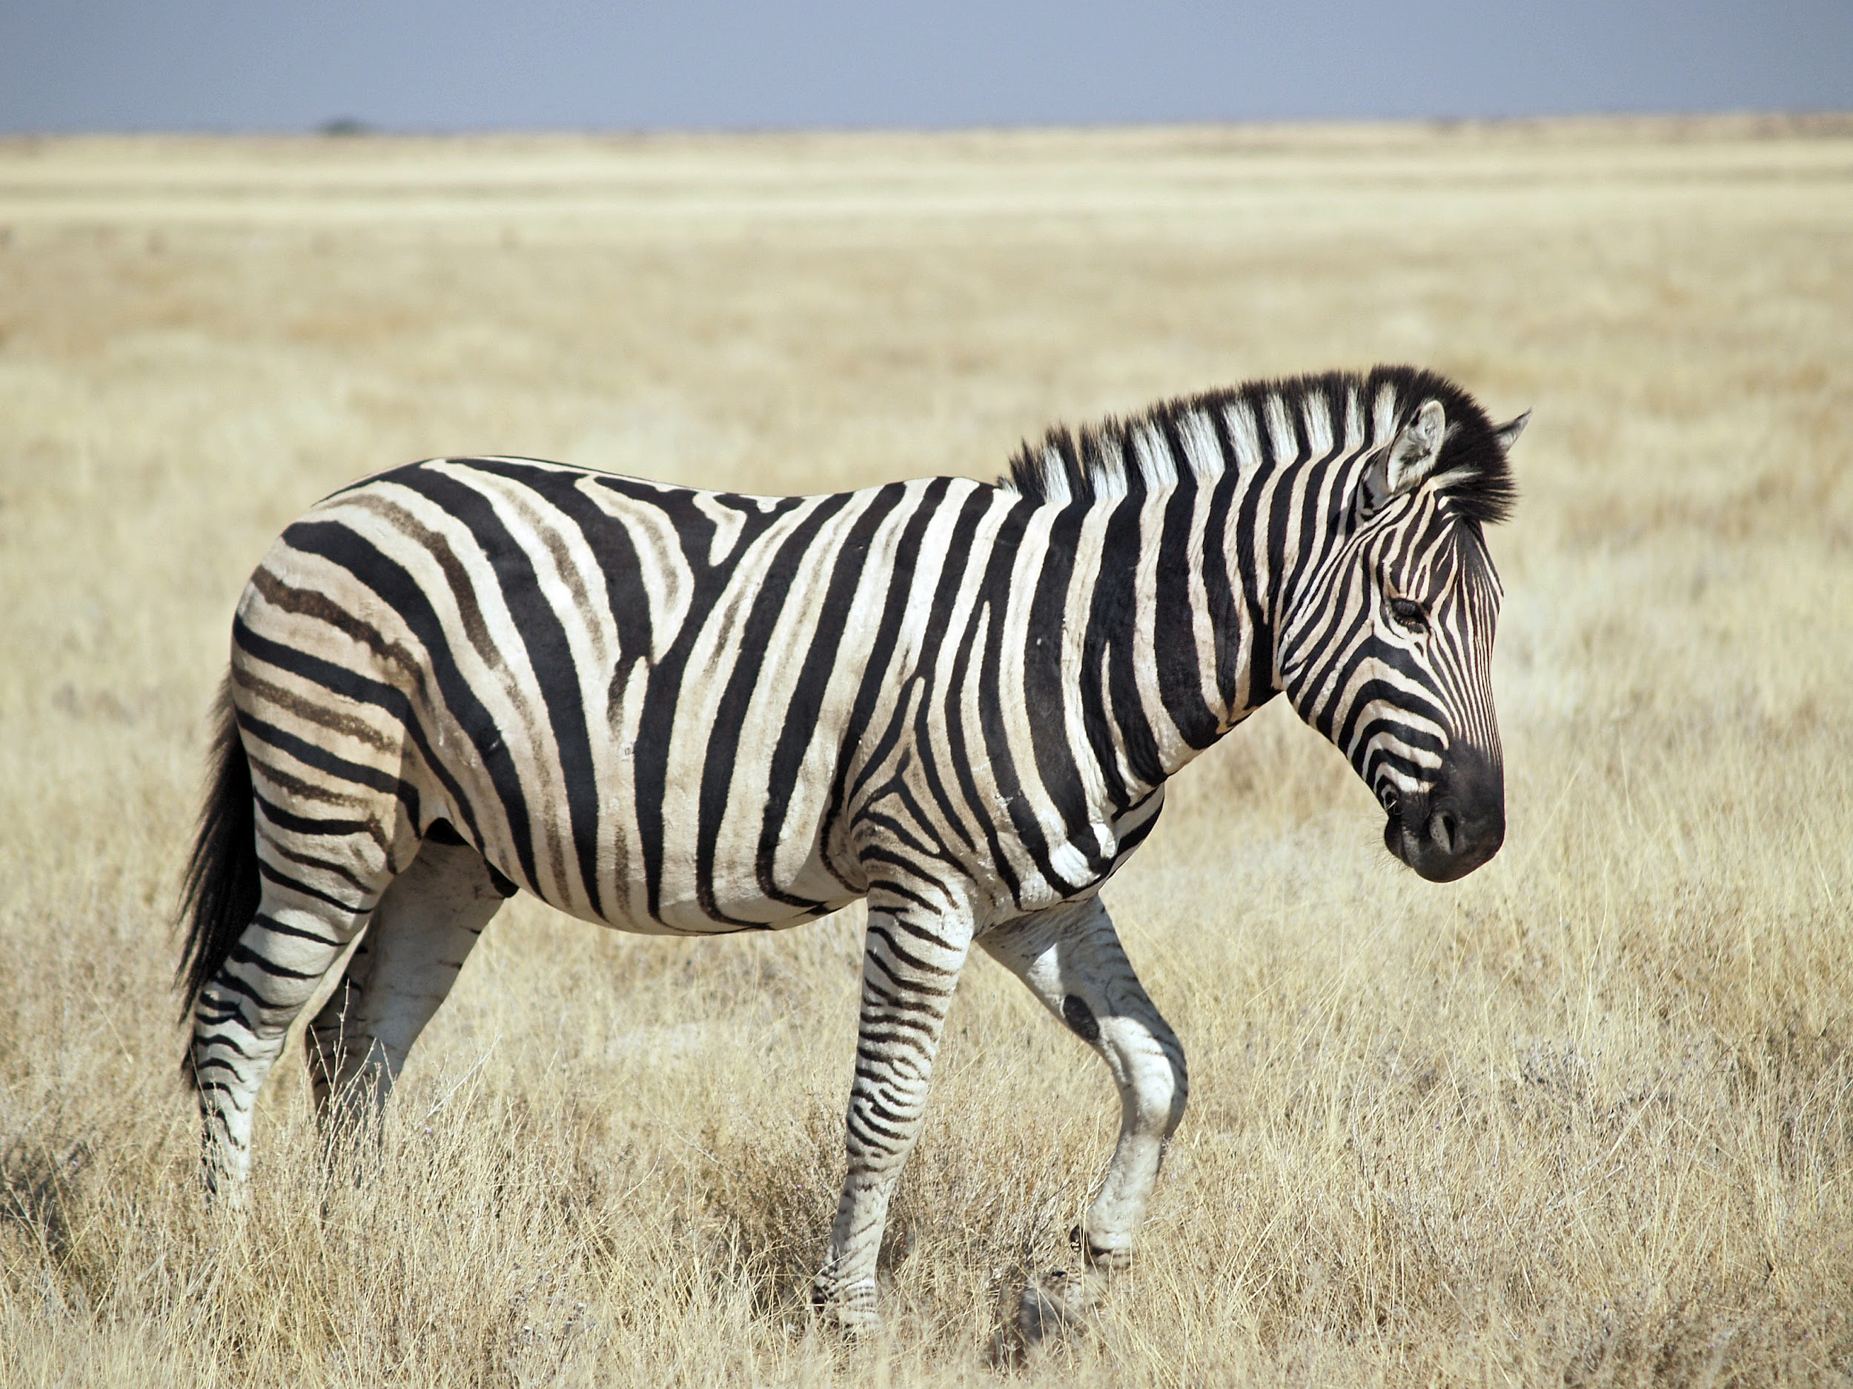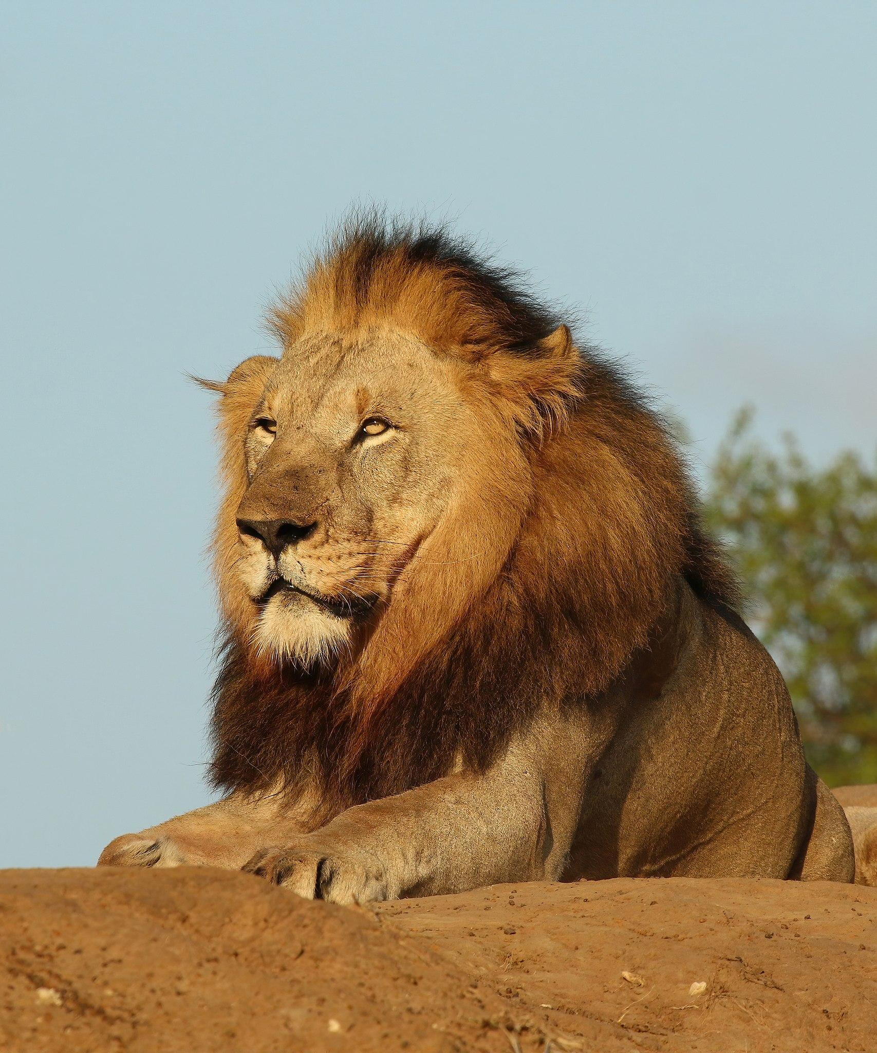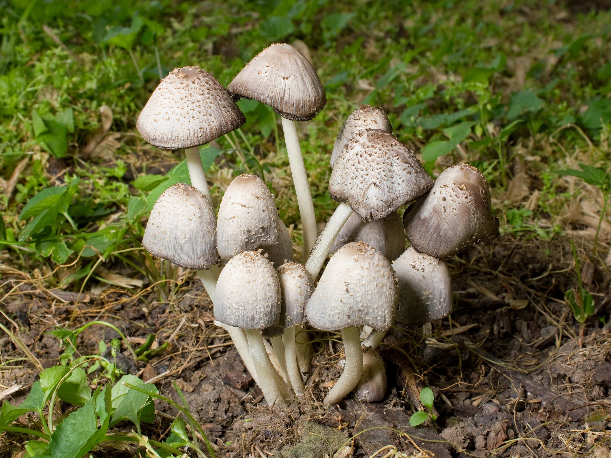

Copy and paste the web addresses of all resources below. These must be included in your presentation to receive full credit.
10 points
http://kids.nceas.ucsb.edu/biomes/savanna.html#:~:text=WEATHER%3A%20An%20important%20factor%20in,%2D%2075%20cm)%20per%20year.
https://ucmp.berkeley.edu/exhibits/biomes/grasslands.php#:~:text=Savannas%20receive%20an%20average%20annual,role%20in%20the%20savanna's%20biodiversity.
https://www.bbc.co.uk/bitesize/guides/zx3hqty/revision/1#:~:text=Savanna%20regions%20have%20two%20distinct,green%20grasses%20and%20wooded%20areas.

https://study.com/academy/lesson/the-african-australian-savanna-food-webs.html#:~:text=African%20Savanna,-The%20African%20savanna&text=Large%2C%20grazing%20animals%20are%20the,producers%2C%20making%20them%20primary%20consumers.https://sciencing.com/trophic-levels-savanna-8659442.html#:~:text=Secondary%20consumers%20in%20the%20savannas,carnivores%20as%20well%20as%20herbivores.
https://sciencing.com/decomposers-live-savannas-24064.html
https://www.wildnatureinstitute.org/blog/natures-web-of-life-mutualism#:~:text=One%20interesting%20example%20of%20mutualism,the%20trees%20from%20browsing%20herbivores.
https://www.reference.com/science/example-commensalism-savanna-15abc1f561bac751
https://www.reference.com/science/example-parasitism-savanna-a99cec4c22457753

Once you have collected all your information for your Biome and put the information in complete sentences, you will need to make a slideshow about your Biome. Each topic needs to be a slide in your slide show. Below are the requirements you have to include in each slide:
30 points total

Each slide have a different background
Each slide have pictures
Each slide have transitions (information slides in, rotates, etc.)

Additionally, you will need to find a video on your biome from youtube and attach the link to your slide show

Extra Credit

Create a slide telling me if you would want to live in your biome
Create a slide telling me which countries you would find your biome

Please attach the link to your google slides right here:

