Biome Project
Below is all the information you need to include in your Biome project. You will have until October 22nd at Midnight to turn in this assignment. This assignment is worth 100 points.

Choose one Biome to research. For the Freshwater and Marine Biomes, you may only select one area.

Polar Region
Tundra
Taiga
Temperate Forest
Temperate Grasslands
Savanna
Desert
Tropical Rainforest
Marine (Pacific Ocean, Atlantic Ocean or Indian Ocean
Freshwater (Lakes and Ponds, Rivers , Wetlands)
Coral Reef

Once you have picked your Biome, you need to find the following information on your biome. Please make sure all the information is in complete sentences. If the information is not in complete sentences, you will lose points. Conduct your research through Google and copy and paste the addresses of all websites you use below the table.
5 points for each section
Biome Name: | Tropical Rainforest
What is your Biome like? ( Climate, average temperature, average rain amount, seasons if it has any) | The tropical Rainforest is like a hot, moist biome when it rains with its average temperature from 20°C (68°F) to 25°C (77°F).
Any adaptations creatures need to survive in your biome | What do toucans adaptations need to be in the Tropical Rainforest? The toucans adaptation is their beak which helps it to defend itself against smaller predators.
Examples of Producers in your biome: | One example of a producer that is in the Tropical Rainforest is vines.
Examples of Primary Consumers in your Biome | A monkey is an example of a primary consumer in the Tropical Rainforest.
Examples of Secondary Consumers in your Biome: | An example of a secondary consumer in the tropical rainforest is a tree frog.
Examples of Tertiary Consumers in your Biome: | Pumas are examples of tertiary consumers that live in the tropical Rainforest.
Examples of Decomposers in your Biome: | Scorpions are an example of decomposers that live in the Tropical Rainforest.
Example of Mutualism in your Biome: | An example of mutualism in the tropical rainforest is a monarch butterfly because they travel in large groups to stay safe.
Example of Commensalism in your Biome: | An example of Commensalism in the Tropical Rainforest are epiphyte plants. Because??
Example of Parasitism in your Biome: | An example of parasitism in the Tropical Rainforest are leaf-cutter ants.Because??
Recreate a food web found in your Biome: | 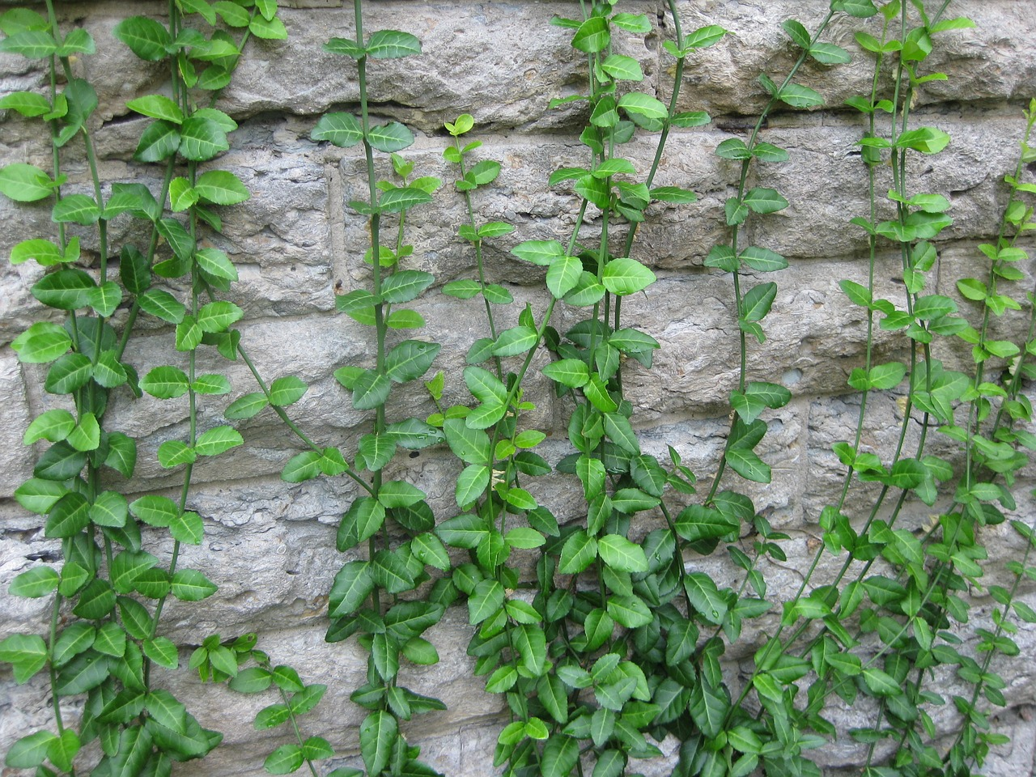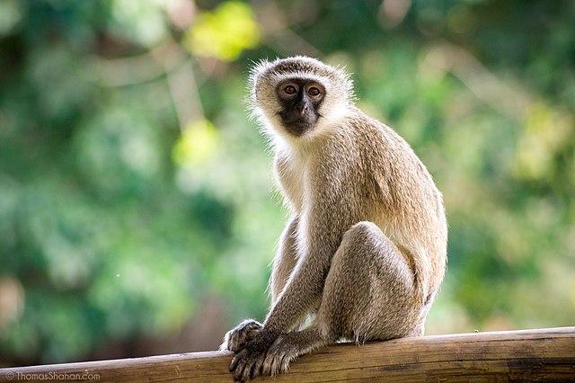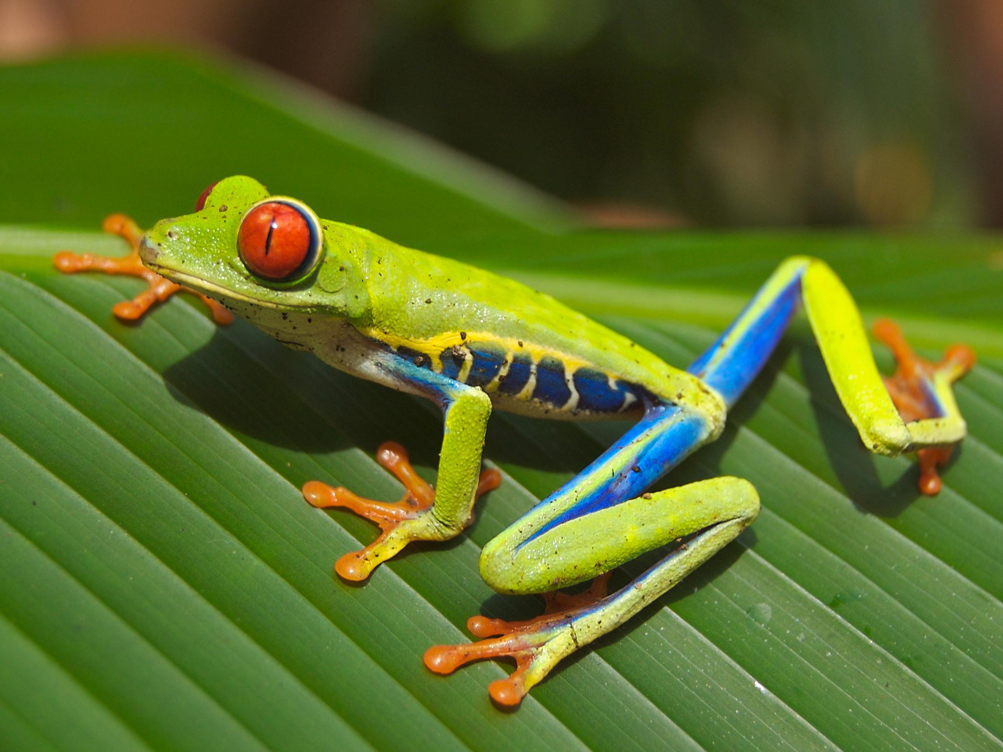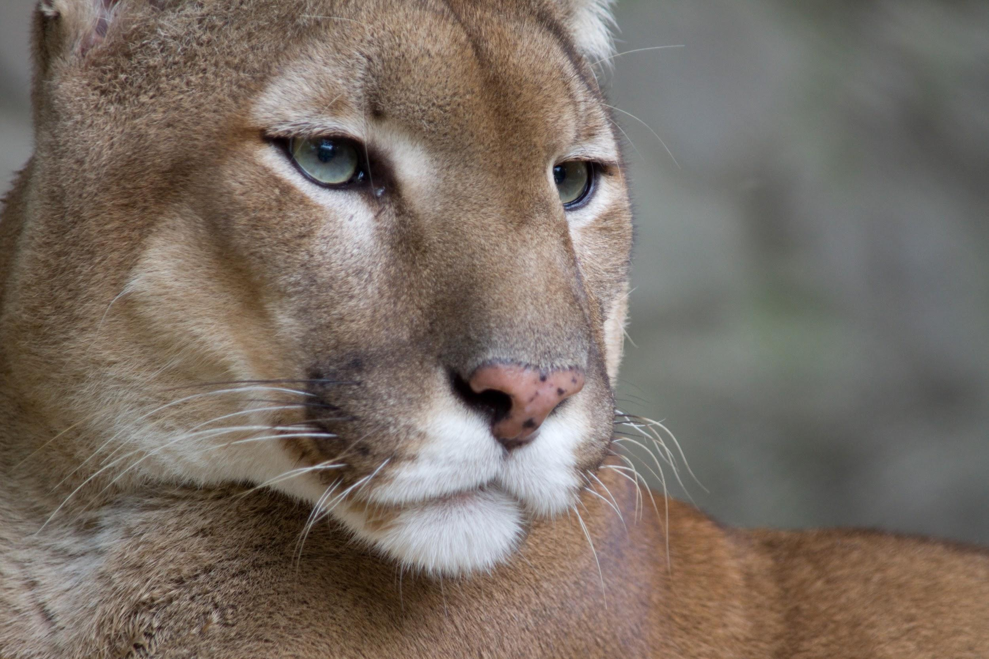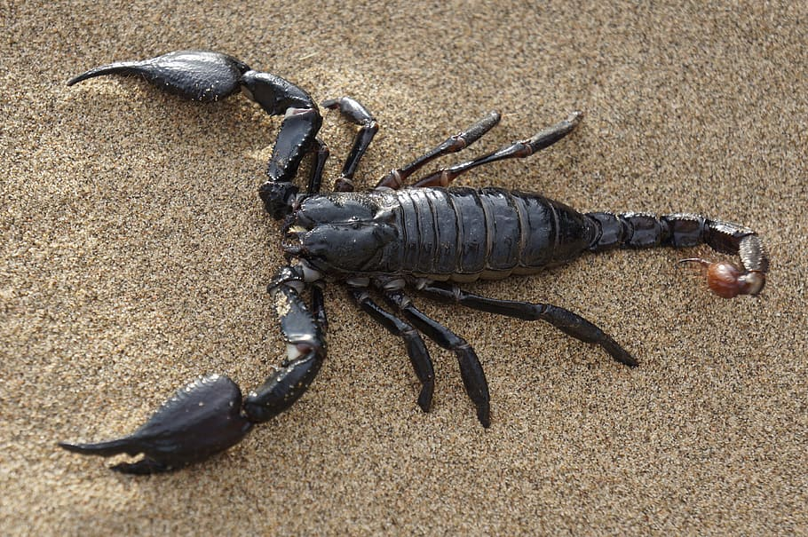

Copy and paste the web addresses of all resources below. These must be included in your presentation to receive full credit.
10 points
Brandhome.com National Geographic Society lisbdnet.com
Study.com edtechlens.com earthobservatory.nasa.gov

Sciencing.com storymaps.arcgis.com

Once you have collected all your information for your Biome and put the information in complete sentences, you will need to make a slideshow about your Biome. Each topic needs to be a slide in your slide show. Below are the requirements you have to include in each slide:
30 points total

Each slide have a different background
Each slide have pictures
Each slide have transitions (information slides in, rotates, etc.)

Additionally, you will need to find a video on your biome from youtube and attach the link to your slide show

Extra Credit

Create a slide telling me if you would want to live in your biome
Create a slide telling me which countries you would find your biome

Please attach the link to your google slides right here:
Jennifer Ramirez - Biome Slides

