Biome Project
Below is all the information you need to include in your Biome project. You will have until October 22nd at Midnight to turn in this assignment. This assignment is worth 100 points.

Choose one Biome to research. For the Freshwater and Marine Biomes, you may only select one area.

Polar Region
Tundra
Taiga
Temperate Forest
Temperate Grasslands
Savanna
Desert
Tropical Rainforest
Marine (Pacific Ocean, Atlantic Ocean or Indian Ocean
Freshwater (Lakes and Ponds, Rivers , Wetlands)
Coral Reef

Once you have picked your Biome, you need to find the following information on your biome. Please make sure all the information is in complete sentences. If the information is not in complete sentences, you will lose points. Conduct your research through Google and copy and paste the addresses of all websites you use below the table.
5 points for each section
Biome Name: | Desert
What is your Biome like? ( Climate, average temperature, average rain amount, seasons if it has any) | In the desert the temperature is as high as 54c (130F). The average temperature is a little over 100F. The amount of rain is 250 millimeters (10 inches) of rain per year.
Any adaptations creatures need to survive in your biome | Camels are an animal that has adapted in the desert.. They have to eat cactus so they can survive because cactus have water in them. Birds have also adapted as they have to eat flies because flies have water in them.
Examples of Producers in your biome: | Cactus are the only producers in the desert. (not true
Examples of Primary Consumers in your Biome | The primary consumers in the desert include camels and Gazelles.
Examples of Secondary Consumers in your Biome: | The secondary consumers in the desert includescorpions, tarantulas, rattlesnakes, and small lizards.
Examples of Tertiary Consumers in your Biome: | Tertiary consumers in the desert are hawks and vultures.
Examples of Decomposers in your Biome: | Decomposers in the desert include the dung beetle, fly, millipede, and saharan silver ant.
Example of Mutualism in your Biome: | An example of mutualism in the desert might be a phainopepla who eats mistletoe berries. (and explain how this is mutual).
Example of Commensalism in your Biome: | An example of commensalism in the desert include moss growing on trees. Moss benefits by being raised above forest floor competition. And how does the tree benifit?)
Example of Parasitism in your Biome: | A flea is a parasitism on a coyote. (make this a complete sentence).
Recreate a food web found in your Biome: | 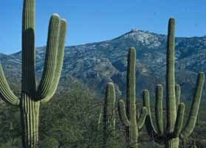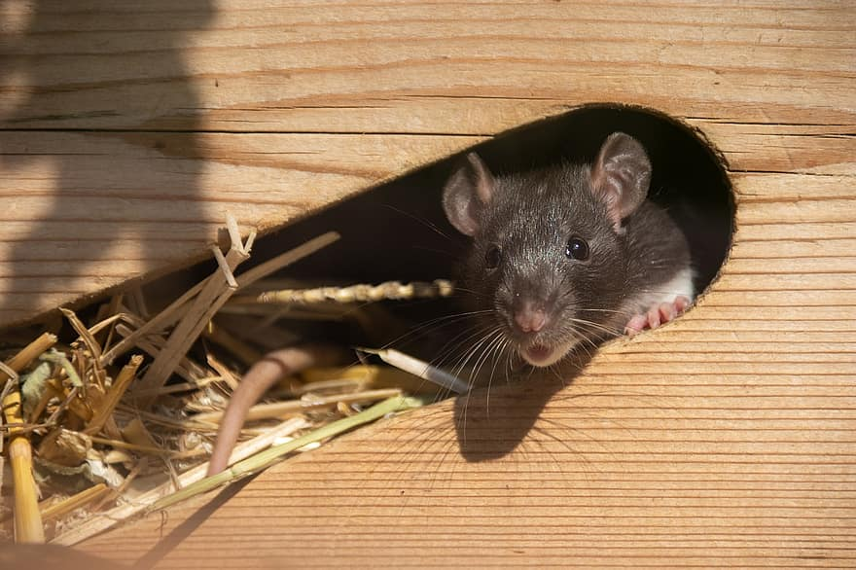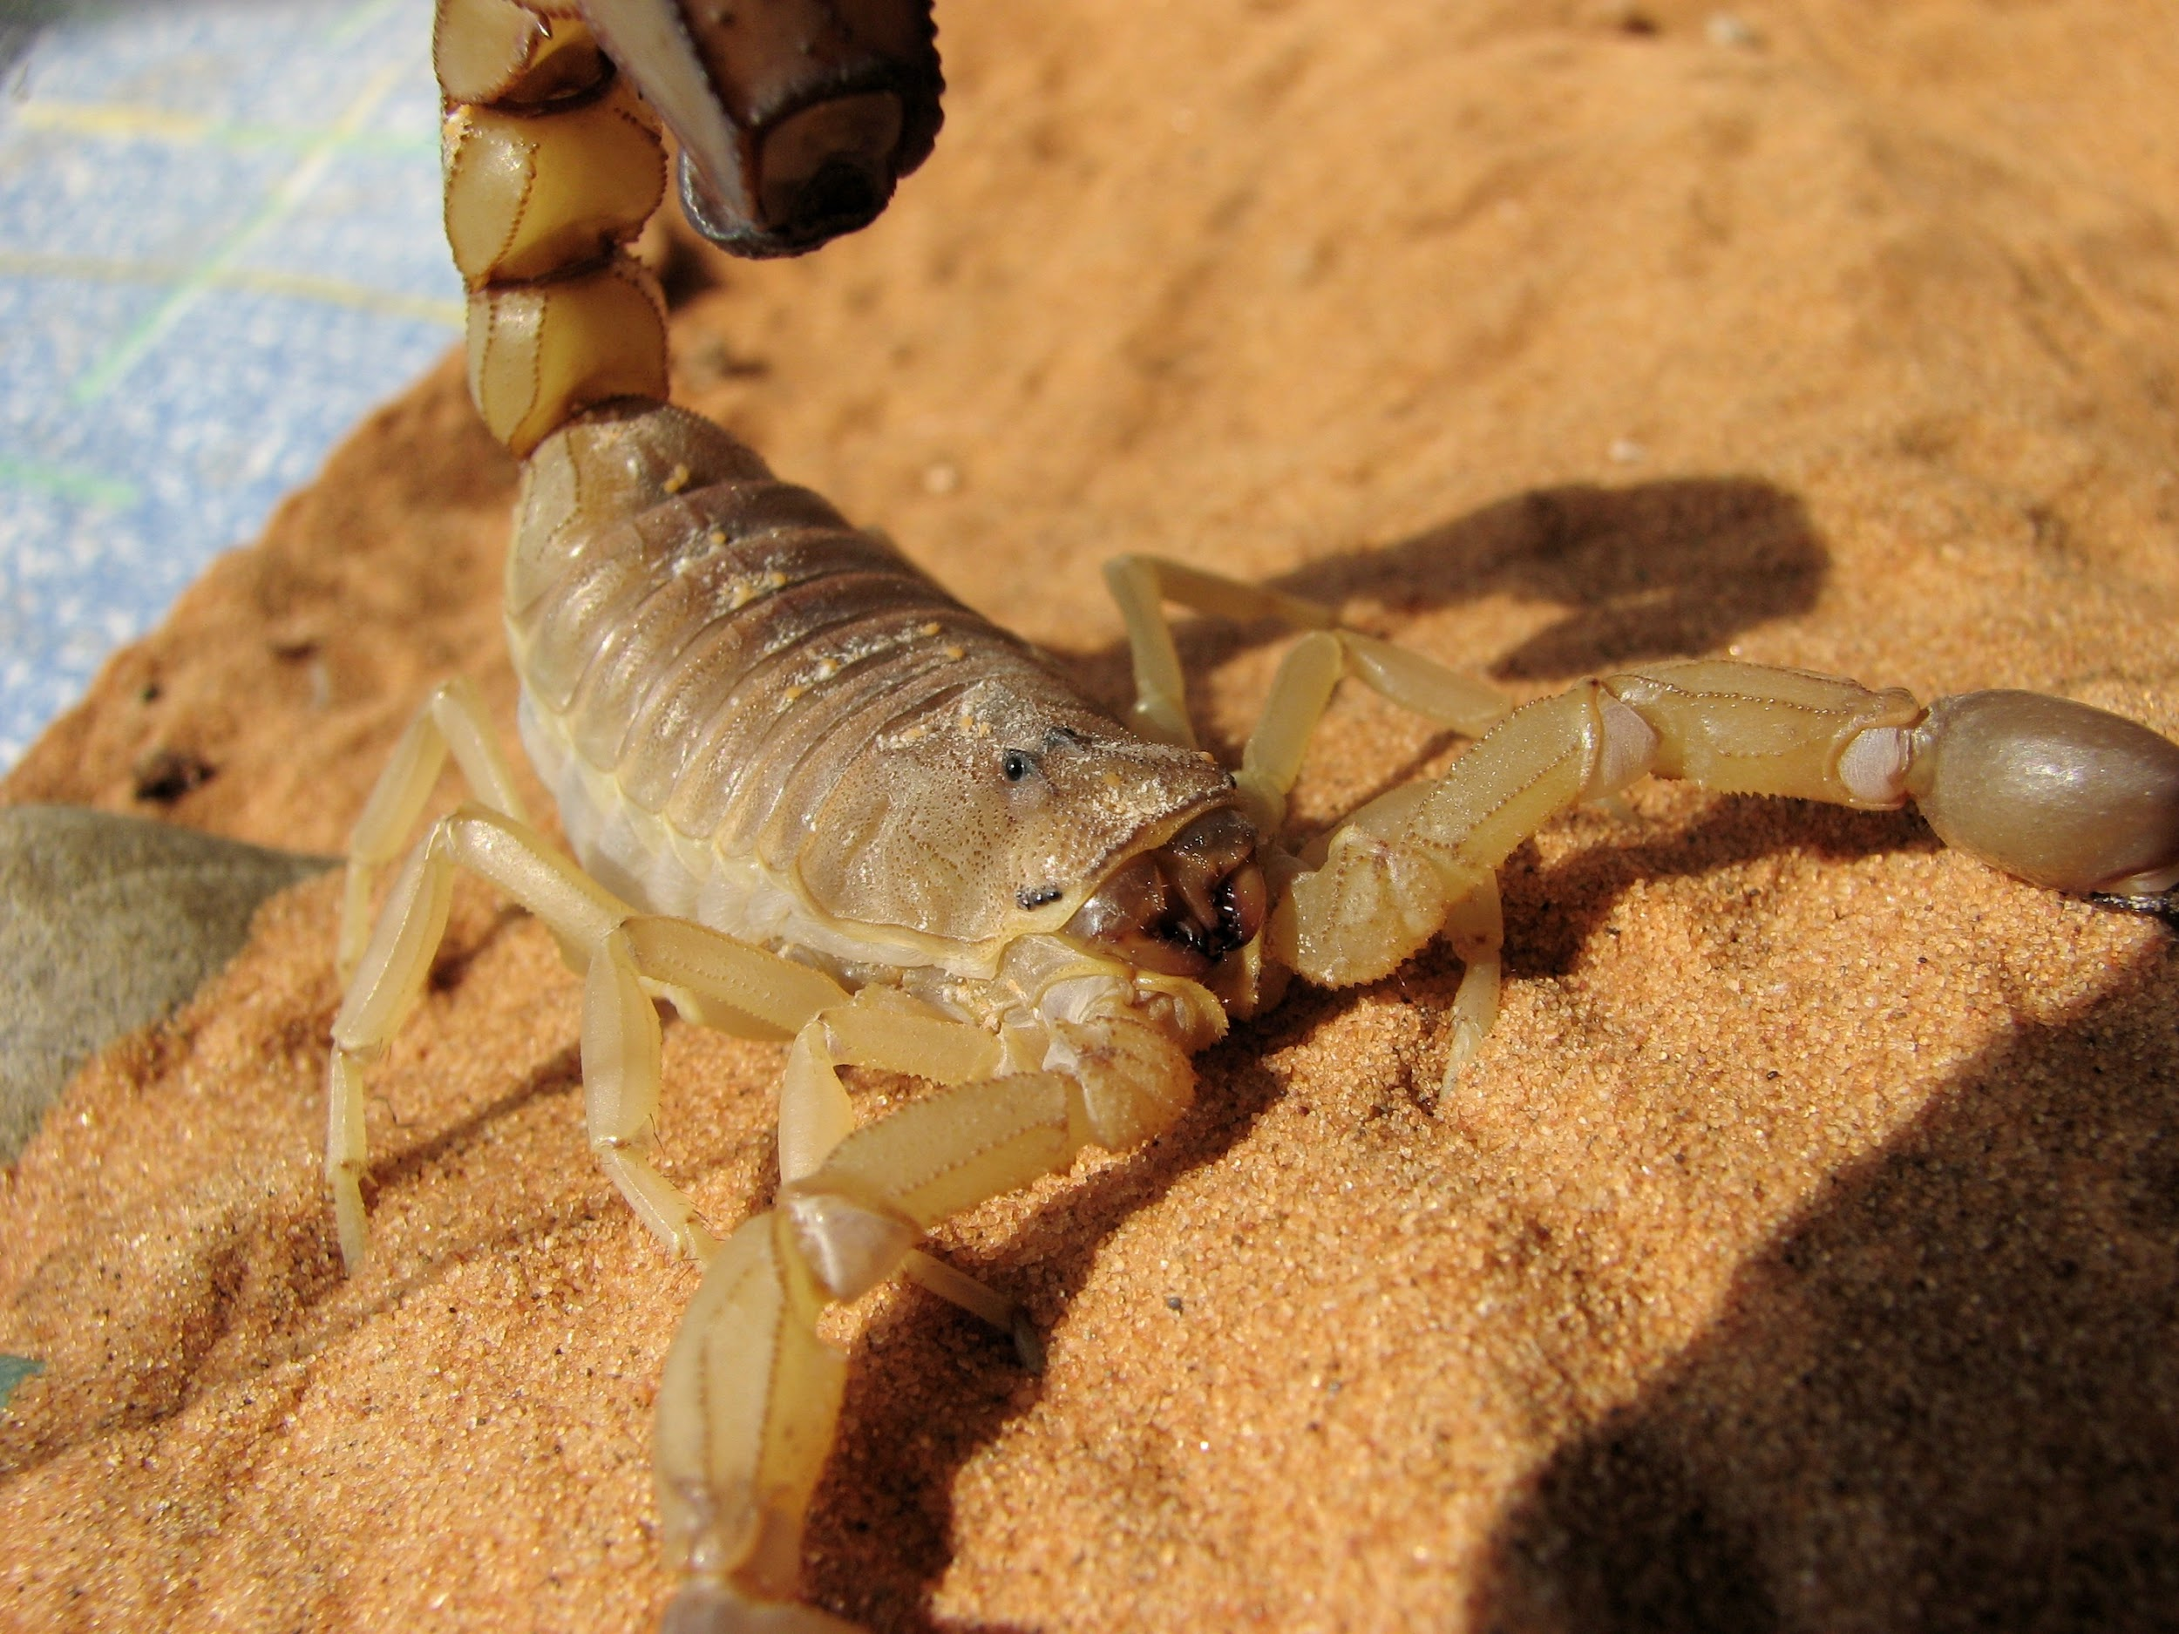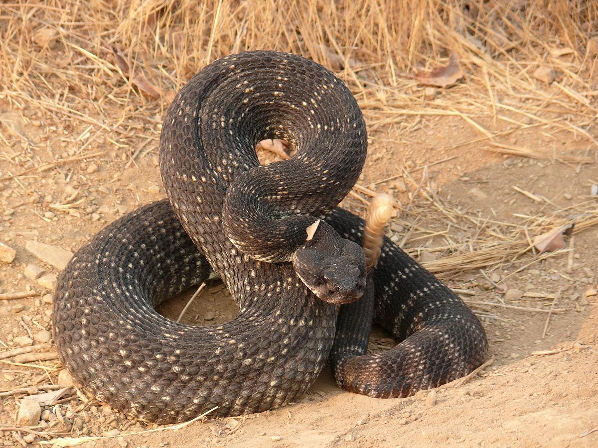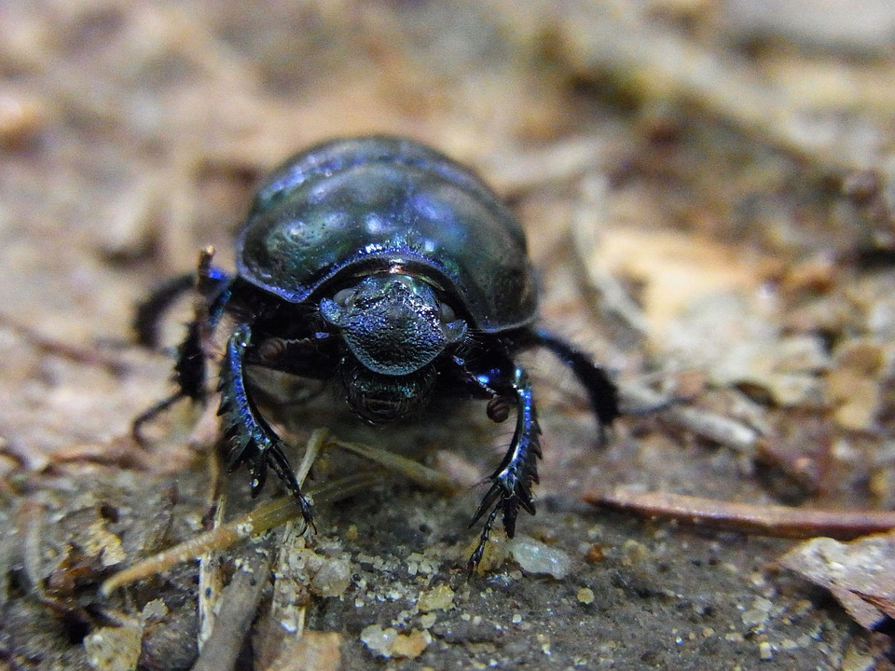  Cactus (produers)  Mice (primary consumer)  Scorpion (secondary consumer)  Dung beetle(decomposer)  Rattle snake (tertiary consumer)

Copy and paste the web addresses of all resources below. These must be included in your presentation to receive full credit.
10 points
https://lisbdnet.com
http://mojavedesert.net/glossary/
https://www.pbs.org/wnet/nature
https://a-z-animals.com/

Once you have collected all your information for your Biome and put the information in complete sentences, you will need to make a slideshow about your Biome. Each topic needs to be a slide in your slide show. Below are the requirements you have to include in each slide:
30 points total

Each slide have a different background
Each slide have pictures
Each slide have transitions (information slides in, rotates, etc.)

Additionally, you will need to find a video on your biome from youtube and attach the link to your slide show https://www.youtube.com/watch?v=n4crvs-KTBw

Extra Credit

Create a slide telling me if you would want to live in your biome
Create a slide telling me which countries you would find your biome

Please attach the link to your google slides right here:
docs.google.com/presentation/d/1hYRvx9QnRHgUkW3OVBe8D0GLGDX1548iRxbG6Nq5RIo/edit#slide=id.g11539201da2_0_40

