Biome Project
Below is all the information you need to include in your Biome project. You will have until October 22nd at Midnight to turn in this assignment. This assignment is worth 100 points.

Choose one Biome to research. For the Freshwater and Marine Biomes, you may only select one area.

Tundra
Taiga
Temperate Forest
Temperate Grasslands
Savanna
Desert
Tropical Rainforest
Marine (Pacific Ocean, Atlantic Ocean or Indian Ocean
Freshwater (Lakes and Ponds, Rivers , Wetlands)
Coral Reef

Once you have picked your Biome, you need to find the following information on your biome. Please make sure all the information is in complete sentences. If the information is not in complete sentences, you will lose points. Conduct your research through Google and copy and paste the addresses of all websites you use below the table.
5 points for each section
Biome Name: | Polar Region
What is your Biome like? ( Climate, average temperature, average rain amount, seasons if it has any) | The Polar Region Is extremely cold with an average temperature of less than 10 °C (50 °F). Also, it rains less than 25 cm each year.
Any adaptations creatures need to survive in your biome | For Polar Bears in the polar region they have a thick layer of fur and fator insulation against the cold, a small surface area to volume ratio.
Examples of Producers in your biome: | Examples of producers in the polar region are lichens and algae.
Examples of Primary Consumers in your Biome | Examples of Primary Consumer in this biome are caribou, rabbits and there are other animals.
Examples of Secondary Consumers in your Biome: | Here are some examples of secondary consumers in the Polar region: arctic foxes, brown bears, arctic wolves, snowy owls, and penguins.
Examples of Tertiary Consumers in your Biome: | Here are some examples of Tertiary consumers in the Polar Region: Polar Bear, wolves, and eagles.
Examples of Decomposers in your Biome: | Examples of decomposers are Staphylococcus, Bacillus, Corynebacterium, Micrococcus, Streptococcus, Neisseria molds, Yeasts, the Fungi from lichen, and microorganisms.
Example of Mutualism in your Biome: | Examples of mutualism in the polar region are Caribou and the Arctic Fox. When Caribou are out looking for food, the Arctic fox follows.
Example of Commensalism in your Biome: | Arctic foxes traveling behind polar bears and scavenge on scraps of food is an example of communsalism in the polar region.
Example of Parasitism in your Biome: | Typically, parasitism can be seen in the case of a liver tapeworm cys., These organisms are prone to live and thrive in the bodies of various animals including wolves who are native to the polar region
Recreate a food web found in your Biome: | 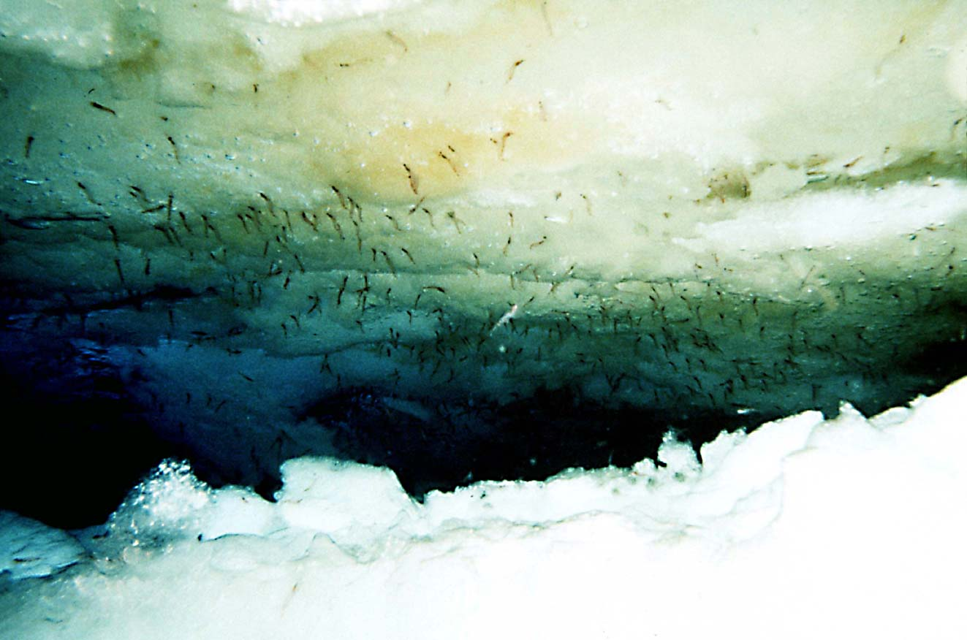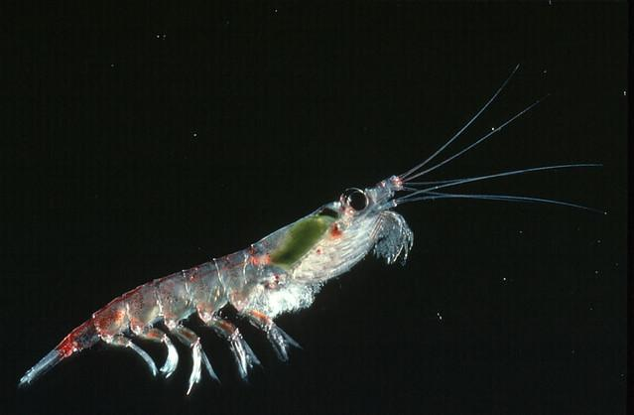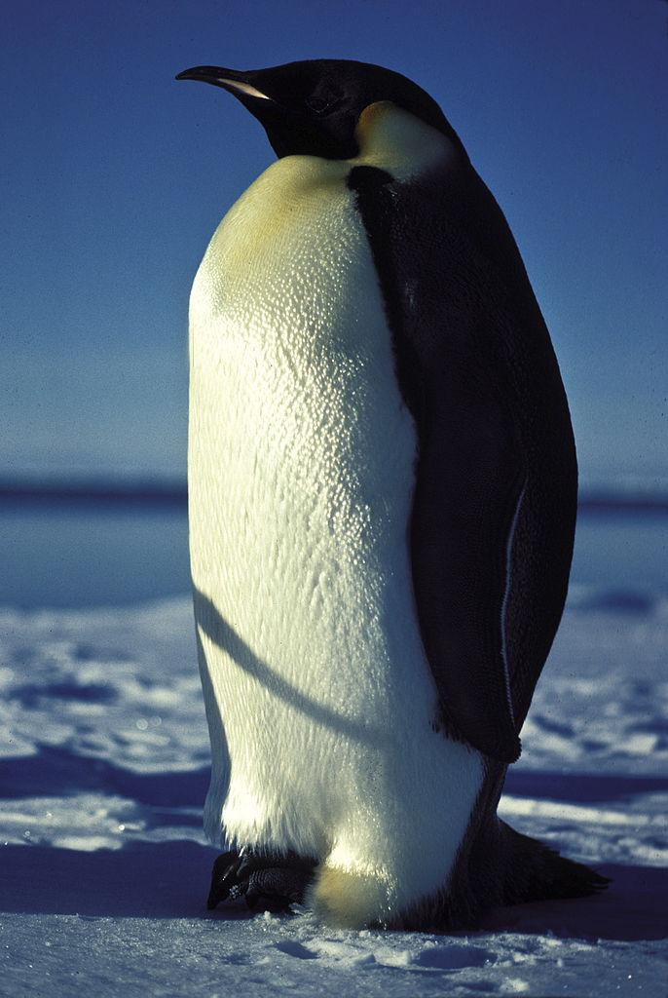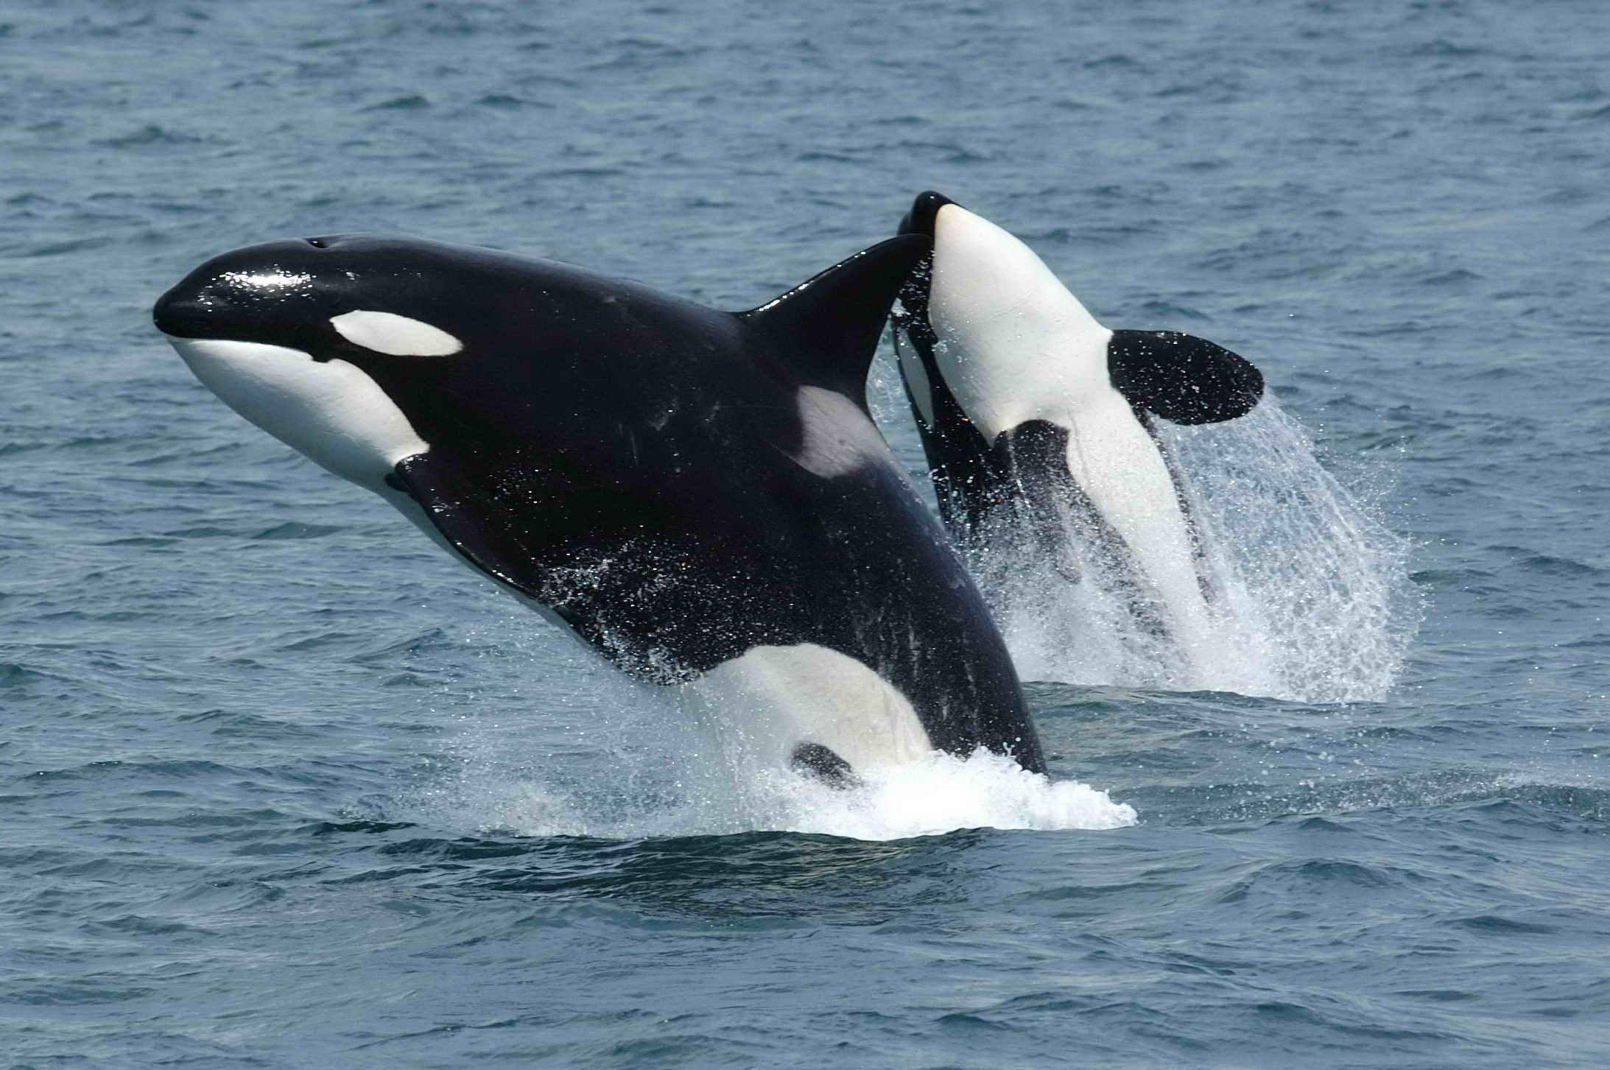  Algae ( producer)  Krill(Primary)  Penguin(Secondary)  Killer Whale or Orcas(Tertiary)

Copy and paste the web addresses of all resources below. These must be included in your presentation to receive full credit.
10 points
Adaptations for cold climates - Old and new species - GCSE Biology (Single Science) Revision - BBC Bitesize
Study.com
Tundra: Life in the Polar Extremes

Once you have collected all your information for your Biome and put the information in complete sentences, you will need to make a slideshow about your Biome. Each topic needs to be a slide in your slide show. Below are the requirements you have to include in each slide:
30 points total

Each slide have a different background
Each slide have pictures
Each slide have transitions (information slides in, rotates, etc.)

Additionally, you will need to find a video on your biome from youtube and attach the link to your slide show

Extra Credit

Create a slide telling me if you would want to live in your biome
Create a slide telling me which countries you would find your biome

Please attach the link to your google slides right here:

