Biome Project
Below is all the information you need to include in your Biome project. You will have until October 22nd at Midnight to turn in this assignment. This assignment is worth 100 points.

Choose one Biome to research. For the Freshwater and Marine Biomes, you may only select one area.

Polar Region
Tundra
Taiga
Temperate Forest
Temperate Grasslands
Savanna
Desert
Tropical Rainforest
Marine (Pacific Ocean, Atlantic Ocean or Indian Ocean
Freshwater (Lakes and Ponds, Rivers , Wetlands)
Coral Reef

Once you have picked your Biome, you need to find the following information on your biome. Please make sure all the information is in complete sentences. If the information is not in complete sentences, you will lose points. Conduct your research through Google and copy and paste the addresses of all websites you use below the table.
5 points for each section
Biome Name: | Polar region
What is your Biome like? ( Climate, average temperature, average rain amount, seasons if it has any) | The polar climate regions are characterized by a lack of warm summers. Every month in a polar climate has an average temperature of less than 10 °C (50 °F).
Any adaptations creatures need to survive in your biome | cPlease write some adaptations here
Examples of Producers in your biome: | Producers that live in the polar region are sea ice, algae, microalgae, and phytoplankton.
Examples of Primary Consumers in your Biome | Examples of primary consumers are arctic rabbits, pikas, musk oxen, caribou, lemmings, and arctic hares.
c | Examples of secondary consumers are arctic foxes, brown bears, and arctic wolves.
Examples of Tertiary Consumers in your Biome: | Examples of tertiary consumers are the polar bear, and the eagles; which prey on the arctic fox as well as other primary consumers
Examples of Decomposers in your Biome: | The decomposers found in the Polar Region are bacteria.
Example of Mutualism in your Biome: | A mutualism relationship between the animals of the Arctic include the Caribou and the Arctic Fox. When Caribou are out looking for food, the Arctic fox follows. The caribou exposes a small bit of itself, bringing closer other mammals.
Example of Commensalism in your Biome: | A commensalism relationship between the animals and the arctic include the arctic fox and the polar bear. Arctic foxes travel behind polar bears and scavenge on scraps of food. The polar bear is hardly affected and the fox benefits from the food.
Example of Parasitism in your Biome: | Typically, parasitism is seen in the case of a liver tapeworm cyst. These organisms are prone to live and thrive in the bodies of various animals including wolves, caribou, polar bears, and moose. They feed on the food the animal eats, and as a result, the animal develops malnutrition.
Recreate a food web found in your Biome: | 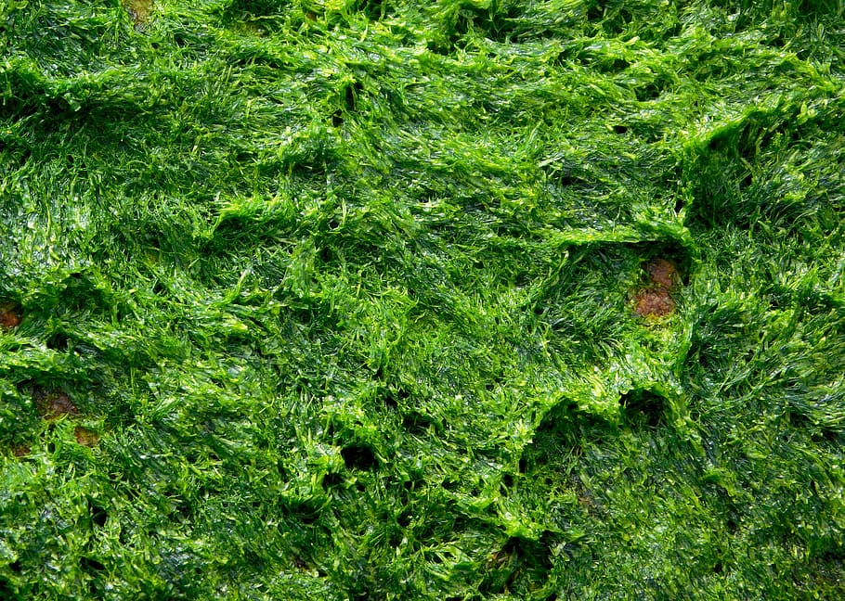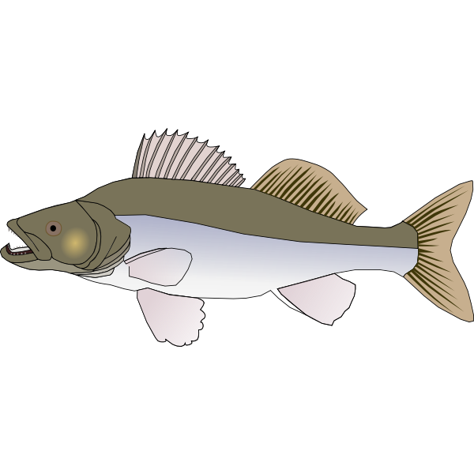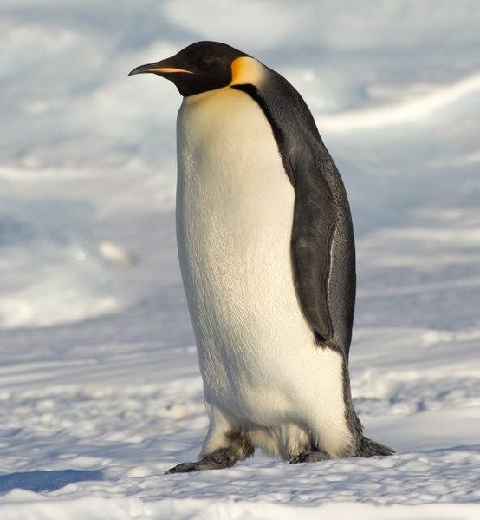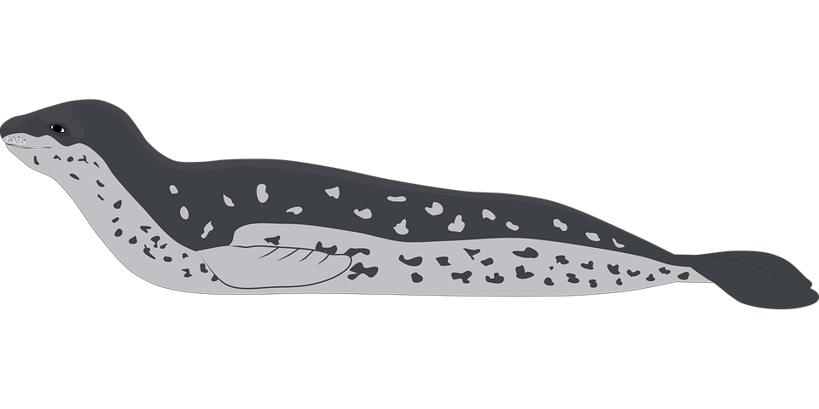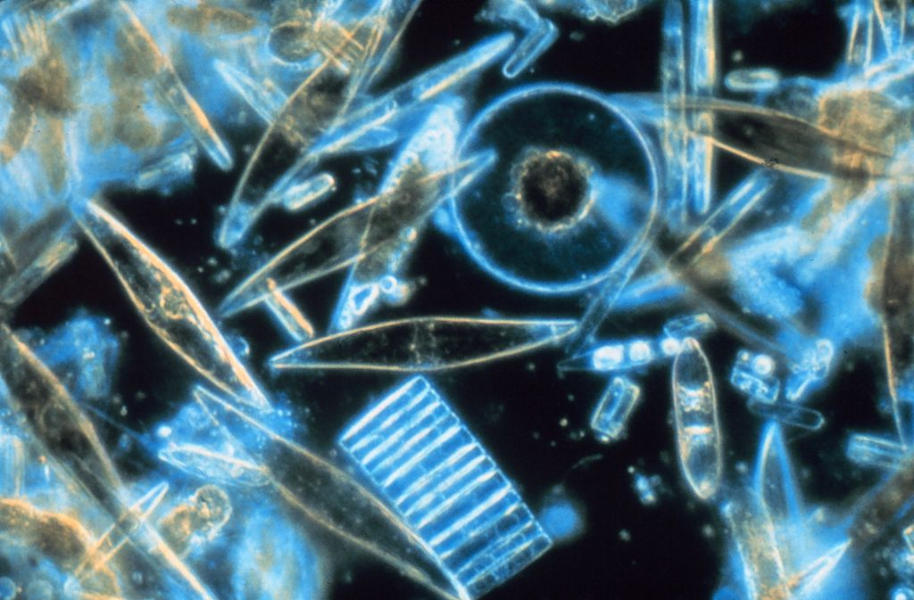

Copy and paste the web addresses of all resources below. These must be included in your presentation to receive full credit.
10 points
Please place sources here.

Once you have collected all your information for your Biome and put the information in complete sentences, you will need to make a slideshow about your Biome. Each topic needs to be a slide in your slide show. Below are the requirements you have to include in each slide:
30 points total

Each slide have a different background
Each slide have pictures
Each slide has transitions (information slides in, rotates, etc.)

Additionally, you will need to find a video on your biome from youtube and attach the link to your slide show

Extra Credit

Create a slide telling me if you would want to live in your biome
Create a slide telling me which countries you would find your biome

Please attach the link to your google slides right here:

