Biome Project
Below is all the information you need to include in your Biome project. You will have until October 22nd at Midnight to turn in this assignment. This assignment is worth 100 points.

Choose one Biome to research. For the Freshwater and Marine Biomes, you may only select one area.

Polar Region
Tundra
Taiga
Temperate Forest
Temperate Grasslands
Savanna
Desert
Tropical Rainforest
Marine (Pacific Ocean, Atlantic Ocean or Indian Ocean
Freshwater (Lakes and Ponds, Rivers , Wetlands)
Coral Reef

Once you have picked your Biome, you need to find the following information on your biome. Please make sure all the information is in complete sentences. If the information is not in complete sentences, you will lose points. Conduct your research through Google and copy and paste the addresses of all websites you use below the table.
5 points for each section
Biome Name: | Tropical rainforest
What is your Biome like? ( Climate, average temperature, average rain amount, seasons if it has any) | The tropical rainforest is hot and mostly moist.  The temperature is 68 F to 77F.  2,000 to 10,000 millimeters (79 to 394 inches) of rain per year.
Any adaptations creatures need to survive in your biome | Creatures need camouflage and mimicry to survive in a tropical rainforest
Examples of Producers in your biome: | Example of producers are trees, vines, mosses, grasses, and tropical fruit trees,
Examples of Primary Consumers in your Biome | Primary consumers in a tropical rainforest are monkeys and birds.
Examples of Secondary Consumers in your Biome: | Secondary consumers in a tropical rainforest are tree frogs, and giant spiders.
Examples of Tertiary Consumers in your Biome: | Tertiary consumers in a tropical rain forest are jaguar and snakes.
Examples of Decomposers in your Biome: | Decomposers such as termites, slugs, scorpions, worms, and fungi, live in the rainforest.
Example of Mutualism in your Biome: | Examples of mutualism at work are Monarch butterflies traveling in large groups to stay safe. Certain insects such as ants and termites rely on each other and work as a team to build mounds where the group will live, or hunt together to find food.
Example of Commensalism in your Biome: | A tree frog taking shelter under a leaf or seeds falling from plants into the fur or feathers of animals to spread themselves around the forest might be an example of commensalism in the rainforest.
Example of Parasitism in your Biome: | An example of parasitism in the rainforest is the strangler fig tree and other host trees.
Recreate a food web found in your Biome: | 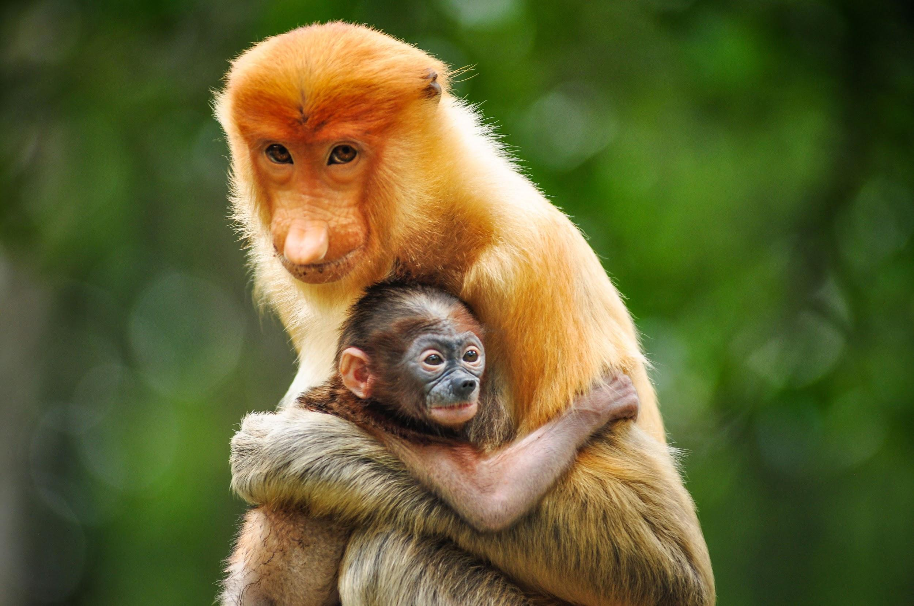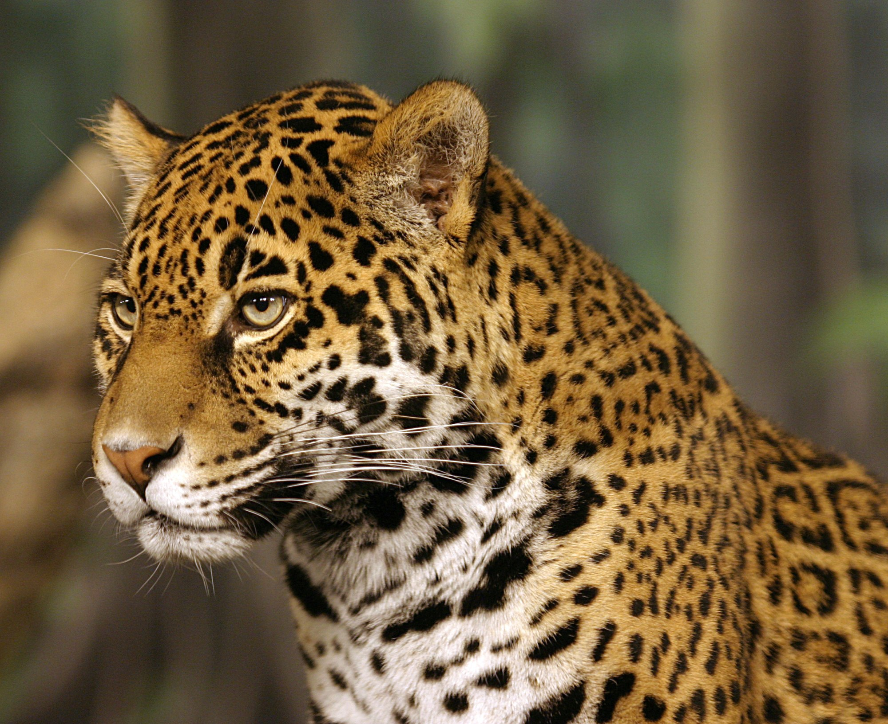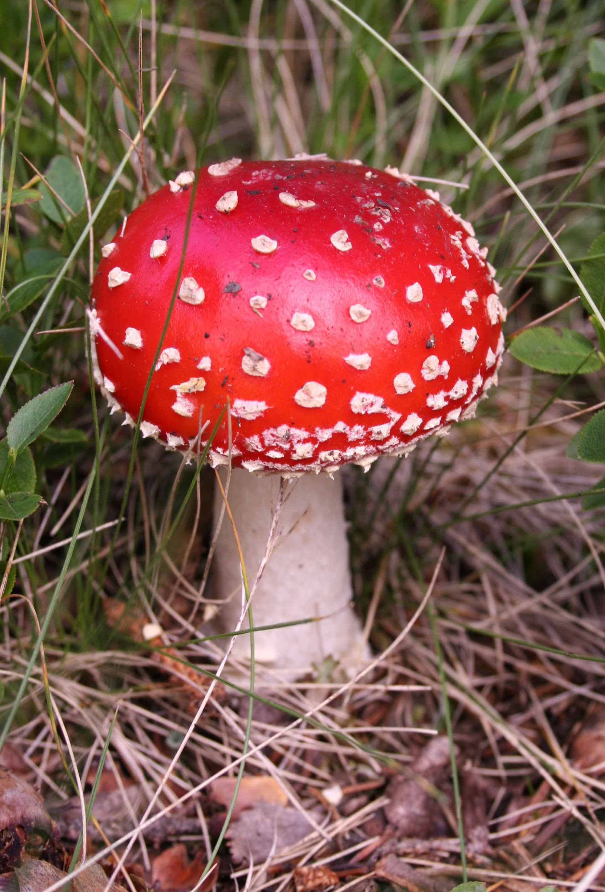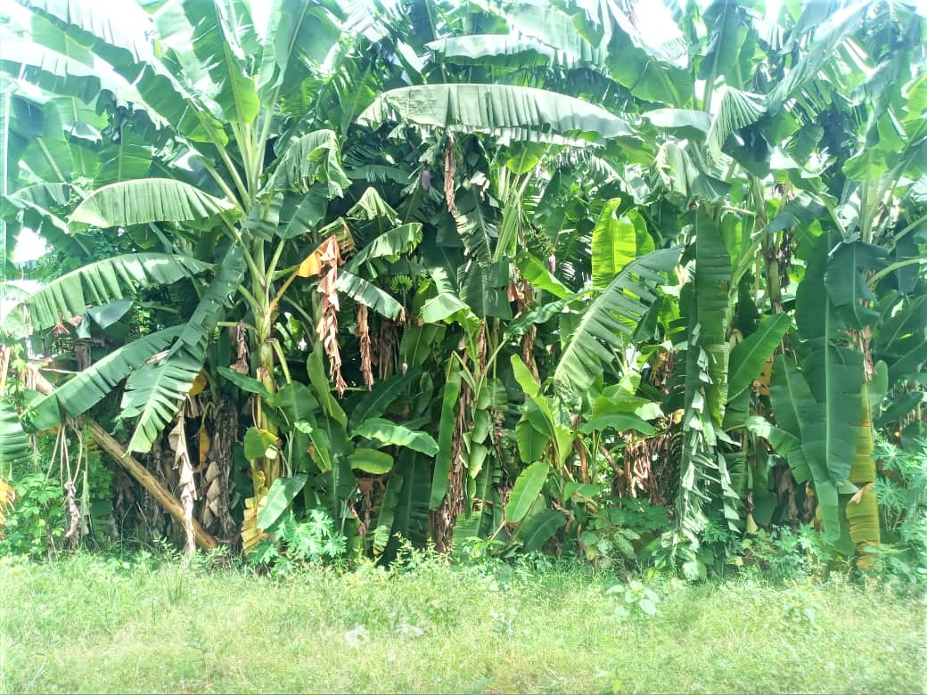  Banan tree  (producer)  Monkey  (primary consumer )  Jaguar  (Secondary consumer)  Mushroom  (decomposer)

Copy and paste the web addresses of all resources below. These must be included in your presentation to receive full credit.
10 points
https://earthobservatory.nasa.gov/biome/biorainforest.php#:~:text=The%20tropical%20rainforest%20is%20a,it%20rains%20all%20year%20long.&text=Because%20of%20the%20small%20amount,wet%20leaves%20and%20leaf%20litter.

What are examples of commensalism in a tropical rainforest? - Quora

https://www.bioexplorer.net/tropical-rainforest-animal-adaptations.html/#:~:text=In%20this%20article%2C%20let's%20explore,changing%20of%20habitats%20with%20illustrations.

Once you have collected all your information for your Biome and put the information in complete sentences, you will need to make a slideshow about your Biome. Each topic needs to be a slide in your slide show. Below are the requirements you have to include in each slide:
30 points total

Each slide have a different background
Each slide have pictures
Each slide have transitions (information slides in, rotates, etc.)

Additionally, you will need to find a video on your biome from youtube and attach the link to your slide show

Extra Credit

Create a slide telling me if you would want to live in your biome
Create a slide telling me which countries you would find your biome

Please attach the link to your google slides right here:

