Biome Project
Below is all the information you need to include in your Biome project. You will have until October 22nd at Midnight to turn in this assignment. This assignment is worth 100 points.

Choose one Biome to research. For the Freshwater and Marine Biomes, you may only select one area.

Polar Region
Tundra
Taiga
Temperate Forest
Temperate Grasslands
Savanna
Desert
Tropical Rainforest
Marine (Pacific Ocean, Atlantic Ocean or Indian Ocean
Freshwater (Lakes and Ponds, Rivers , Wetlands)
Coral Reef

Once you have picked your Biome, you need to find the following information on your biome. Please make sure all the information is in complete sentences. If the information is not in complete sentences, you will lose points. Conduct your research through Google and copy and paste the addresses of all websites you use below the table.
5 points for each section
Biome Name: | Please place biome name here.
What is your Biome like? ( Climate, average temperature, average rain amount, seasons if it has any) | Temperatures in the tropical rainforest are between 20 and 29c, the average is 20c. The seasons in the tropical rainforest are either one long wet winter or a short drier summer.
Any adaptations creatures need to survive in your biome | One adaptation that can be found in the rainforest is a Toucan’d beak which provides a way of cleaning feathers and while also a way of defending off smaller predators.
Examples of Producers in your biome: | Examples of the producers in my biome are trees, vines, mosses, and grasses.
Examples of Primary Consumers in your Biome | Monkey, birds. Please make this a complete sentence (ex the one above).
Examples of Secondary Consumers in your Biome: | Tree frogs, giant spiders. Please make this a complete sentence.
Examples of Tertiary Consumers in your Biome: | Harpy eagles, jaguars, and anacondas. Please make this a complete sentence.
Examples of Decomposers in your Biome: | Termites, slugs, scorpions, worms, and fungi.Please make this a complete sentence.
Example of Mutualism in your Biome: | Please make this a complete sentence. Include an example and what is benefited.
Example of Commensalism in your Biome: | Epiphyte plants, such as orchards, growing on other trees. Please make this a complete sentence.Include an example and what is benefited.
Example of Parasitism in your Biome: | The Strangler fig tree and their host trees. Please make this a complete sentence.Include an example and what is benefited.
Recreate a food web found in your Biome: | 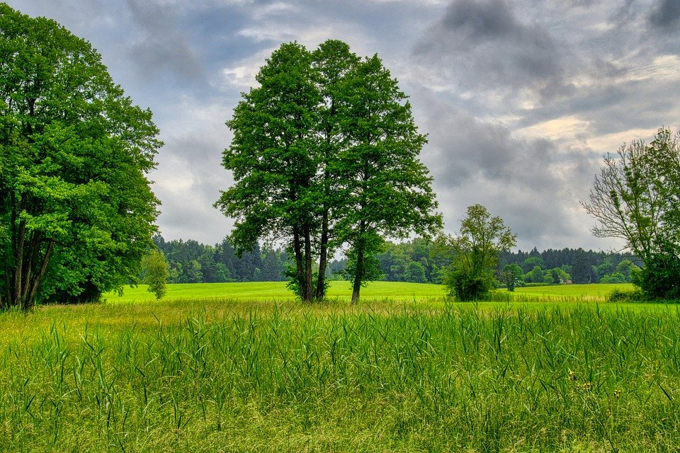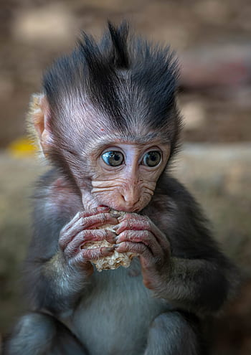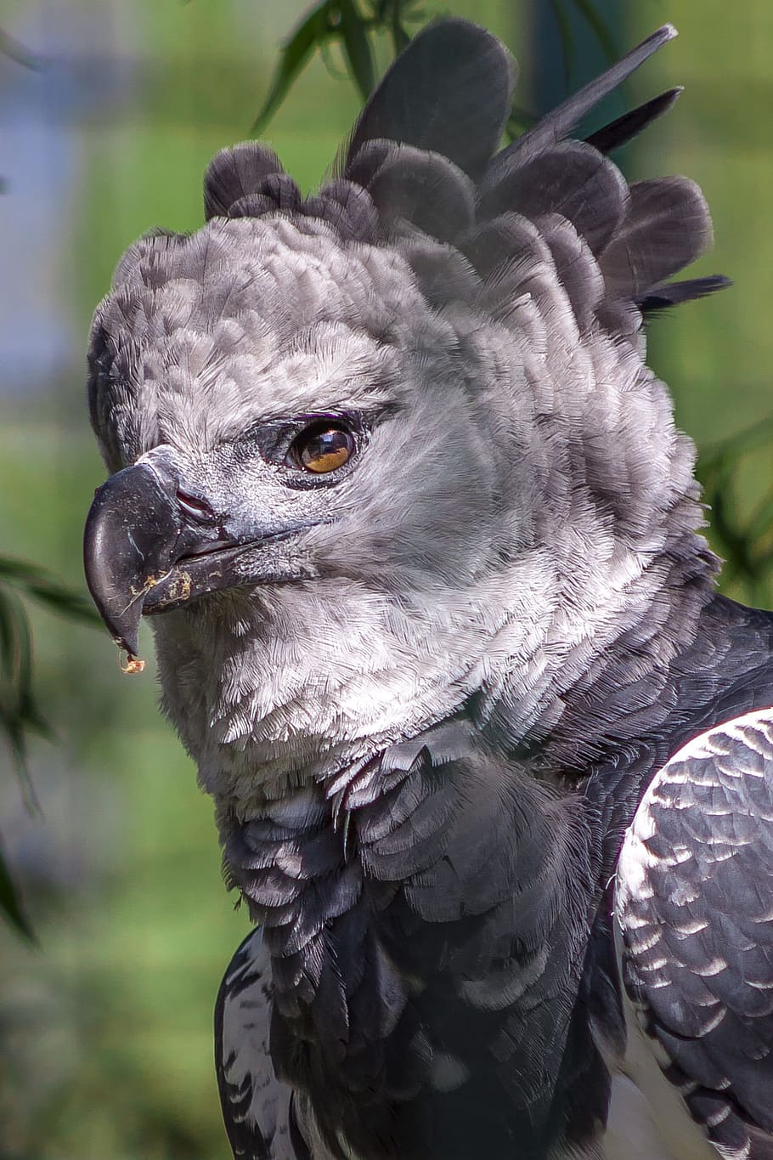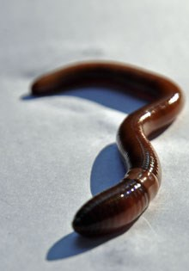  Producer  Primary consumer  Tertiary consumer  Decomposer

Copy and paste the web addresses of all resources below. These must be included in your presentation to receive full credit.
10 points
Please place sources here.

Once you have collected all your information for your Biome and put the information in complete sentences, you will need to make a slideshow about your Biome. Each topic needs to be a slide in your slide show. Below are the requirements you have to include in each slide:
30 points total

Each slide have a different background
Each slide have pictures
Each slide have transitions (information slides in, rotates, etc.)

Additionally, you will need to find a video on your biome from youtube and attach the link to your slide show

Extra Credit

Create a slide telling me if you would want to live in your biome
Create a slide telling me which countries you would find your biome

Please attach the link to your google slides right here:

