Biome Project
Below is all the information you need to include in your Biome project. You will have until October 22nd at Midnight to turn in this assignment. This assignment is worth 100 points.

Choose one Biome to research. For the Freshwater and Marine Biomes, you may only select one area.

Polar Region
Tundra
Taiga
Temperate Forest
Temperate Grasslands
Savanna
Desert
Tropical Rainforest
Marine (Pacific Ocean, Atlantic Ocean or Indian Ocean
Freshwater (Lakes and Ponds, Rivers , Wetlands)
Coral Reef

Once you have picked your Biome, you need to find the following information on your biome. Please make sure all the information is in complete sentences. If the information is not in complete sentences, you will lose points. Conduct your research through Google and copy and paste the addresses of all websites you use below the table.
5 points for each section
Biome Name: | Taiga
What is your Biome like? ( Climate, average temperature, average rain amount, seasons if it has any) | The Taiga is identified by a cold harsh climate.  Temperatures in the Taiga range from a few degrees Celsius above freezing to -10 °C (14 °F) or more.  The average rain amount is 15-33 inches.  The Taiga has 2 major seasons which are Winter and Summer.
Any adaptations creatures need to survive in your biome | In the Tundra, birds stay warm using their feathers.  Some animals hibernate.
Examples of Producers in your biome: | Needleleaf and Coniferous trees are examples of Producers in the Taiga
Examples of Primary Consumers in your Biome | Rabbits, Voles, Mice, and Shrews are all examples of Primary consumers in the Taiga.
Examples of Secondary Consumers in your Biome: | The secondary consumers in the Taiga are Lynx, Bobcats, and Carnivorous birds.
Examples of Tertiary Consumers in your Biome: | Bears, Owls, Eagles, and Large Cats are the Tertiary Consumers in the Taiga.
Examples of Decomposers in your Biome: | The Decomposers in the Taiga are, Fungi, Slime molds, Bacteria, Slugs, Snails, Woodlice, Springtails, Earthworms, Flies, Maggots, Beetles, and their larvae.
Example of Mutualism in your Biome: | An example of mutualism in the Taiga are plants and bees. The plants benefit by getting pollinated and the bees benefit by getting food.
Example of Commensalism in your Biome: | An example of commensalism in the Taiga is Moss and Trees. The Moss benefits because it has a nice and shady place to grow, the tree doesn’t benefit nor does it get harmed.
Example of Parasitism in your Biome: | An example of Parasitism in this biome is a winter tick and a moose. The winter tick benefits by getting food and blood while the moose on the other hand is getting the opposite, the moose does not benefit and gets harmed.
Recreate a food web found in your Biome: | 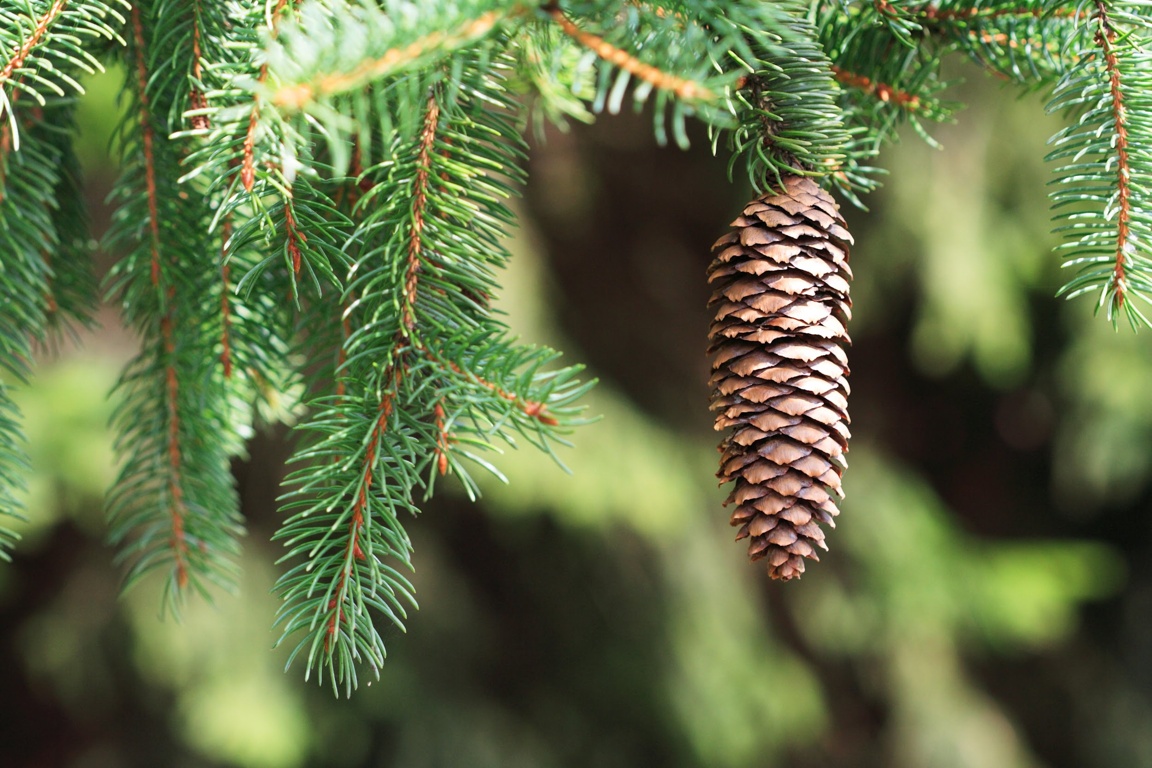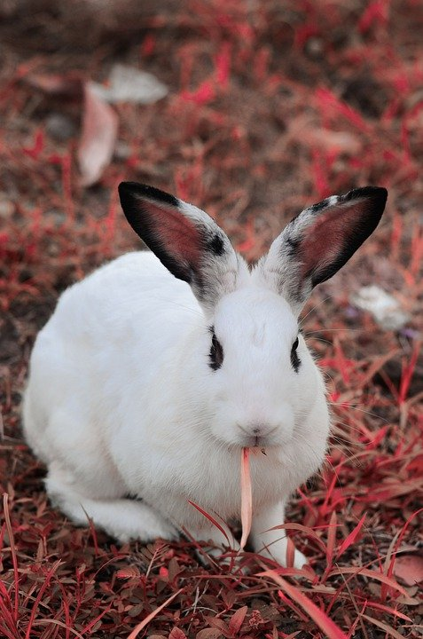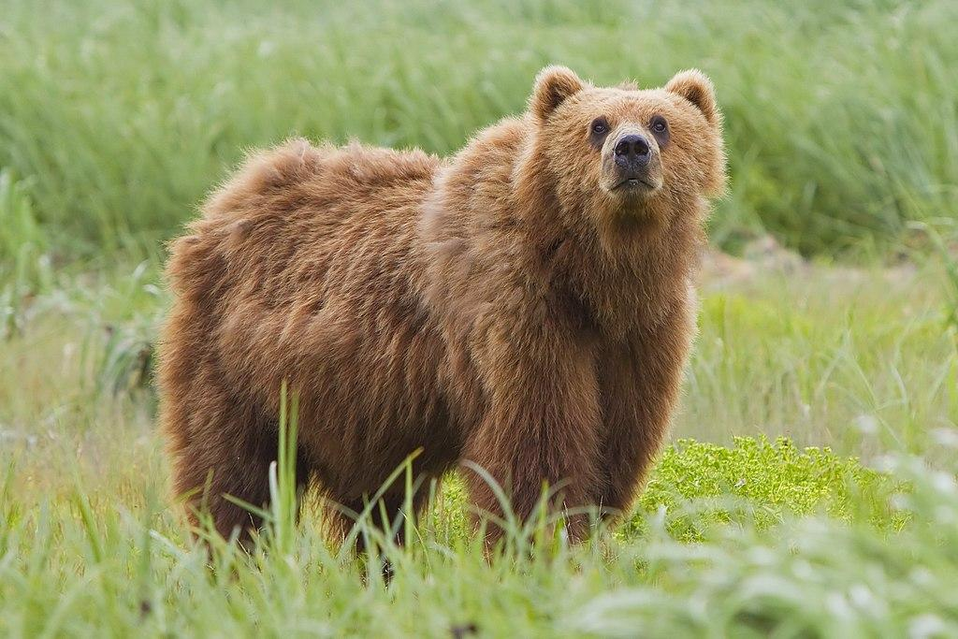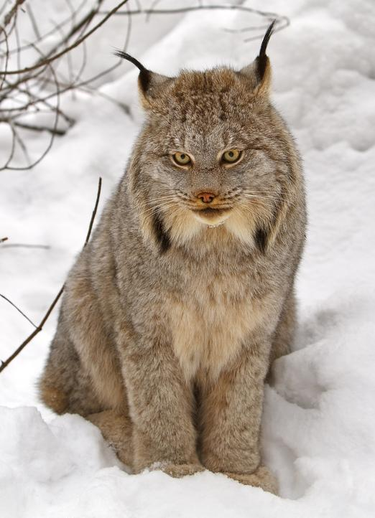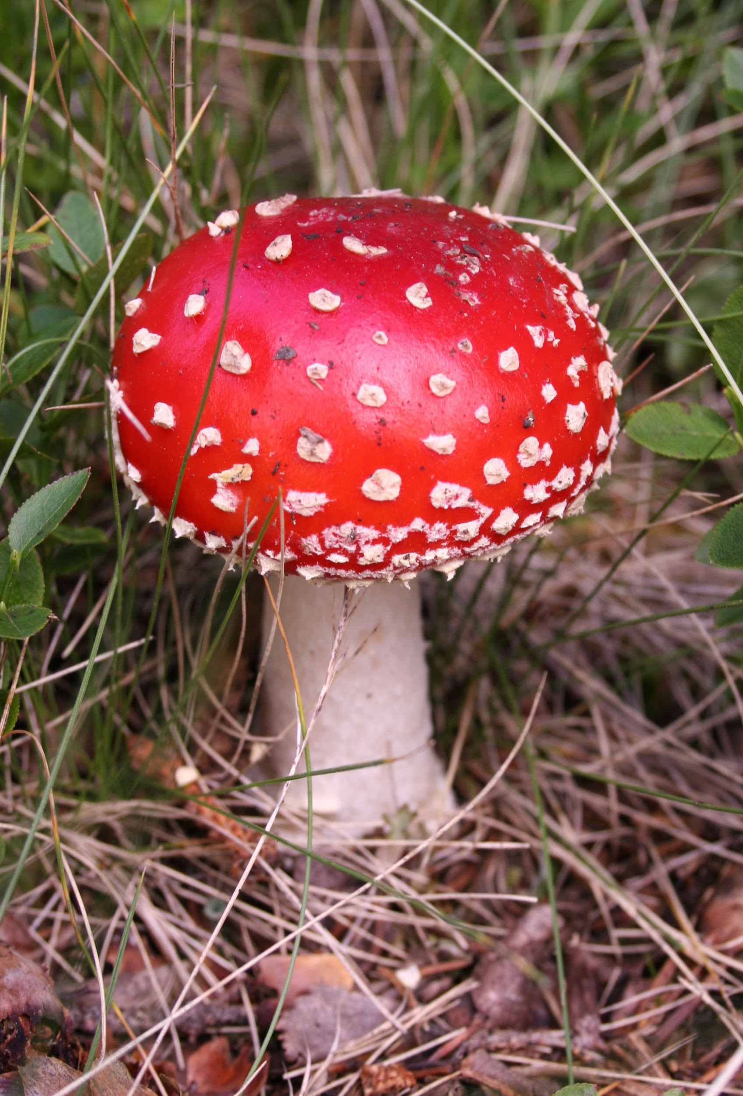  Needle leaf tree  (Producer)  Rabbit  (Primary Consumer)  Lynx  (Secondary Consumer)  Bear  (Tertiary Consumer)  Mushroom  (Decomposer)

Copy and paste the web addresses of all resources below. These must be included in your presentation to receive full credit.
10 points
https://borealforestandtaiga.weebly.com/
https://taigaofbiomes.weebly.com/
https://sciencestruck.com/

Once you have collected all your information for your Biome and put the information in complete sentences, you will need to make a slideshow about your Biome. Each topic needs to be a slide in your slide show. Below are the requirements you have to include in each slide:
30 points total

Each slide have a different background
Each slide have pictures
Each slide have transitions (information slides in, rotates, etc.)

Additionally, you will need to find a video on your biome from youtube and attach the link to your slide show

Extra Credit

Create a slide telling me if you would want to live in your biome
Create a slide telling me which countries you would find your biome

Please attach the link to your google slides right here:

