Biome Project
Below is all the information you need to include in your Biome project. You will have until October 22nd at Midnight to turn in this assignment. This assignment is worth 100 points.

Choose one Biome to research. For the Freshwater and Marine Biomes, you may only select one area.

Polar Region
Tundra
Taiga
Temperate Forest
Temperate Grasslands
Savanna
Desert
Tropical Rainforest
Marine (Pacific Ocean, Atlantic Ocean or Indian Ocean
Freshwater (Lakes and Ponds, Rivers , Wetlands)
Coral Reef

Once you have picked your Biome, you need to find the following information on your biome. Please make sure all the information is in complete sentences. If the information is not in complete sentences, you will lose points. Conduct your research through Google and copy and paste the addresses of all websites you use below the table.
5 points for each section
Biome Name: | Polar Region
What is your Biome like? ( Climate, average temperature, average rain amount, seasons if it has any) | In the polar region there are minimal warm summers and the average is about 10 degrees celsius. Since it is so cold it can result in sometimes permanent layers of ice; the 2 seasons are summer and winter
Any adaptations creatures need to survive in your biome | Adaptations in the polar region include animals who use their white fur as a disguise to hide from predators, and their fur is double layered so they don't freeze to death.
Examples of Producers in your biome: | Producers in the polar region include mosses, lichens, sedges, grasses, and dwarf woody shrubs.
Examples of Primary Consumers in your Biome | Primary consumers in the polar region include herbivores such as pikas, musk oxen, caribou, lemmings, and arctic hares..
Examples of Secondary Consumers in your Biome: | Secondary consumers in my biome include omnivores and carnivores such as the arctic foxes, brown bears, arctic wolves, and snowy owls.
Examples of Tertiary Consumers in your Biome: | Tertiary consumers in the polar region include polar bears, wolves, and eagles, which prey on the arctic fox as well as on primary consumers.
Examples of Decomposers in your Biome: | The decomposers found in the Arctic tundra are bacteria, which are microorganisms, and fungi, which we previously mentioned as a member of the lichen.
Example of Mutualism in your Biome: | One mutualistic relationship between the animals of the Arctic is between the Caribou and the Arctic Fox. When Caribou are out looking for food the Arctic fox follows. And does what?
Example of Commensalism in your Biome: | Commensalism is where one species benefits while the other is unaffected One example are arctic foxes who travel behind polar bears and scavenge on scraps of food.
Example of Parasitism in your Biome: | Even the Arctic has parasitism. Typically, it is seen in the case of a tapeworm cyst these organisms are prone to live in the bodies of different animals like wolves, caribou, polar bears, and moose. And what do they do?
Recreate a food web found in your Biome: | 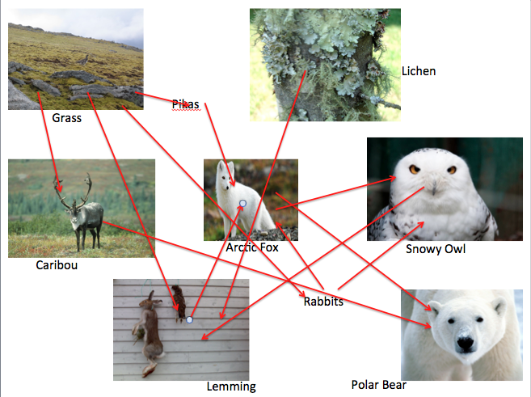

Copy and paste the web addresses of all resources below. These must be included in your presentation to receive full credit.
10 points
https://www.theschoolrun.com/homework-help/polar-habitats#:~:text=Polar%20habitats%20are%20located%20in,summer%20is%20normally%20very%20cold).
https://kids.nationalgeographic.com/nature/habitats/article/polar
https://www.worldwildlife.org/habitats/polar-regions

Once you have collected all your information for your Biome and put the information in complete sentences, you will need to make a slideshow about your Biome. Each topic needs to be a slide in your slide show. Below are the requirements you have to include in each slide:
30 points total

Each slide have a different background
Each slide have pictures
Each slide have transitions (information slides in, rotates, etc.)

Additionally, you will need to find a video on your biome from youtube and attach the link to your slide show

Extra Credit

Create a slide telling me if you would want to live in your biome
Create a slide telling me which countries you would find your biome

Please attach the link to your google slides right here:

