Biome Project
Below is all the information you need to include in your Biome project. You will have until October 22nd at Midnight to turn in this assignment. This assignment is worth 100 points.

Choose one Biome to research. For the Freshwater and Marine Biomes, you may only select one area.

Polar Region
Tundra
Taiga
Temperate Forest
Temperate Grasslands
Savanna
Desert
Tropical Rainforest
Marine (Pacific Ocean, Atlantic Ocean or Indian Ocean
Freshwater (Lakes and Ponds, Rivers , Wetlands)
Coral Reef

Once you have picked your Biome, you need to find the following information on your biome. Please make sure all the information is in complete sentences. If the information is not in complete sentences, you will lose points. Conduct your research through Google and copy and paste the addresses of all websites you use below the table.
5 points for each section
Biome Name: | Taiga Region
What is your Biome like? ( Climate, average temperature, average rain amount, seasons if it has any) | In the Taiga Biome, there are harsh and very cold winters with extreme rain and snow. The Taiga Biome receives up to 30 to 50 cm of annual precipitation. The Taiga region has only Winter and Summer seasons.
Any adaptations creatures need to survive in your biome | Bears and other animals need to hibernate, some need insulated feet, and some need seasonal coats. These are just a couple of the adaptations occurring in the Taiga.
Examples of Producers in your biome: | In the Taiga region, some of the producers there include pine trees, fir trees, evergreen spruce, and the larch or tamarack.
Examples of Primary Consumers in your Biome | In the Taiga region, the primary consumers there include small mammals such as rabbits, voles, mice, shrews, and other rodents.
Examples of Secondary Consumers in your Biome: | In the Taiga region, the secondary consumers there include the hawk owl, ermine, marten, red-throated loon and the sable.
Examples of Tertiary Consumers in your Biome: | In the Taiga region, the tertiary consumers there include Canada Lynx, Peregrine Falcon, Wolverine, Red Fox, and the Black Bear.
Examples of Decomposers in your Biome: | In the Taiga region, the decomposers there include honey fungus, fungi, moss, worms and soil bacteria.
Example of Mutualism in your Biome: | An example of mutualism in theTaiga biome is when bees fly from plant to plant. The flowers are benefiting by getting pollinated and the bees are getting food.
Example of Commensalism in your Biome: | An example of commensalism in the Taiga biome is moss growing on trees because the moss benefits by having a cool place to grow because if it grew in the sun it would dry up, but the tree is neither benefited or harmed.
Example of Parasitism in your Biome: | An example of parasitism in the Taiga biome is when a winter tick hitchhikes on a moose's back. The winter tick is receiving food and a place to stay while sucking blood from the moose's body which is beneficial for the tick, but the complete opposite for the moose.
Recreate a food web found in your Biome: | 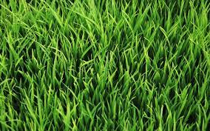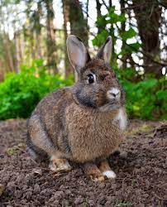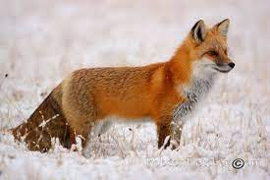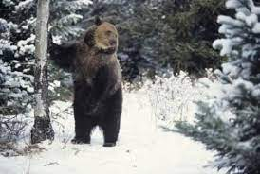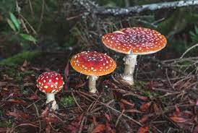  Food web in the Taiga Biome: Grass is the producer, and the Rabbit will eat the grass, the Red Fox will eat the rabbit, the Bear will eat the Red Fox, and the Fungi will then decompose the Bear, then restarting the cycle.

Copy and paste the web addresses of all resources below. These must be included in your presentation to receive full credit.
10 points
Taiga Biome: Location, Climate, Temperature, Precipitation ...
What Are the Adaptations for Animals to Survive in the Taiga?

Once you have collected all your information for your Biome and put the information in complete sentences, you will need to make a slideshow about your Biome. Each topic needs to be a slide in your slide show. Below are the requirements you have to include in each slide:
30 points total

Each slide have a different background
Each slide have pictures
Each slide have transitions (information slides in, rotates, etc.)

Additionally, you will need to find a video on your biome from youtube and attach the link to your slide show

Extra Credit

Create a slide telling me if you would want to live in your biome
Create a slide telling me which countries you would find your biome

Please attach the link to your google slides right here:

