Biome Project
Below is all the information you need to include in your Biome project. You will have until October 22nd at Midnight to turn in this assignment. This assignment is worth 100 points.

Choose one Biome to research. For the Freshwater and Marine Biomes, you may only select one area.

Polar Region
Tundra
Taiga
Temperate Forest
Temperate Grasslands
Savanna
Desert
Tropical Rainforest
Marine (Pacific Ocean, Atlantic Ocean or Indian Ocean
Freshwater (Lakes and Ponds, Rivers , Wetlands)
Coral Reef

Once you have picked your Biome, you need to find the following information on your biome. Please make sure all the information is in complete sentences. If the information is not in complete sentences, you will lose points. Conduct your research through Google and copy and paste the addresses of all websites you use below the table.
5 points for each section
Biome Name: | Tropical RainForest
What is your Biome like? ( Climate, average temperature, average rain amount, seasons if it has any) | The temperature in the rain forest remains warm all year. The average temperature in the rain forest is 68 degrees Fahrenheit to 84 degrees Fahrenheit. The average rain amount is 79 to 394 inches of rain per year.
Any adaptations creatures need to survive in your biome | Some of the adaptations that animals have in the tropical rain forest is camouflage, poison, and reduction of size. Some animals also have bright colored eyes to hunt in the dark.
Examples of Producers in your biome: | Some examples of producers in the Tropical Rain forest are trees, vines, mosses, grasses, tropical fruit trees, and decomposers.
Examples of Primary Consumers in your Biome | Examples for primary consumers in the rain forest are monkeys, and birds.
Examples of Secondary Consumers in your Biome: | Secondary consumers in the rain forest are tree frogs, and giant spiders.
Examples of Tertiary Consumers in your Biome: | The rainforests tertiary consumers are pumas, jaguars, crocodiles, and poison dart frogs.
Examples of Decomposers in your Biome: | Decomposers in the tropical rainforests are termites, slugs, scorpions, worms, and fungi.
Example of Mutualism in your Biome: | An example of mutualism in the rainforest is flowers and bees.
Example of Commensalism in your Biome: | In the rainforest an example of commensalism is orchids growing on branches. It is commensal because the orchid has the benefit of having a place to live whereas the branch is not harmed.
Example of Parasitism in your Biome: | An example of parasitism is the phorid fly and leaf-cutter ants in the tropical rainforest. When these leaf-cutter ants are collecting leaves, the phorid flies attack them and lay their eggs in the crevices of the worker ant's head.
Recreate a food web found in your Biome: | 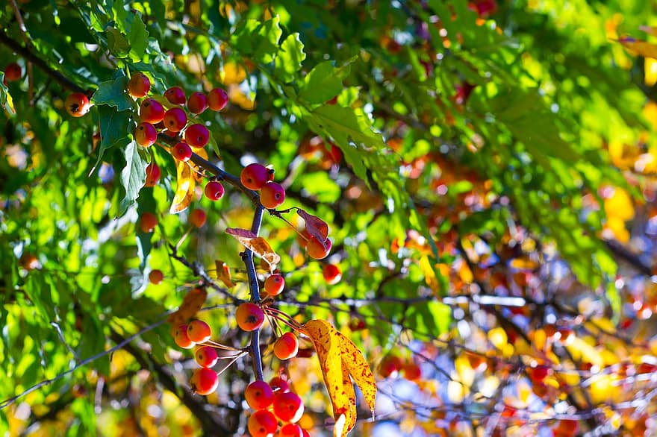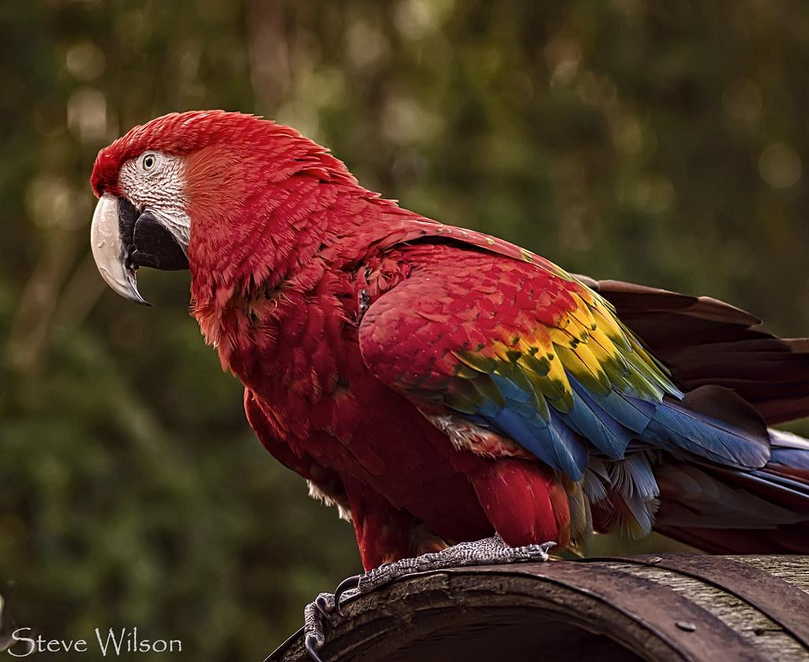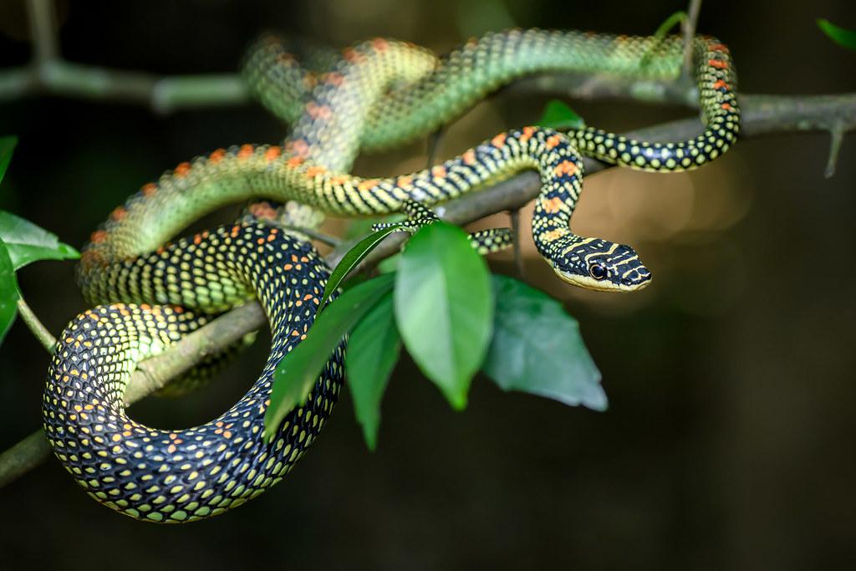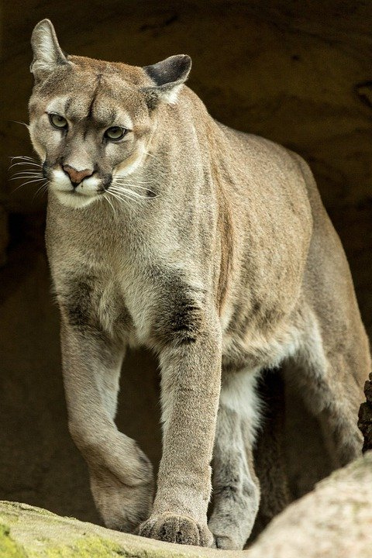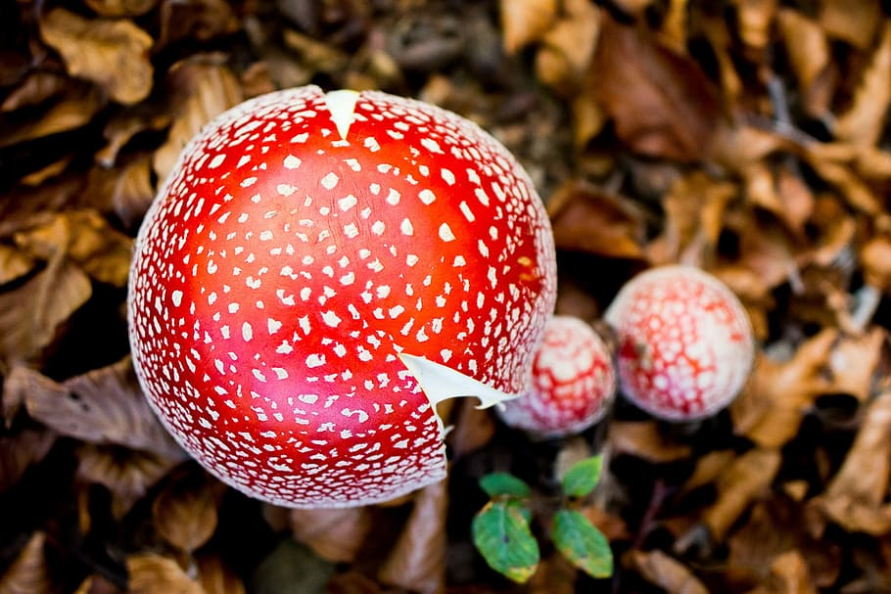  Berry Tree (Producers)  Macaw (Primary consumer)  Snake (Secondary consumer)  Pumas (Tertiary consumer)  Fungi (Decomposer)

Copy and paste the web addresses of all resources below. These must be included in your presentation to receive full credit.
10 points
https://study.com/academy/lesson/tropical-rainforest-producers-and-consumers.html
https://birdfact.com/articles/do-birds-eat-frogs
https://www.bioexplorer.net/tropical-rainforest-animal-adaptations.html
https://sciencing.com/food-chain-animals-rain-forest-6733903.html
https://prezi.com/scytixxmykhb/amazon-rainforest-food-web/
https://www.britannica.com/science/tropical-rainforest

Once you have collected all your information for your Biome and put the information in complete sentences, you will need to make a slideshow about your Biome. Each topic needs to be a slide in your slide show. Below are the requirements you have to include in each slide:
30 points total

Each slide have a different background
Each slide have pictures
Each slide has transitions (information slides in, rotates, etc.)

Additionally, you will need to find a video on your biome from youtube and attach the link to your slide show

Extra Credit

Create a slide telling me if you would want to live in your biome
Create a slide telling me which countries you would find your biome

Please attach the link to your google slides right here:

https://docs.google.com/document/d/1KPnArX2F8My2B-PJ6aPJ4oaZveObzcqpomzFQTL_Fe0/edit

Yasleen Perez - Biome Project

