Biome Project
Below is all the information you need to include in your Biome project. You will have until October 22nd at Midnight to turn in this assignment. This assignment is worth 100 points.

Choose one Biome to research. For the Freshwater and Marine Biomes, you may only select one area.

Polar Region
Tundra
Taiga
Temperate Forest
Temperate Grasslands
Savanna
Desert
Tropical Rainforest
Marine (Pacific Ocean, Atlantic Ocean or Indian Ocean
Freshwater (Lakes and Ponds, Rivers , Wetlands)
Coral Reef

Once you have picked your Biome, you need to find the fllowing information on your biome. Please make sure all the information is in complete sentences. If the information is not in complete sentences, you will lose points. Conduct your research through Google and copy and paste the addresses of all websites you use below the table.
5 points for each section
Biome Name: | Tropical rainforest
What is your Biome like? ( Climate, average temperature, average rain amount, seasons if it has any) | The Tropical rainforest is Hot and sometimes it rains all year. The rainforest biome remains warm all year. The average daily temperatures range from 20 C (68 F) to 25 C (77 F). The average rain amount is about 2,000 to 10,000 milliliters (79 to 394 inches) of rain per year. The season they have is one long wet winter, and a short drier summer.  o
Any adaptations creatures need to survive in your biome | Many animals have adapted to the unique condition of the Tropical rainforest. For an example, a slothcamouflages itself and it moves very slowly to make it difficult for predators to see them. The animals from the tropical rainforest are monkeys, birds (parrots, tucans) snakes, rodent, frogs, and lizards.
Examples of Producers in your biome: | Trees, vines, mosses, grasses, tropical fruit trees, and decomposers are the producers of the tropical rainforest.
Examples of Primary Consumers in your Biome | Examples of primary consumers from the tropical rainforest are monkeys and birds. I think its only those two.
Examples of Secondary Consumers in your Biome: | Examples of Secondary consumers are trees, frogs, and giant spiders.
Examples of Tertiary Consumers in your Biome: | Tertiary Consumers in tropical rainforest are Jaguars, dolphins, and giant fish.
Examples of Decomposers in your Biome: | The Decomposers in the rainforest are termites, slugs, scorpions, worms, and fungi.
Example of Mutualism in your Biome: | An example of Mutualism in the tropical rainforest is Monarch butterflies. Monarch butterflies travel in large groups to stay safe and help each other.
Example of Commensalism in your Biome: | An example of commensalism in the rainforest are orchids growing on trees.
Example of Parasitism in your Biome: | An example of Parasitism in the tropical rainforest is the strangler fig tree and other host trees.
Recreate a food web found in your Biome: | 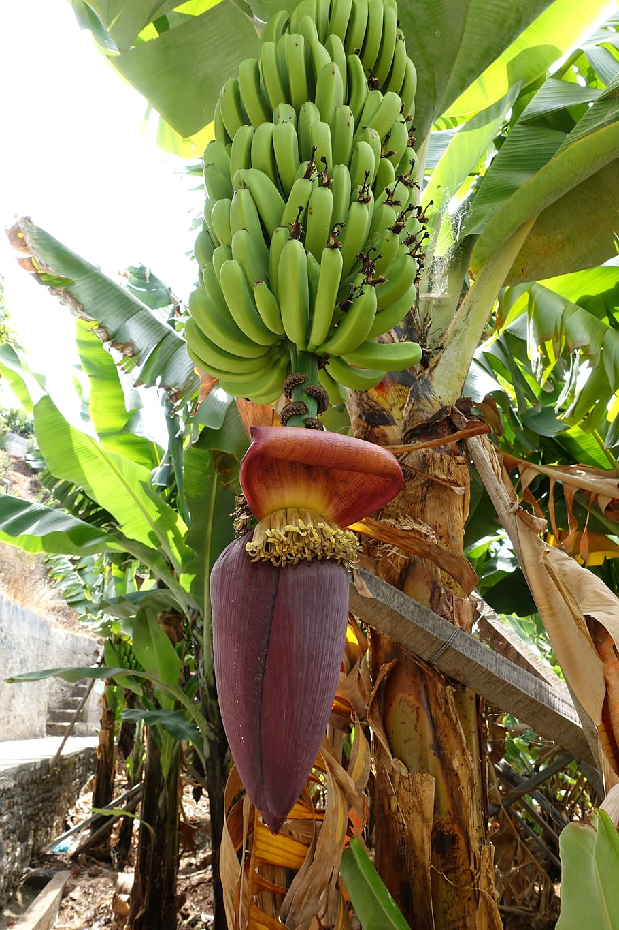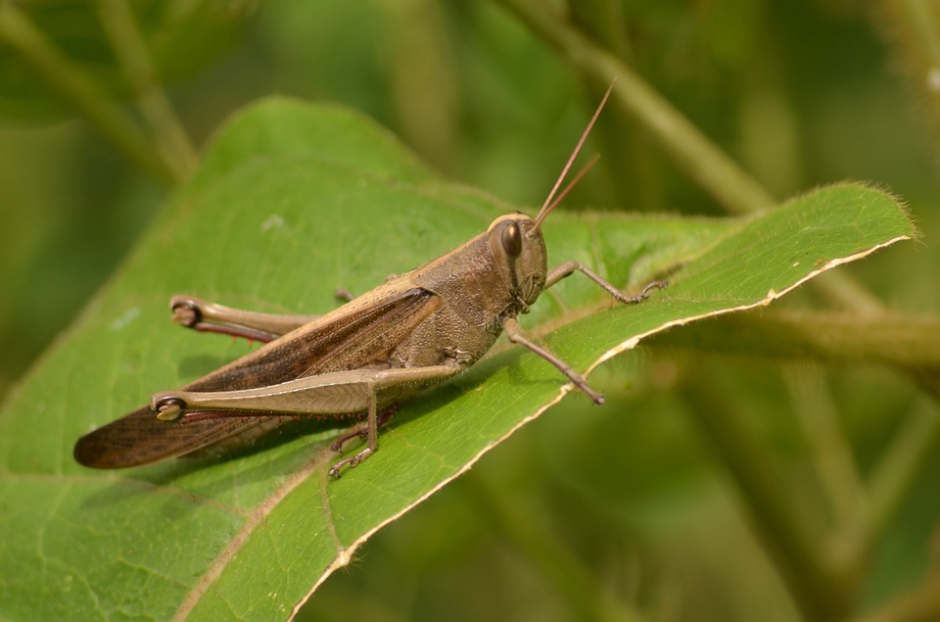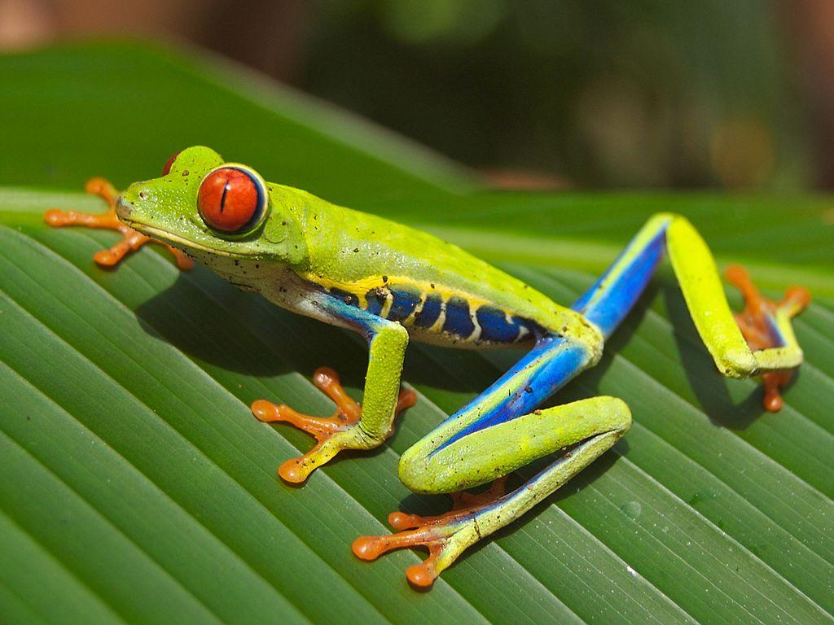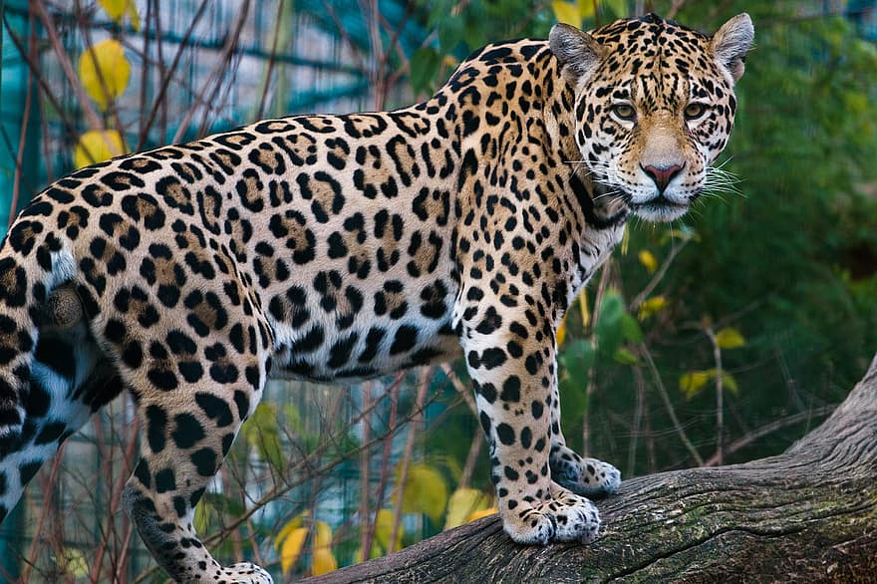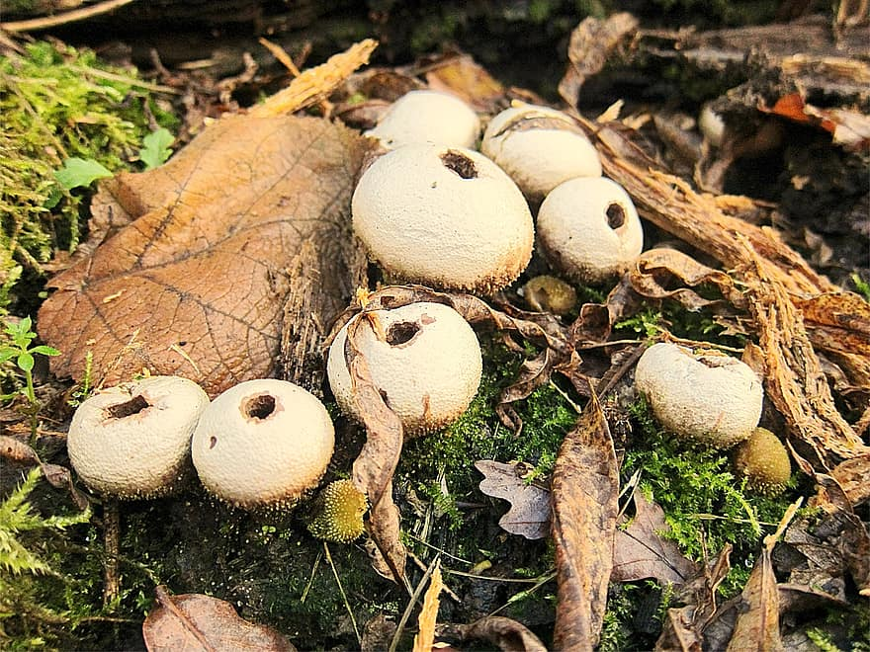  Bananas trees  (Producer)  Grasshopper  (Primary consumer)  Frog  (Secondary Consumer)  Jaguar  (tertiary consumer)  Fungi  (decomposer)

Copy and paste the web addresses of all resources below. These must be included in your presentation to receive full credit.
10 points
https://www.britannica.com/science/tropical-rainforest

Once you have collected all your information for your Biome and put the information in complete sentences, you will need to make a slideshow about your Biome. Each topic needs to be a slide in your slide show. Below are the requirements you have to include in each slide:
30 points total

Each slide have a different background
Each slide have pictures
Each slide have transitions (information slides in, rotates, etc.)

Additionally, you will need to find a video on your biome from youtube and attach the link to your slide show

Extra Credit

Create a slide telling me if you would want to live in your biome
Create a slide telling me which countries you would find your biome

Please attach the link to your google slides right here:

