Energy Flow in Ecosystems

Engage | Watch this Video on Energy Flow in Ecosystems  ?  Write three sentences explaining Energy Flow seen in Kalahari Desert Ecosystem (Where do the Sand People get their energy? The Kudu? The Organisms the Kudu eat?)  The sand people get their energy from hunting animals like the Kudu. The Kudu eats plants. These plants could be leaves, shrubs, twigs, grasses, herbs and roots
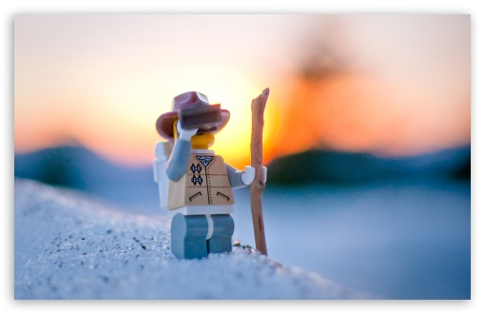  Explore | - Download this copy of the Vocabulary Slides  - Create each slide with the correct definition  - Include a picture on each which helps in your understanding of the word  - Use slide #1 as an example  - When you are done place a Link to it Below  https://docs.google.com/presentation/d/1WbN-kX-vG3PQ5QyEGS58aoSfD6LDPNLuLXNa-Fz43A0/edit#slide=id.g1c758eb772_1_0  - Read this National Geographic Article  ?  What is the difference between primary, secondary, tertiary consumers?  (include a quote from the article to support your explanation)  Primary consumers are herbivores. Secondary consumers eat herbivores. And Tertiary consumers eat secondary consumers.  - Watch these 3 videos on Food Webs  Fabulous Food Chains the Dirt on Decomposers Home Sweet Habitat  - Check out this Food Chain Example:  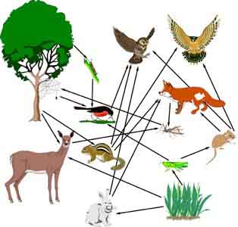  - Complete the Food Chain Games (Select 2)  - Watch this video on Energy Pyramids  A Pyramid shape is used because energy is lost at each trophic level when organisms use it up.  Why is the Energy Pyramid shaped like a pyramid?  Why does the energy ”go down” at each level?  The energy goes down each level because the organisms have to undergo life activities.
  Explain | - Create a Food Web from the following images  https://docs.google.com/drawings/d/1gfcm5cr6H_G0nqjYXAOIeO7QPlW28U3DvziQQzvdED0/edit  - Create an Energy Pyramid on the following document  (this should match what your food pyramid shows)  https://docs.google.com/drawings/d/1vLR056nu-ELMv7M2cIGp_vw95JFBHazQd721MX83bNc/edit
  Elaborate | ?  Using your Food Web and Energy Pyramid describe the flow of energy through your ecosystem.  - Start with the sun and end at your top predators.  - Include the trophic levels  - Describe what happens to energy as it moves through different organisms  Answer in at least 4 sentences  The sun produces energy which is then collected by the plant. The plant is then eaten by a primary consumer which could be a rabbit. The rabbit then could be eaten by a secondary consumer which could be a snake. Finally, my snake could be eaten by a tertiary consumer which could be a hawk.  You are done, Submit this Doc. through Classroom

