1/21/22, 7:41 AM Airplane Parts - Worksheet

**PRINT THIS ANSWER SHEET TO FILL OUT AND TURN IN.**

NAME_________________________________ CLASS____________________ DATE____________ **Airplane Parts Identification & FunctionsWorksheet**

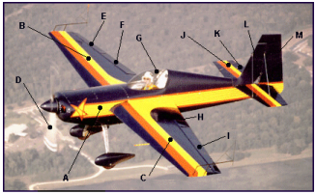

Using the letters shown on the airplane photograph above, identify the airplane parts listed below. Write both correct letters where needed.

1. wings ________B C______

2. vertical stabilizer ___L_____________

3. fuselage ________A________

4. flaps ____F H__________

5. cockpit _______G_________

6. propeller _____D___________

7. rudder ____M____________

8. ailerons ______E I________

9. elevator _____K___________

10.horizontal stabilizer ________J________

1. Write the names of the three airplane parts that can be used to change the shape of the wings. _____Spoiler_____ _____Aileron_____ _____Slats_____

2. The wing generates lift because of its shape. Look at the airplane above. Which other part of the airplane, because of its similar shape, should also generate lift? ____Horizontal Stabilizer____

3. Look at the airplane above. Which moveable part would the pilot use to make the airplane turn to the left? ____Ailerons ____

https://www.grc.nasa.gov/www/k-12/BGA/Sheri/airplane_parts_wks.htm 1/2

1/21/22, 7:41 AM Airplane Parts - Worksheet

4. Which part would the pilot move in order to tip the left wing lower than the right? _____Aileron_______

5. Which part of the airplane in the picture above is generating thrust?

_____Propeller_______

https://www.grc.nasa.gov/www/k-12/BGA/Sheri/airplane_parts_wks.htm 2/2