1/21/22, 7:41 AM Airplane Parts - Worksheet

**PRINT THIS ANSWER SHEET TO FILL OUT AND TURN IN.**

NAME__Niko Antongiorgi_______________________________ CLASS___AOPA 9th_________________ DATE___1/21/22_________ **Airplane Parts Identification & FunctionsWorksheet**

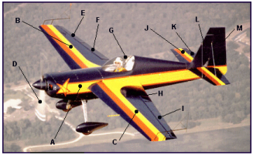

Using the letters shown on the airplane photograph above, identify the airplane parts listed below. Write both correct letters where needed.

1. wings __C,B_______________

2. vertical stabilizer ______,L___________

3. fuselage __A_______________

4. flaps _H,F________________

5. cockpit _G________________

6. propeller _D________________

7. rudder ___M______________

8. ailerons __I,E_______________

9. elevator __K______________

10.horizontal stabilizer __J_______________

1. Write the names of the three airplane parts that can be used to change the shape of the wings. ______rubber___________ _______elevator__________ _____flaps____________

2. The wing generates lift because of its shape. Look at the airplane above. Which other part of the airplane, because of its similar shape, should also generate lift? The wings_________________

3. Look at the airplane above. Which moveable part would the pilot use to make the airplane turn to the left? _____The rubber____________

https://www.grc.nasa.gov/www/k-12/BGA/Sheri/airplane_parts_wks.htm 1/2

1/21/22, 7:41 AM Airplane Parts - Worksheet

4. Which part would the pilot move in order to tip the left wing lower than the right? ___Ailerons______________

5. Which part of the airplane in the picture above is generating thrust?

_______propellers__________

https://www.grc.nasa.gov/www/k-12/BGA/Sheri/airplane_parts_wks.htm 2/2