1/21/22, 7:41 AM Airplane Parts - Worksheet

**PRINT THIS ANSWER SHEET TO FILL OUT AND TURN IN.**

NAME___Elizabeth Laughlin______________________________ CLASS___AOPA 9_________________ DATE____1/21/22________ **Airplane Parts Identification & FunctionsWorksheet**

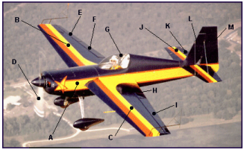

Using the letters shown on the airplane photograph above, identify the airplane parts listed below. Write both correct letters where needed.

1. wings _____B & C____________

2. vertical stabilizer _____L____________

3. fuselage _____A____________

4. flaps ____F & H_____________

5. cockpit _____G____________

6. propeller _______D__________

7. rudder ______M___________

8. ailerons ______E & I___________

9. elevator _______K__________

10.horizontal stabilizer _______J__________

1. Write the names of the three airplane parts that can be used to change the shape of the wings. _____Flaps____________ ________Ailerons_________ ________Spoiler_________

2. The wing generates lift because of its shape. Look at the airplane above. Which other part of the airplane, because of its similar shape, should also generate lift? ___Flaps______________

3. Look at the airplane above. Which moveable part would the pilot use to make the airplane turn to the left? _____Aileron____________

https://www.grc.nasa.gov/www/k-12/BGA/Sheri/airplane_parts_wks.htm 1/2

1/21/22, 7:41 AM Airplane Parts - Worksheet

4. Which part would the pilot move in order to tip the left wing lower than the right? _____Spoiler____________

5. Which part of the airplane in the picture above is generating thrust?

_______Propeller__________

https://www.grc.nasa.gov/www/k-12/BGA/Sheri/airplane_parts_wks.htm 2/2