1/21/22, 7:41 AM Airplane Parts - Worksheet

**PRINT THIS ANSWER SHEET TO FILL OUT AND TURN IN.**

NAME____Ethan Harris________ CLASS___A.O.P.A._9th______ DATE___1/21/2022__ **Airplane Parts Identification & FunctionsWorksheet**

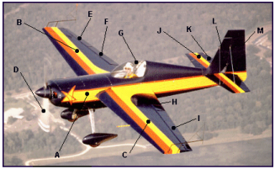

Using the letters shown on the airplane photograph above, identify the airplane parts listed below. Write both correct letters where needed.

1. wings ___B and C____

2. vertical stabilizer ____L____

3. fuselage ___A___

4. flaps ___H___

5. cockpit ____G____

6. propeller ____D____

7. rudder ___M____

8. ailerons ___I___

9. elevator ____K___

10.horizontal stabilizer ____J____

1. Write the names of the three airplane parts that can be used to change the shape of the wings. __Aileron__ ____Flaps___ ___Winglet____

2. The wing generates lift because of its shape. Look at the airplane above. Which other part of the airplane, because of its similar shape, should also generate lift? ___The Slats____

3. Look at the airplane above. Which moveable part would the pilot use to make the airplane turn to the left? __M the Rudder___

https://www.grc.nasa.gov/www/k-12/BGA/Sheri/airplane_parts_wks.htm 1/2

1/21/22, 7:41 AM Airplane Parts - Worksheet

4. Which part would the pilot move in order to tip the left wing lower than the right? __I the Flaps_________

5. Which part of the airplane in the picture above is generating thrust?

__D the Proppeler____

https://www.grc.nasa.gov/www/k-12/BGA/Sheri/airplane_parts_wks.htm 2/2