1/21/22, 7:41 AM Airplane Parts - Worksheet

**PRINT THIS ANSWER SHEET TO FILL OUT AND TURN IN.**

NAME_Mari-Ana Vargas____________________________ CLASS__AOPA______________ DATE_1-21-22__________ **Airplane Parts Identification & FunctionsWorksheet**

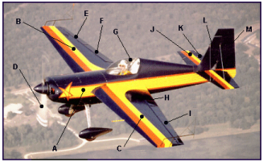

Using the letters shown on the airplane photograph above, identify the airplane parts listed below. Write both correct letters where needed.

1. wings _B_____________

2. vertical stabilizer ____L__________

3. fuselage ____A___________

4. flaps ____F_____________

5. cockpit _________________

6. propeller __D______________

7. rudder _______M__________

8. ailerons _________________

9. elevator _________________

10.horizontal stabilizer ____J____________

1. Write the names of the three airplane parts that can be used to change the shape of the wings. _____ rudders**,** elevators**,** flaps**,** ___________

2. The wing generates lift because of its shape. Look at the airplane above. Which other part of the airplane, because of its similar shape, should also generate lift? _________________

3. Look at the airplane above. Which moveable part would the pilot use to make the airplane turn to the left? ______Alleron_________

https://www.grc.nasa.gov/www/k-12/BGA/Sheri/airplane_parts_wks.htm 1/2

1/21/22, 7:41 AM Airplane Parts - Worksheet

4. Which part would the pilot move in order to tip the left wing lower than the right? ___Spolier ____________

5. Which part of the airplane in the picture above is generating thrust?

_______Turbine engine__________

https://www.grc.nasa.gov/www/k-12/BGA/Sheri/airplane_parts_wks.htm 2/2