Reference the VFR Sectional Chart excerpt for Questions 1 through 3.

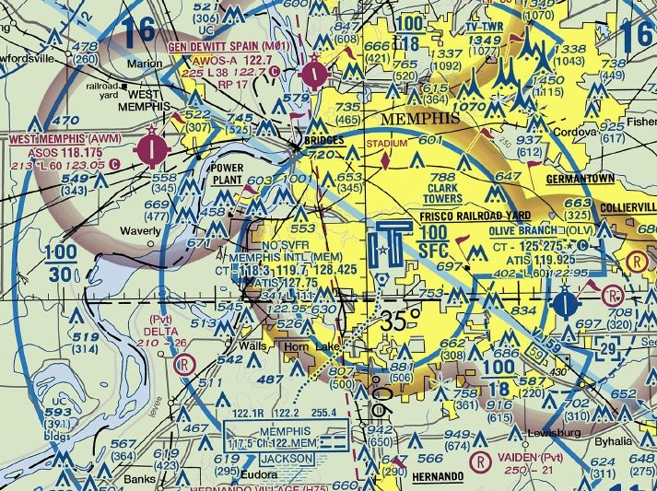

1. You are diverting to the West Memphis airport. What frequency should you use in the traffic pattern? (6.A.1)
2. **123.05**
3. 118.175
4. 118.3
5. 117.5
6. You are flying in the traffic pattern (1,000 ft AGL) at Gen Dewitt Spain Airport (M01). What are the minimum visibility and cloud clearance requirements for VFR operations at that airport? (6.A.1)
7. 1 mile visibility and clear of clouds.
8. 3 miles visibility and clear of clouds.
9. **3 miles visibility and 500 feet below, 2,000 feet horizontally from, and 1,000 feet above clouds.**
10. 5 miles visibility and 1,000 feet below, 1 mile horizontally from, and 1,000 feet above clouds.
11. When measuring distance on a VFR Sectional Chart, it is useful to remember that one degree of latitude is equal to ___ nautical miles. (6.A.2)

1. 1
2. 30
3. **60**
4. The distance varies, getting smaller as you approach the poles.
5. A pilot departs Washington, DC, at 1300 EST on a flight to San Francisco, CA. The flight time is 5 hours. At what coordinated universal time (UTC) would the plane land? Reference the table below. (6.A.2)

U.S. Time Zone UTC

Eastern EST + 5 hours

Central CST + 6 hours

Mountain MST + 7 hours

Pacific PST + 8 hours

1. 1000 UTC
2. 1300 UTC
3. 1800 UTC
4. **2300 UTC**

Use the map to answer question 5.

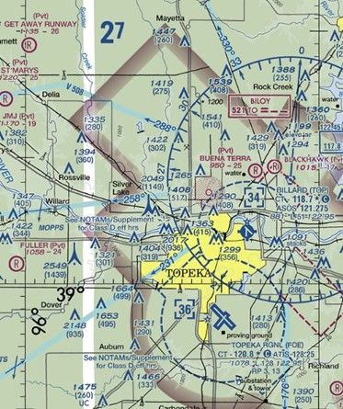

Editorial credit: SkyVector

1. Reference the image above. What are the latitude and longitude for Topeka Regional (FOE)? (6.A.2)
2. 38°55′N, 96°20′W
3. **38°57′N, 95°40′W**
4. 39°05′N, 95°37′W
5. 38°35′N, 95°40′W
6. What heading is associated with southeast? (6.B.1)
7. 035°
8. 090°
9. **135°**
10. 315°
11. An airline pilot who had a first class medical certificate is on furlough and not planning to fly for the airlines in the near future. It has been 13 months since the pilot’s first class medical evaluation. The pilot is over 40 years old. The pilot decides to go rent and fly a Cessna to take their family on a local flight. What is the pilot’s medical status? (8.A.1)
12. The pilot must renew their medical before they can fly.
13. **The pilot may fly, exercising the privileges of a third class medical certificate.**
14. The pilot may fly using their driver’s license under Sport Pilot privileges.
15. The pilot can take an online course and fly under BasicMed.
16. With a true course of 260 degrees, a magnetic variation of 8 degrees east, and a compass deviation of +2 degrees, what would the compass heading be? (6.B.2)
17. **254°**
18. 270°
19. 266°
20. 268°
21. A pilot is planning a flight to Denver at a true airspeed of 165 knots. The distance is 300 nautical miles, and forecasts predict a 15-knot headwind. Approximately how long will the flight take? (6.B.2)

1. 1.7 hours
2. 1.8 hours
3. **2.0 hours**
4. 2.2 hours
5. A pilot is planning a day VFR flight that will take about 2.5 hours. The aircraft burns 8 gallons per hour in cruise flight. Accounting for required reserves, approximately how much fuel needs to be on board the aircraft? (6.B.2)
6. 20 gallons
7. **24 gallons**
8. 26 gallons
9. 28 gallons
10. Reference the E6-B figure below. A pilot using this E6-B flight computer marked the wind speed on the wheel (the red mark) and then turned the disk to align the true course at the top of the true index. With a magnetic variation of 6 degrees West, what is the magnetic heading? (6.B.3)

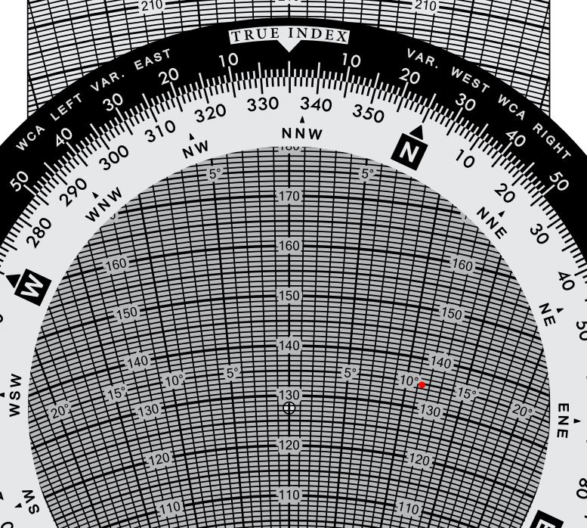

1. 318°
2. 330°
3. 340°
4. **352°**
5. The E6-B below has been aligned to calculate the fuel burn rate, with 11 gallons used in 1 hour 10 minutes. The 11 and 1:10 are already aligned on the flight computer. What is the fuel burn rate shown on the E6-B? (6.B.3)

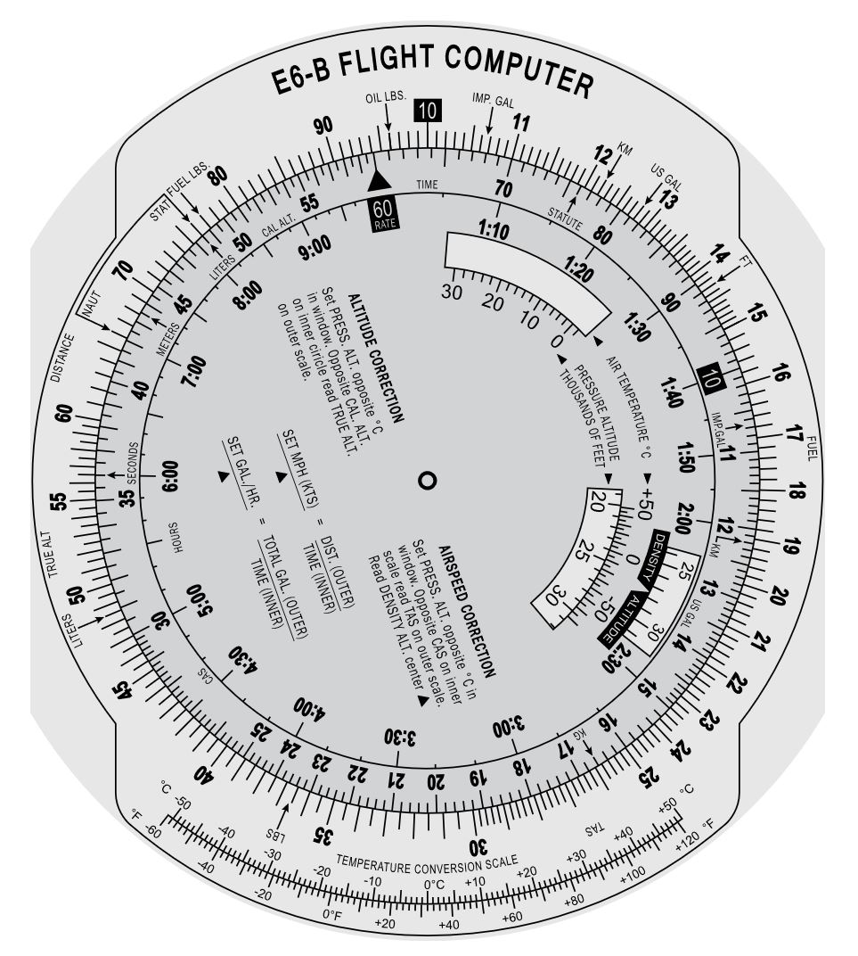

1. 7.0 GPH.
2. **9.4 GPH.**
3. 12 GPH.
4. 15.3 GPH.
5. Pilots who navigate by looking out the window, finding landmarks, and updating their course based on those landmarks are navigating by (6.C.1)
6. GPS.
7. **Pilotage.**
8. Dead Reckoning.
9. Land Navigation.
10. According to 14 CFR 91.103, in preflight planning the pilot in command is responsible for becoming familiar with (6.C.2)
11. Weather and fuel requirements.
12. Alternates and traffic delays.
13. Runway lengths and takeoff/landing distances.
14. **All of the above.**
15. Which FAA publication provides very detailed information on airports throughout the United States? (6.C.2)
16. **Chart Supplement U.S.**
17. VFR sectional chart.
18. Terminal procedures.
19. Chart User’s Guide.
20. How can pilots determine if the GPS signal may be unreliable during their flight? Choose two correct answers. (6.C.3)
21. Checking the GPS status map at www.nasa.gov.
22. **Reviewing GPS NOTAMs for known or anticipated outages.**
23. **Performing a preflight Receiver Autonomous Integrity Monitoring (RAIM) check.**
24. Ensuring the system’s GPS database is up-to-date.

Reference the following VOR display for question 17.

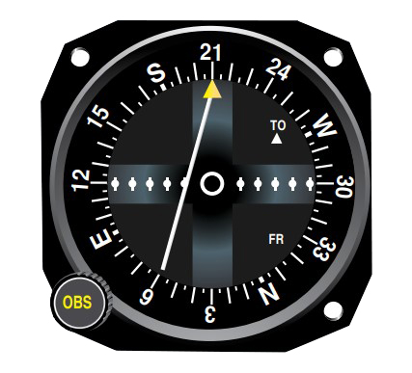

Editorial credit: Pilot's Handbook of Aeronautical Knowledge

1. Where is the aircraft in relation to the VOR? (6.C.3)
2. Northwest.
3. **Northeast.**
4. Southwest.
5. Southeast.
6. Reference the VFR Sectional excerpt above. The blue lines labeled V553, V307, and V71 which emanate from the Pawnee City VOR are known as (6.C.3)

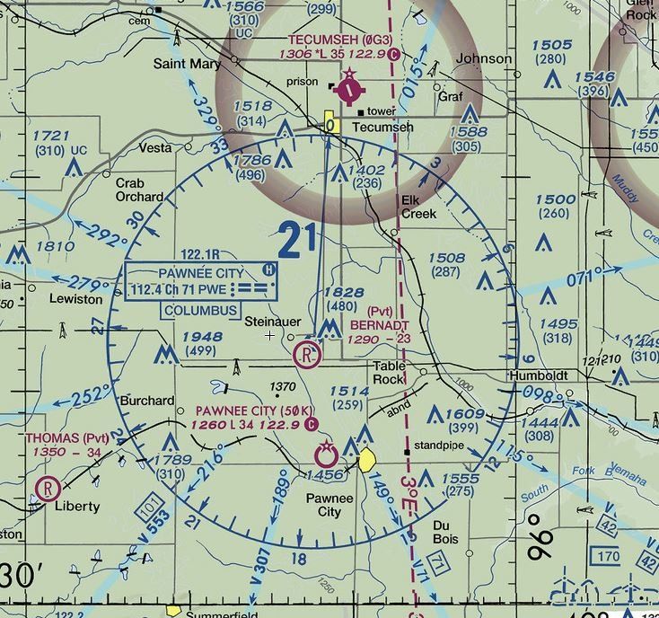

Editorial credit: SkyVector

1. **Victor airways.**
2. T Routes.
3. Military VR Routes.
4. Radials.
5. Using the following data and chart, determine where the aircraft falls within its operating envelope. (7.A.1)

Empty Weight: 2110 lbs Moment/100: 1652 in-lb  
 Occupants: 500 lbs Moment/100: 256 in-lb  
 Fuel: 40 gallons Moment/100: 221 in-lb  
 Baggage: 50 lbs Moment/100: 75 in-lb

*(Total Weight: 2900 lbs Moment/100: 2204 in-lb)*

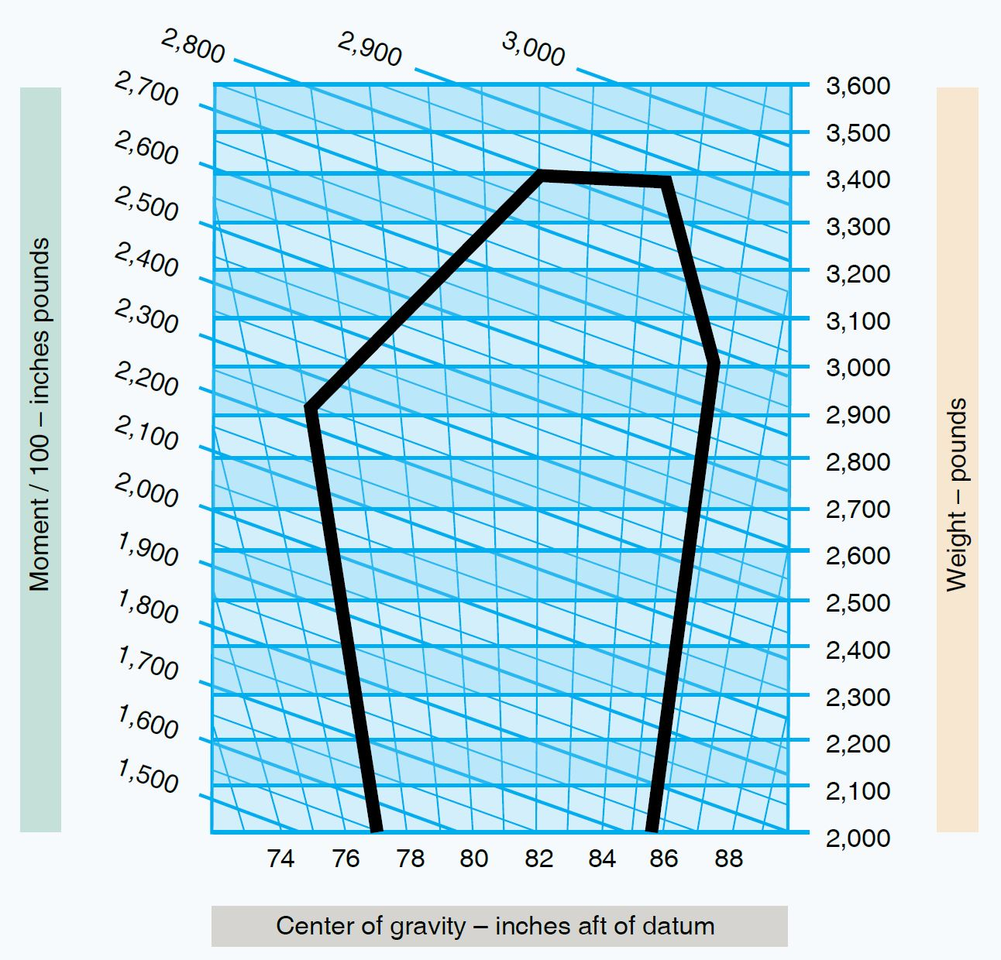

Editorial credit: Airman Knowledge Testing Supplement

1. The aircraft is within its operating envelope.
2. The aircraft is overweight.
3. **The aircraft’s CG is beyond the forward limit.**
4. The aircraft’s CG is beyond the aft limit.

1. Who is responsible for ensuring an aircraft is operated within its approved weight and balance envelope? (7.A.1)
2. The aircraft owner or operator.
3. The loadmaster or crew that loads the aircraft.
4. The customers who declare their weight and the weight of their cargo.
5. **The pilot in command.**
6. If an aircraft is over its approved maximum gross weight, how can a pilot legally fly the aircraft without removing cargo or passengers? (7.A.1)
7. Wait until cooler temperatures when takeoff performance will be better.
8. **Remove fuel from the aircraft’s fuel tanks until the weight is below the maximum required.**
9. Shift passengers and cargo around the aircraft to achieve a better balance.
10. Obtain permission from the owner and/or passengers to operate at that weight.
11. Which hazardous attitude is displayed by a pilot who says, “it can’t happen to me”? (8.D.1)
12. Macho.
13. **Invulnerable.**
14. Impulsivity.
15. Resignation.
16. Which of the following flight conditions is most affected by density altitude? (7.A.2)
17. **Takeoff distance.**
18. Taxi performance.
19. Descent performance.
20. Turn performance.
21. Use the chart below to determine the density altitude based on the following conditions.

Airport Elevation: 1,665 ft OAT: 21°C Altimeter Setting: 30.10 in Hg

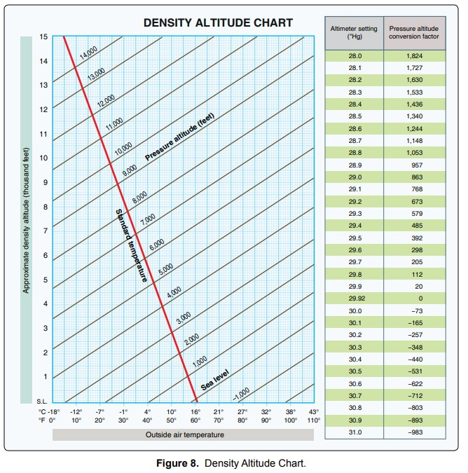

Editorial credit: Airman Knowledge Testing Supplement

1. 1,000 ft.
2. **2,500 ft.**
3. 2,800 ft.
4. 5,100 ft.
5. Which of the following changes to takeoff factors would result in an increased takeoff ground roll? (7.A.3)
6. Reducing the weight of the aircraft.
7. Using all available engine performance and acceleration.
8. **Switching from a paved runway to a grass runway.**
9. Adding grooves to the runway.
10. Using the takeoff distance chart below, what would the takeoff ground roll be for an aircraft under the following conditions: (7.A.3)

Weight: 2,200 lb Pressure Altitude of 4,000 ft Temperature: 20°C 10-knot headwind

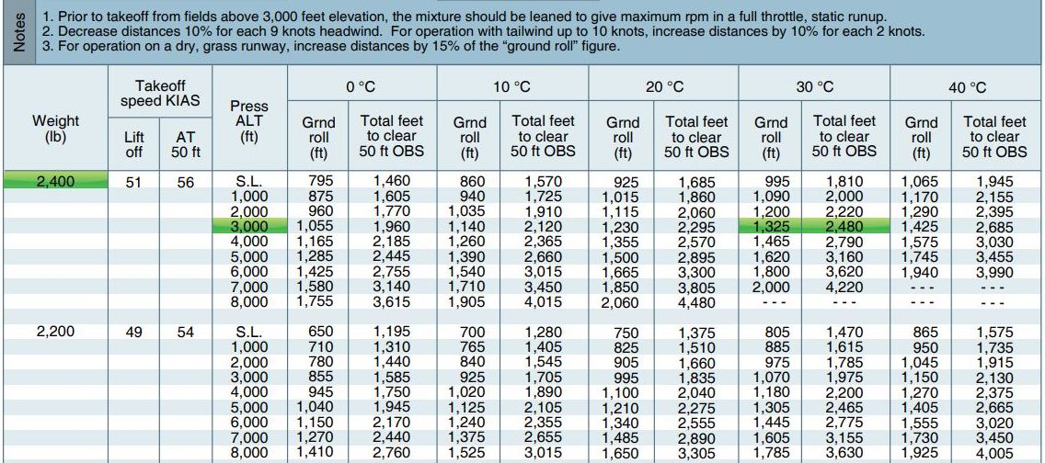

Editorial credit: Pilot's Handbook of Aeronautical Knowledge

1. **990 ft.**
2. 1,100 ft.
3. 1,836 ft.
4. 2,040 ft.
5. As altitude increases, the aircraft’s rate of climb performance (7.A.4)
6. increases.
7. **decreases.**
8. remains constant.
9. changes at the same rate as the dry adiabatic lapse rate.
10. Reference the performance chart below. Based on a 2,550-lb aircraft at an airport elevation of 1,000 feet and standard temperature, what is the time, total fuel used, and distance in a climb to 9,000 feet? (7.A.4)

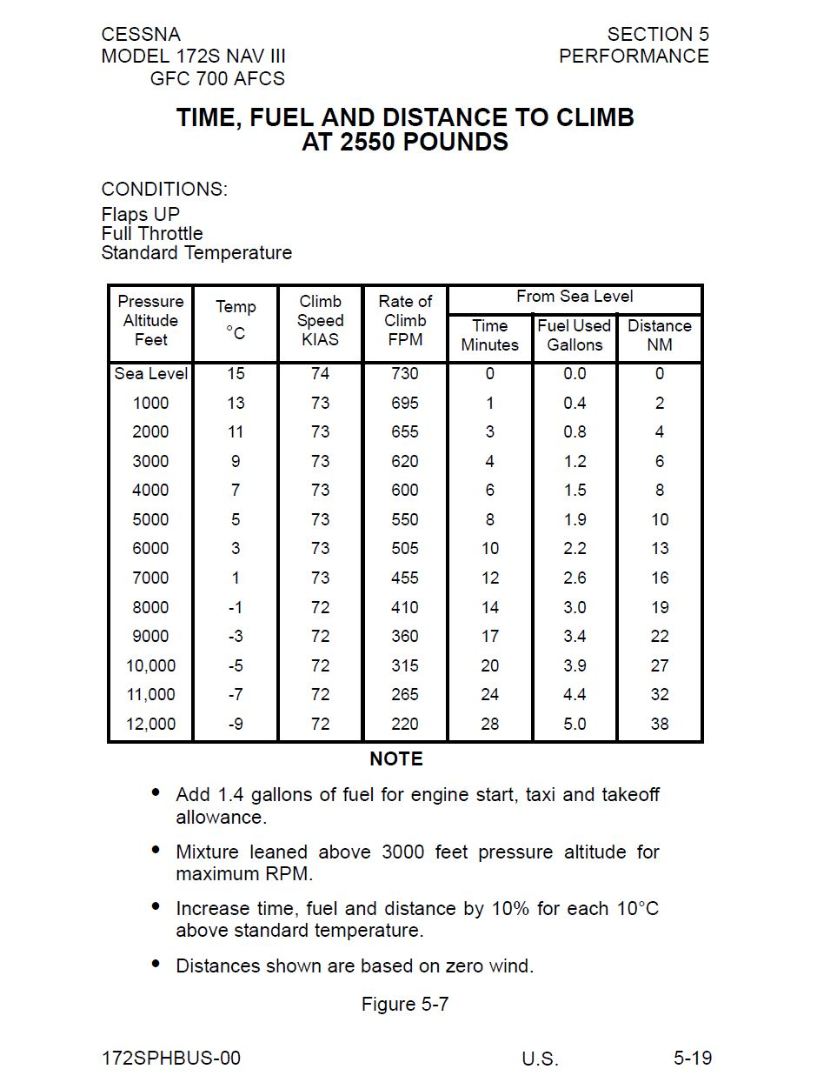

Editorial credit: Cessna

1. **16 minutes, 3.0 gallons, 20 NM.**
2. 16 minutes, 4.4 gallons, 20 NM.
3. 17 minutes, 3.4 gallons, 22 NM.
4. 17 minutes, 4.8 gallons, 22 NM.
5. Reference the chart below. A pilot plans a flight at 8,000 feet pressure altitude and a power setting of 2,650 RPM. The forecast temperature at that altitude was 20°C below standard, but a final check of the weather before takeoff revealed that the temperature was likely to be at standard.

What is the new rate of fuel consumption that the pilot should use to amend their fuel planning calculation? (7.A.4)

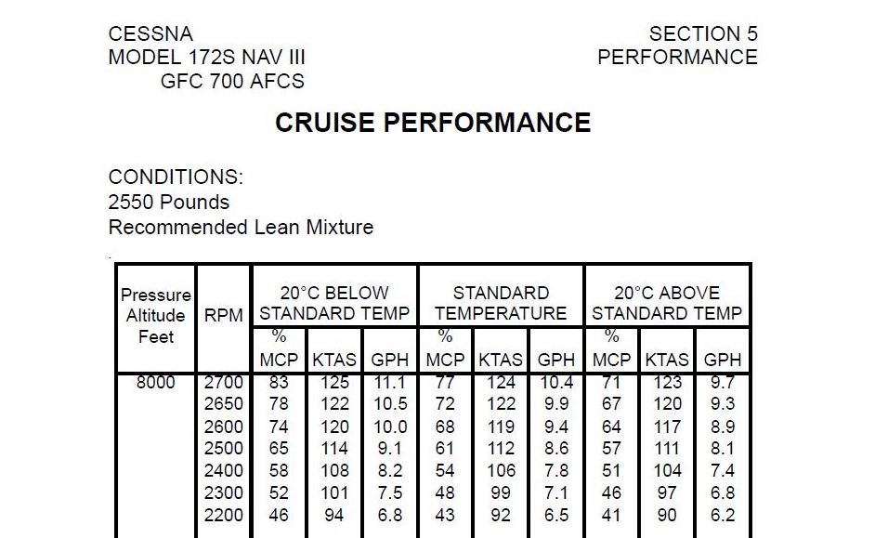

Editorial credit: Cessna

1. 10.5 GPH.
2. **9.9 GPH.**
3. 9.3 GPH.
4. 10.0 GPH
5. A student pilot training to obtain their private pilot certificate is about to apply for a medical certificate. Which of these is the student pilot not able to obtain first? (8.A.1)

1. **BasicMed**
2. Third Class.
3. Second Class.
4. First Class.
5. When you plot a course on a VFR sectional chart using a plotter and the lines of latitude and longitude, the course you measure will be (6.B.1)

1. wind-corrected.
2. the compass heading.
3. **True.**
4. Magnetic.
5. Supplemental oxygen is necessary as aircraft climb because (8.B.1)
6. There is a lower percentage of oxygen in the air at higher altitude.
7. **Reduced density means there is not as much oxygen in the same volume of air.**
8. Reduced pressure means more nitrogen is forced into the bloodstream.
9. Carbon dioxide in the aircraft cabin increases, reducing the amount of oxygen in the lungs.
10. A pilot will be flying a solo ferry flight to deliver an aircraft to another airport. The planned altitude is 14,500 feet. At this altitude, the pilot will need supplemental oxygen (8.B.1)

1. available.
2. after 30 minutes.
3. **immediately.**
4. for the passengers but not themselves.
5. Night vision is substantially different than seeing during the day. At night, (8.B.2)
6. the cones are the primary light receptors.
7. **depth perception, sharpness, and clarity are degraded.**
8. there is a blind spot in the periphery of the vision.
9. color is more perceptible.
10. Which FAA publication contains non-regulatory, practical information covering pilot procedures and general flight operations? (9.D.1)
11. **Aeronautical Information Manual.**
12. Federal Aviation Regulations.
13. Advisory circulars.
14. NOTAMs.
15. What is the name of the fluid in the inner ear whose movement triggers signals to the brain? (8.B.3)
16. **Endolymph.**
17. Otolith.
18. Cupola.
19. Semicircular Canal.
20. What illusion occurs when pilots do not realize they are in a turn and they try to correct a descent by increasing pitch, which actually increases the rate of descent and compounds the disorientation? (8.B.3)

1. The leans.
2. Coriolis illusion.
3. **Graveyard spiral.**
4. Giant hand.
5. Federal regulations require pilots to have a minimum of _______ between the consumption of alcohol and performing duties as a crew member. (8.C.1)
6. **8 hours**
7. 12 hours
8. 24 hours
9. zero hours so long as the pilot’s BAC is less than 0.04%
10. Federal regulations restrict a pilot from taking what kinds of substances? (8.C.1)
11. Over-the-counter drugs.
12. Only illegal drugs.
13. Prescription drugs.
14. **Any substance that may inhibit performance.**
15. Why does the FAA generally restrict the use of antihistamines by pilots? (8.C.1)
16. Antihistamines are a stimulant which may make the pilot more alert.
17. **One side effect of antihistamines is drowsiness, which could hinder pilot performance.**
18. The use of antihistamines indicates an underlying medical condition that is disqualifying.
19. The use of antihistamines could cause sinus or ear blockages during flight.
20. Aircraft accidents are rarely caused by a single factor. Instead, the accident can be traced through a series of decisions and incidents known as (8.D.1)
21. aeronautical decision making
22. **the accident chain.**
23. risk management.
24. hazardous attitudes.
25. Which of the following environmental factors does NOT affect density altitude? (7.A.2)
26. Pressure altitude.
27. Temperature.
28. Humidity.
29. **Wind.**
30. Special advisories for pilots, often of a short-term duration, that affect operations in specific locations are published in (9.A.1)
31. **Notices to airmen.**
32. Airworthiness directives
33. Advisory circulars.
34. Federal Aviation Regulations.
35. When the FAA determines that a certain model of aircraft has a hazardous condition that owners need to resolve, the FAA typically issues (9.A.1)
36. Notices to airmen.
37. **Airworthiness directives.**
38. Advisory circulars.
39. Federal Aviation Regulations.
40. To be eligible for a single engine airplane student pilot certificate, an applicant must (9.B.1)
41. be at least 17 years old.
42. **be at least 16 years old.**
43. be at least 14 years old.
44. be at least 14 years old, if flying with a CFI.
45. A student pilot may act as the pilot in command when (9.B.1)
46. passengers are on board.
47. the aircraft is used in furtherance of a business.
48. flying for hire.
49. **the student is flying solo.**
50. What is the lowest altitude to which a pilot is allowed to descend over a congested area? (9.C.1)
51. 2,000 feet.
52. **1,000 feet.**
53. 500 feet.
54. 500 feet away from people or structures.
55. When may a pilot intentionally deviate from a federal aviation regulation? (9.C.1)
56. When directed by air traffic control
57. On the authority of the aircraft owner.
58. **During an in-flight emergency requiring immediate action.**
59. Not at any time.
60. How can pilots mitigate the black hole illusion while landing at night? (8.B.2)

1. Focus strictly on the approach end of the runway.
2. **Use visual approach aids (VASI, PAPI).**
3. Request that tower turn up the brightness of the runway lights.
4. Adjust the cockpit lighting to full brightness.
5. The President of the United States will be visiting a major city, which will require a temporary flight restriction (TFR) at the location. What FAA publication will contain the relevant TFR information for pilots? (9.D.2)
6. Aeronautical Information Manual.
7. Federal Aviation Regulations.
8. Advisory circulars.
9. **NOTAMs.**