# Weather phenomena, such as clouds and precipitation, could be caused by which of these? (1.A.1)

* 1. Proximity to mountains
  2. Proximity to oceans
  3. Movement of an air mass
  4. All of the above

# What happens to air in an area of low pressure? (1.B.2)

* 1. Diverges and rises
  2. Converges and sinks
  3. Diverges and sinks
  4. Converges and rises

# The atmosphere is best described as that surrounds the earth. (1.B.1)

* 1. a blanket of air and precipitation
  2. an envelope of gases
  3. a stream of clouds
  4. a cushion of hot and cold air

# What process is demonstrated in the diagram? (1.B.2)

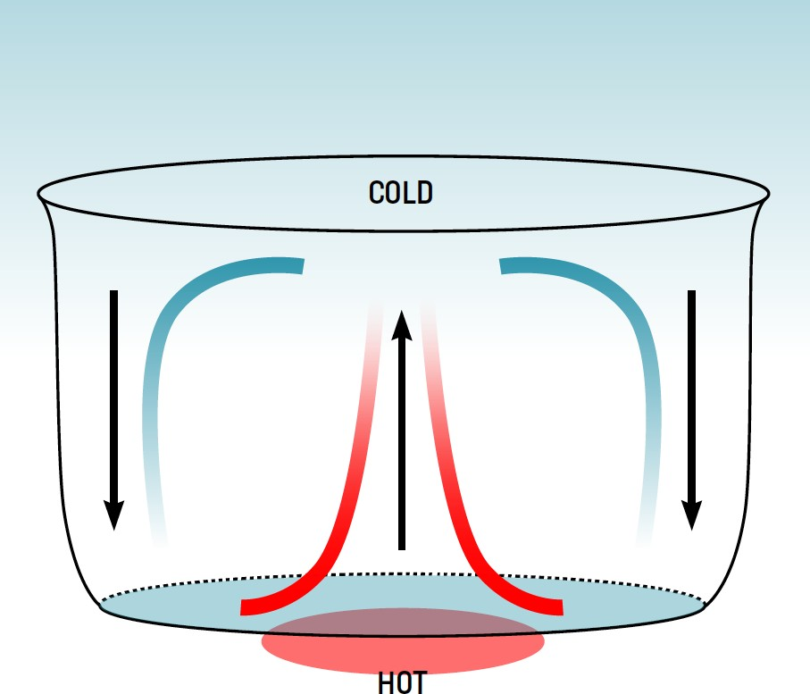

* 1. convection
  2. precipitation
  3. dissipation
  4. condensation

# Fog is formed when the air just above the ground cools to the dew point, causing the air to . (1.B.3)

* 1. rise and then expand
  2. become saturated with moisture
  3. become precipitous
  4. condense and become a cloud

# Which condition is most likely to cause turbulence during flight? (1.A.1)

* 1. Precipitation
  2. Wind
  3. Humidity
  4. Clouds

# What kind of clouds are shown in this picture? (1.B.3)

* 1. Cumulus
  2. Stratus
  3. Stratocumulus
  4. Cirrus

# What conditions are likely to occur before a cold front? Select all that apply. (1.B.4)

* 1. High dew point
  2. Rain
  3. Excellent visibility
  4. Falling pressure

# As the continental polar air mass moves over warm water, . (1.B.4)

* 1. it could produce clouds and drizzle
  2. it could become unstable and create rain showers
  3. the air near the surface will become warmer and gain moisture
  4. it tends to be very stable with fog or little precipitation

# Which best defines viscosity? (3.A.1)

* 1. The resistance an object experiences as it moves through a fluid
  2. The ability of any fluid to change shape
  3. The velocity at which air moves over a surface
  4. The resistance of a fluid to change in shape or a change in its motion

# Jets typically fly at the top of the troposphere where the air is the coolest. Why do jets operate only in the troposphere, even though they are often capable of climbing higher? (1.B.1)

* 1. Jet engines run efficiently in the exact temperature at the top of the troposphere; navigation tools are inoperable above the troposphere.
  2. The cool air at the top of the troposphere helps jet engines to run efficiently; operating above the troposphere could interfere with satellite data.
  3. Jet engines run efficiently in the exact temperature at the top of the troposphere; cooler temperatures

could cause engine failure.

* 1. The cool air at the top of the troposphere helps jet engines to run efficiently; the air is not cooler above the troposphere.

# The intensities of turbulence are called light, moderate, severe, and . (1.B.5)

* 1. dense
  2. extreme
  3. heavy
  4. dangerous

# What does the radar indicate? (1.B.5)

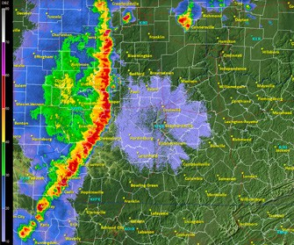

* 1. eastern front
  2. squall line
  3. warm front
  4. low ceiling

# As an airplane starts entering a microburst, performance increases. (1.B.5)

* 1. True
  2. False

# What is the basic cause of all weather? (1.B.2)

* 1. Clouds and precipitation
  2. Wind pushing against low pressure areas
  3. Uneven heating of the earth’s surface
  4. Ocean and land interactions

# Virga is rain that evaporates prior to reaching the ground and may precede . (1.B.3)

* 1. a warm air layer
  2. sleet
  3. snow
  4. a microburst

# Wind may have a variety of effects on an aircraft. Select all the ways wind may affect a flight. (1.A.1)

* 1. Wind may cause turbulence.
  2. A tailwind may increase an aircraft’s speed across the ground.
  3. A strong headwind can result in an aircraft using more fuel in flight compared to the same flight with no wind.
  4. Wind changes affect the effectiveness of aircraft controls.

# Towering cumulonimbus with strong weather is a likely indication of . (1.B.4)

* 1. a stationary front
  2. an occluded front
  3. a cold front
  4. a warm front

# What kind of information would you receive from a radar image? (2.A.1)

* 1. Wind speed and direction
  2. Cloud cover
  3. Precipitation intensity
  4. Atmospheric pressure

# A weather report predicts what the weather will be at a future point in time. (2.A.1)

* 1. True
  2. False

# Weather forecasts are often based on complex mathematical models. They may take hundreds of thousands of variables into account, sometimes causing forecasts to be . (2.A.1)

* 1. difficult to interpret
  2. inaccurate
  3. overly detailed
  4. slow in response

# Use the textual METAR to answer questions 22-23.

**KDAL 111656Z 16030G34KT 6SM –SHRA BKN070 SCT150 12/08 A3016 RMK AO2**

1. **What are the winds? Are they in magnetic or true? (2.A.2)**
   1. 6° true direction, at 16 knots gusting to 30 knots
   2. 11° magnetic direction, at 16 knots gusting to 56 knots
   3. 160° true direction, at 30 knots gusting to 34 knots
   4. 160° variable to 30° magnetic direction, gusting to 34 knots

# What type of precipitation is the airport experiencing? (2.A.2)

* 1. Snow
  2. Mild winds
  3. No precipitation
  4. Light rain showers

# Use the PIREP to answer questions 24-25.

**UA /OV CYS360070 /TM 0130 /FL035 /TP C172 /TB MOD SK BKN045-TOP070**

1. **What type of aircraft reported the PIREP? (2.A.2)**
   1. Boeing 727
   2. Boeing 747
   3. Cessna 172
   4. Cessna 170

# What were the sky conditions? (2.A.2)

* 1. Poor visibility from 4500’ to 7000’
  2. Turbulence above 35,000’
  3. Broken clouds from 4500’ to 7000’
  4. Heavy precipitation above 4,500’

# Use the TAF to answer questions 26-27.

**KMCI 042320Z 0500/0600 22012KT P6SM VCTS SCT050CB BKN250**

1. **When was the report published? (2.A.3)**
   1. the 23rd at 0420z
   2. the 4th at 2012z
   3. the 2nd at 2012z
   4. the 4th at 2320z

# What were the wind conditions? (2.A.3)

* 1. from 50 degrees at 6 knots
  2. from 220 degrees at 12 knots
  3. from 42 degrees at 5 knots
  4. from 42 degrees at 32 knots

# An outlook weather briefing is given when . (2.B.1)

* 1. the information requested is an hour before the proposed departure
  2. it is not possible to receive any other kind of briefing
  3. the information requested is 6 or more hours in advance of the proposed departure
  4. the pilot is not able to obtain enough information from a standard briefing

# What kind of briefing would be requested if a pilot delays departure 90 minutes? (2.B.1)

* 1. Standard briefing
  2. In-flight briefing
  3. Delay briefing
  4. Abbreviated briefing

# When requesting a telephone preflight briefing, the pilot needs to provide the departure and destination airports. (2.B.1)

* 1. True
  2. False

# During a flight, a pilot wants to ensure that the weather at the destination airport is what was forecast. Which of these options may be available to the pilot? Select all that apply. (2.B.2)

* 1. The pilot can listen to the AWOS of the destination airport.
  2. The pilot can try to reach the UNICOM so a person at the airport can describe the weather there.
  3. The pilot can contact a Flight Service Station by radio on 122.2 MHz for weather updates.
  4. The pilot can make a “blind call” to other airplanes in the area for pilot weather airports.
  5. The pilot can use an electronic display in the cockpit that shows current weather reports.

# What are the four airport categories? Select four answers. (3.A.1)

* 1. Maritime Airports
  2. General Aviation Airports
  3. Commercial-Service Airports
  4. Public Airports
  5. Reliever Airports
  6. Cargo-Service Airports

# The Automatic Terminal Information Service (ATIS) is used . Select all that apply. (3.A.1)

* 1. during flight
  2. during preflight planning
  3. before taxiing
  4. for emergencies

# What does this sign communicate to the pilot? (3.A.2)

* 1. You are on runway 3.
  2. 3,000 feet of runway remain ahead.
  3. Runway length is 3,000 feet.
  4. You are 300 feet MSL.

# What type of light is this? (3.A.2)

* 1. Touchdown Zone Light
  2. Taxiway Edge Light
  3. Takeoff Holding Light
  4. Runway Edge Light

# What is true of most midair collisions? Select all that apply. (3.A.8)

* 1. They occur in good weather.
  2. They occur when aircraft are low on fuel.
  3. They occur primarily during the day.
  4. They usually occur between jets and propeller-driven aircraft.
  5. Pilots involved are usually flying on expired certificates.

# Use the diagram to answer questions 37-38.

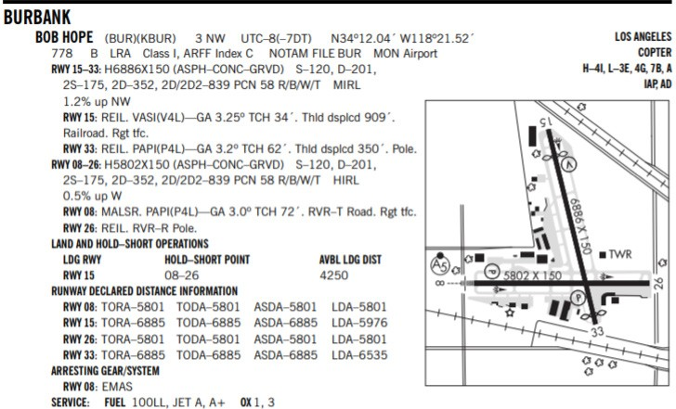

1. **Burbank Airport has a visual approach slope indicator. (3.A.3)**
   1. True
   2. False

# On what runway(s) are there medium intensity lights? (3.A.3)

* 1. RWY 33 only
  2. RWY 15-33
  3. RWY 08 only
  4. RWY 08-26

# Use the diagram to answer questions 39-40.

**36**

1. **A pilot is going to land. Which runway and traffic pattern should they use? (3.A.4)**
   1. Runway 18; left-hand traffic pattern
   2. Runway 18; right-hand traffic pattern
   3. Runway 22; left-hand traffic pattern
   4. Runway 36; right-hand traffic pattern

# Assume the wind is calm. Which runways can be used for takeoff? Select all that apply. (3.A.4)

* 1. Runway 18
  2. Runway 36
  3. Runway 22
  4. All of the above

# The aircraft on the left side of the image is on what leg of the traffic pattern? (3.A.4)

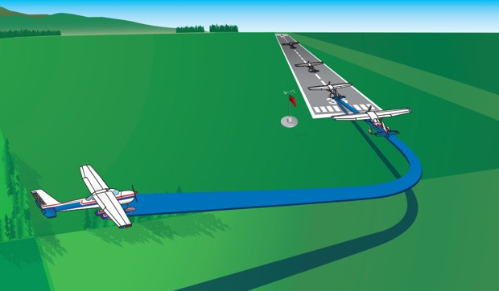

Editorial credit: Airplane Flying Handbook

* 1. downwind leg
  2. base leg
  3. final leg
  4. crosswind leg

# What do flashing green lights from a control tower convey to a pilot? (3.A.5)

* 1. Land with caution.
  2. Give way to other aircraft.
  3. Return for landing.
  4. Cleared to land.

# A pilot looks directly out the left window. Towards what direction are they looking? (3.A.6)

* 1. 8 o’clock
  2. 6 o’clock
  3. 9 o’clock
  4. 3 o’clock

# A(n) replies to inbound ATC radar signals by sending a 4-digit code back to the radar site along with information about aircraft position, speed, and altitude. (3.A.6)

* 1. antenna
  2. beacon
  3. transponder
  4. satellite

# Use the aeronautical chart excerpt below to answer Questions 45-47.

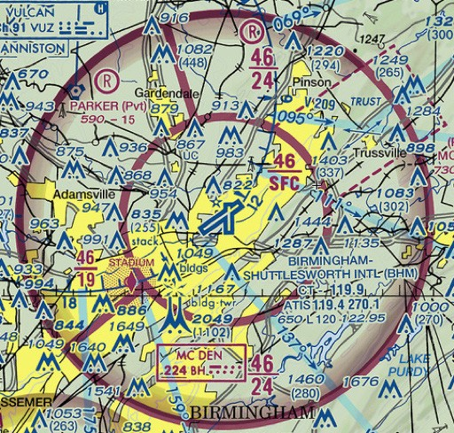

1. **Describe the runways at Birmingham-Shuttlesworth Airport. (4.A.1)**
   1. Hard-surfaced runways greater than 8,069 ft or some multiple runways less than 8,069 ft
   2. Hard-surfaced runways from 1,500 ft to 8,069 ft in length
   3. All hard-surfaced runways greater than 1,500 ft
   4. Other than hard-surfaced runways less than 8,069 ft

# What type of airspace is associated with the Birmingham-Shuttlesworth Airport? (4.A.2)

* 1. Class A
  2. Class B
  3. Class C
  4. Class D

# What is the height in MSL of the obstruction about six miles northeast of KBHM and due west of Trussville? (4.A.2)

a. 1,403 ft

b. 8,980 ft

c. 4,600 ft

d. 3,370 ft

# Use the aeronautical chart excerpt below to answer Questions 48-50.

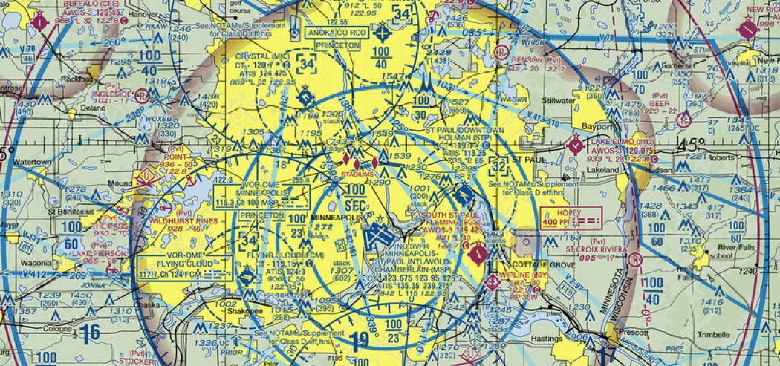

Editorial credit: SkyVector

# What type of airspace is associated with the Minneapolis-St. Paul International Airport? (4.A.2)

* 1. Class G
  2. Class B
  3. Class C
  4. Class D

# What is the Minneapolis-St. Paul International Airport control tower frequency? (4.A.1)

a. 119.425 Hz

b. 123.95 Hz

c. 122.95 Hz

d. 123.675 Hz

# There is a dashed magenta line about 15 NM east of KMSP. What does that tell pilots flying in the vicinity of that line? (4.A.2)

* 1. It is a magnetic variation line telling pilots there is no difference between magnetic and true headings in that area.
  2. It tells pilots traveling from the east that a major airport is ahead to the west.
  3. It is the edge of a MOA.
  4. It is where Class E airspace begins.