Name Class

1. **Radar signals detect clouds when they .**
   1. detect color changes that aren’t visible on the radar
   2. slow down upon entering the cloud
   3. bounce off of water, snow, or ice found in clouds
   4. All of the above
2. **What information does the METAR wind reading give?**

Wind: 22015G25KT

* 1. The wind was from 15 degrees at 220 knots with gusts up to 25 knots.
  2. The wind was from 220 degrees at 15 knots with gusts up to 25 knots.
  3. The wind was from 25 degrees at 15 knots with gusts up to 220 knots.
  4. The wind was from 22 degrees at 15 knots with gusts up to 25 knots.

1. **Terminal Aerodrome Forecasts (TAF) are designed to provide .**
   1. water conditions on a chart
   2. up-to-date severe weather reports
   3. weather forecasts only to light aircraft
   4. expected weather at an airport during a specified period
2. **Which of the following are types of weather briefings? Select three correct answers.**
   1. Outlook briefing
   2. Coastal briefing
   3. Standard briefing
   4. Abbreviated briefing
   5. Early briefing
3. **Which of the following statements about NEXRAD are true? Select two correct answers.**
   1. ATC Centers can’t use NEXRAD.
   2. It should be used only as a reference.
   3. It can be used to penetrate weather.
   4. It can take up to 20 minutes to update.
   5. It can’t be displayed in the cockpit.
4. **A weather forecast is best described as .**
   1. a warning
   2. an observation
   3. a summary
   4. a prediction
5. **What is the reported altitude based on the PIREP code?**

UA /OV CYS360065 /TM 0140 /FL028 /TP C172 /TB MOD SK BKN045-TOP070

a. 2,800 ft

b. 1,400 ft

c. 6,500 ft

d. 3,600 ft

1. **Which of the following is true about the TAF code? Select all that apply.**

TAF

KMCI 042320Z 0500/0600 22012KT P6SM VCTS SCT050CB BKN250

* 1. Published on the 4th at 2320z
  2. Rain in the vicinity
  3. Winds: from 220 degrees at 12 knots
  4. Visibility: more than 12 statute miles
  5. Ceiling of broken clouds at 25,000 feet

1. **“Perceive, Process, Perform” is a three-step process for pilots.**
   1. risk-management
   2. weather avoidance
   3. self-review
   4. instrument rating
2. **Many aircraft manufacturers now produce airplanes that have the capability to display weather products on Electronic Flight Displays (EFD) and Multi-Function Displays (MFD).**
   1. True
   2. False
3. **Where do pilots get weather information?**
   1. Special weather reports for pilots
   2. Radio
   3. TV News
   4. All of the above
4. **What does RADAR stand for?**
   1. Radius Detection and Reaching
   2. Radio Doppler and Ranging
   3. Radio Detection and Ranging
   4. Radius Doppler and Reaching
5. **Weather prognostic charts help pilots to determine .**
   1. the accuracy of TAFs
   2. an overview of pressure systems and fronts
   3. total flight time between major navigation stations
   4. runways closed due to severe weather
6. **Which of the following is a drawback to receiving weather briefings over the phone?**
   1. There is a charge for each briefing.
   2. They aren’t always available.
   3. They are difficult to visualize.
   4. They are typically inaccurate.
7. **Who is the final authority in the decision to continue or discontinue a flight due to the impact of weather on the flight’s safety?**
   1. Federal Aviation Administration (FAA)
   2. Flight Service Station (FSS)
   3. Pilot-in-command (PIC)
   4. Air Traffic Control (ATC)
8. **What are the two types of weather information?**
   1. Reports and forecasts
   2. Print and digital
   3. Radio and TV
   4. Automated or manual
9. **Radar weather reports are important to pilots because they .**
   1. forecast precipitation
   2. indicate intensity of precipitation
   3. find alternate routes based on forecasts
   4. show location of precipitation
   5. indicate cell movement of precipitation
10. **For what weather condition was the following AIRMET issued?**

CHIS WA 050245

AIRMET SIERRA FOR IFR AND MTN OBSCN VALID UNTIL 050900 AIRMET IFR...KY TN

FROM CVG TO HNN TO HMV TO 30ENE GQO TO 50ESE BNA TO 40SE IIU TO CVG

CIG BLW 010/VIS BLW 3SM BR/FG. CONDS DVLPG AFT 06Z. CONDS CONTG BYD 09Z ENDG BY 15Z. OTLK VALID 0900-1500Z...IFR MN IA WI LM LS MI LH

BOUNDED BY YQT-SSM-70SE SSM-30NW MKG-40NE BAE-20ENE GRB-40SW ODI-40S MSP-40ESE BRD-30ENE DLH-YQT

CIG BLW 010/VIS BLW 3SM PCPN/BR/FG. CONDS CONTG THRU 15Z.

* 1. Mist (BR) and fog
  2. Snow and mountain obscuration
  3. IFR conditions and mountain obscuration
  4. IFR conditions and heavy rain

1. **A pilot should get an outlook briefing 30 minutes before a flight.**
   1. True
   2. False
2. **Which of the following are ways that weather information is gathered? Select all that apply.**
   1. Radar observations
   2. Surface observations
   3. Upper air observations
   4. Cell tower observations
   5. Satellite observations
3. **Explain the similarities and differences between METARs and PIREPs.**
4. **Write the following terms in the empty boxes: *Remarks, Temperature and Dew Point, Wind, Report Modifier, Sky Condition, Altimeter, Present Weather, Runway Visual Range, Date and Time, Station Identifier, Type of Report, Visibility.***

# METAR KOKC 011955Z AUTO 22015G25KT

TYPE OF

REPORT

WIND

STATION

IDENTIFIER

DATE / TIME

OF REPORT

REPORT

IDENTIFIER

**3/4SM R17L/2600FT +TSRA BR OVCO10CB 18/16**

**A2992 RMK A01 TSB25 TS OHD MOV E SLP132**

1. **Explain how pilots can get a comprehensive picture of the weather and how it may change.**
2. **Explain why pilots should be wary of relying only on unofficial weather sites and media.**
3. **What weather phenomenon could be occurring inside the black circled region? Explain your answer.**

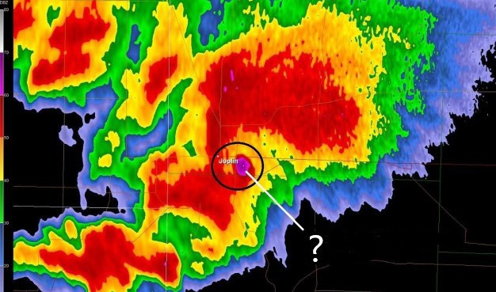

Editorial credit: Paul Douglas