**Name ___________________________________________**

Class ___________________________________________

**­­­­**

1. Which of the following is a reason why a pilot would use Google Earth or Bing Maps when planning a flight?
2. To determine runway length
3. For weather conditions
4. For situational awareness
5. All of the above
6. Why would a commercial airplane land at a reliever airport?
7. The arrival time is much earlier than expected.
8. A larger ground crew is needed for maintenance.
9. It needs to be replaced with another airplane.
10. Too much congestion at the destination airport.
11. According to Federal Aviation Regulations, what has the following definition?

“An area on land or water that is used or intended to be used for the landing and takeoff of aircraft and includes its buildings and facilities, if any.”

1. Terminal
2. Airport
3. Runway
4. None of these
5. What does the diagram show?

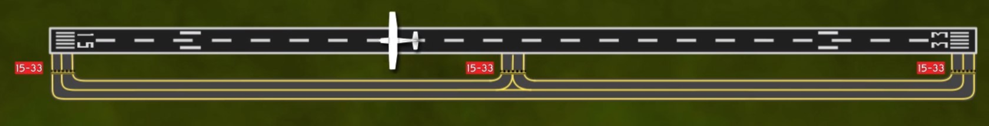

Editorial credit: ERAUSpecialVFR

1. An airplane on runway 33
2. An airplane on runway 15
3. An airplane on taxiway 33
4. An airplane on taxiway 15
5. What do the 6 white stripes indicate?

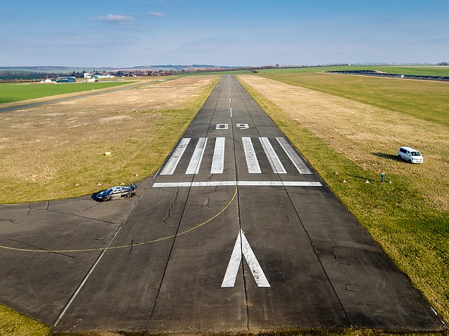

1. Landing threshold
2. Touchdown zone
3. Aiming point
4. Centerline stripes
5. What are the colors of the VASI lights when a pilot’s runway approach is too high?
6. Near VASI lights are red and far VASI lights are white.
7. Near VASI lights are white and far VASI lights are red.
8. Near and far VASI lights are both red.
9. Near and far VASI lights are both white.
10. What rotating light helps pilots locate airports at night?
11. Blue omnidirectional lights
12. Light tower
13. Airport beacon
14. Light gun
15. Why is it necessary to have defined traffic patterns and procedures?
16. Standardized, consistent patterns increase predictability and allow pilots to operate with the same basic set of expectations.
17. A shared understanding of patterns helps pilots know where to look for other aircraft, and how to predict their actions.
18. Increased pilot awareness helps reduce potential for conflicts and midair collisions.
19. All of the above
20. Traffic patterns usually contain only left turns.
21. True
22. False

**Use the diagram to answer Questions 10-11.**

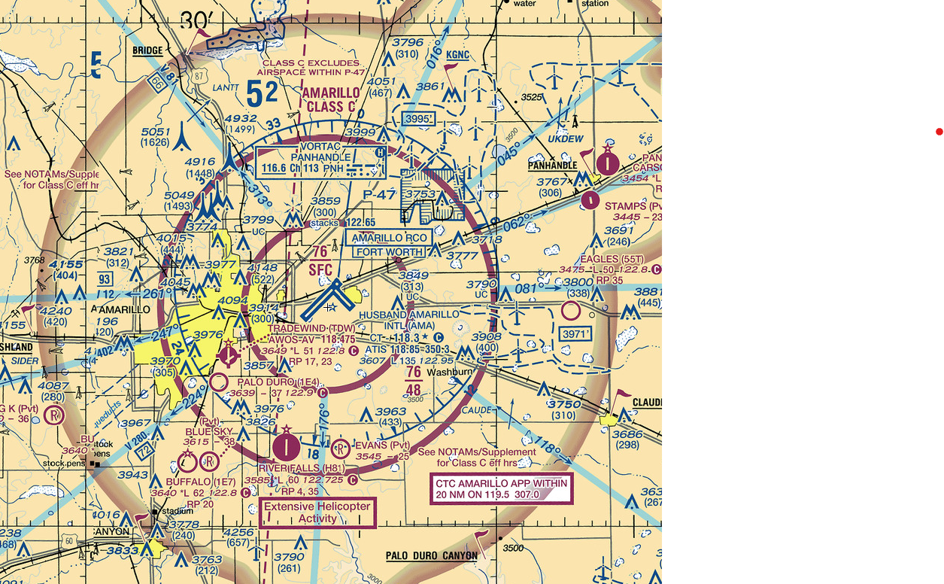

Editorial credit: FAA Sectional Chart

1. What is the name and type of airspace associated with (surrounding) the blue-outlined towered airport at the center of the image?
2. Amarillo Intl; KAMA
3. Texas; Class C
4. Tradewind; Class B
5. Husband Amarillo International; Class C
6. What frequency would a pilot use to obtain the latest weather observation at the blue-outlined towered airport at the center of the image?
7. 118.5 MHz
8. 122.95 MHz
9. 118.85 MHz
10. 118.475 MHz
11. An ATC radar facility issues the following advisory to a pilot during a local flight: “TRAFFIC 2 O’CLOCK, 7 MILES, NORTHBOUND….” Where should the pilot look for this traffic?
12. Between directly ahead and 90° to the left
13. Between directly ahead and 90° to the right
14. Between 90° to the right and 180° to the right
15. Between 90° to the left and 180° to the left
16. What transponder code indicates lost communication or failed radios?
17. 7700
18. 1200
19. 7600
20. 7777
21. What are the 3 elements of communication? Select 3 correct answers.
22. Licenses
23. Equipment
24. Airspace
25. Frequency
26. Procedures
27. Who is the final authority in the decision to accept or decline any land and hold short (LAHSO) clearance?
28. Second-in-Command (SIC)
29. Flight Service Station (FSS)
30. Pilot-in-Command (PIC)
31. Air Traffic Control (ATC)
32. As defined by the FAA, a hotspot is a__________.
33. location on an airport movement area with a history of potential risk of collision or runway incursion, and where heightened attention by pilots is necessary
34. region of airspace where communication can be lost or interrupted, and where pilots should use alternate forms of communication
35. location on an airport non-movement area where most of the communication with air traffic control occurs
36. region of airspace with a history of midair collisions, and where heightened attention by pilots is necessary
37. What response should a pilot give when receiving this message from ATC?

**“Skyhawk 54321, Cleared to land 16 right, hold short of runway 09 for departing traffic.”**

1. “Message received by Skyhawk 54321, will proceed with landing.”
2. “Message received. We will land 16 right, and will hold short of runway 09.”
3. “Skyhawk 54321 cleared to land 16 right, hold short of runway 09.”
4. “Skyhawk 54321 will land 16, and will hold short of runway 09.”
5. What do most midairs have in common?
6. They happen close to an airport, at high altitudes, and during the day.
7. They happen close to an airport, at low altitudes, and during the day.
8. They happen far from an airport, at high altitudes, and during the night.
9. They happen far from an airport, at low altitudes, and during the night.
10. How should a pilot scan the sky while looking out of their window?
11. Scan slowly from 12 o’clock to 6 o’clock and then from 11 o’clock to 7 o’clock.
12. Look ahead but scan from left to right every 60 seconds.
13. Look ahead but scan in 10° increments from right to left every 60 seconds.
14. Scan slowly in 10° segments from 10 o’clock to 2 o’clock.
15. Which of the following are ways that a pilot can avoid wake turbulence? Select three answers.

1. When taking off, wait 2 to 5 minutes for the vortices of a departing large aircraft to dissipate.
2. Take off after the liftoff point of larger airplanes.
3. Remain slightly upwind when following a larger aircraft.
4. Stay above the altitude of the leading airplane.
5. Land after the touchdown point of a large aircraft landing ahead of you.
6. Fly below the final approach glidepath of a landing large aircraft.
7. Explain the similarities and differences between towered and nontowered airports.
8. A runway has a magnetic heading of 154 degrees. What is the runway name? Explain how you found the answer.
9. Use the diagram to locate and name the different kinds of lighting available at Seward Municipal Airport, and explain how they are activated.

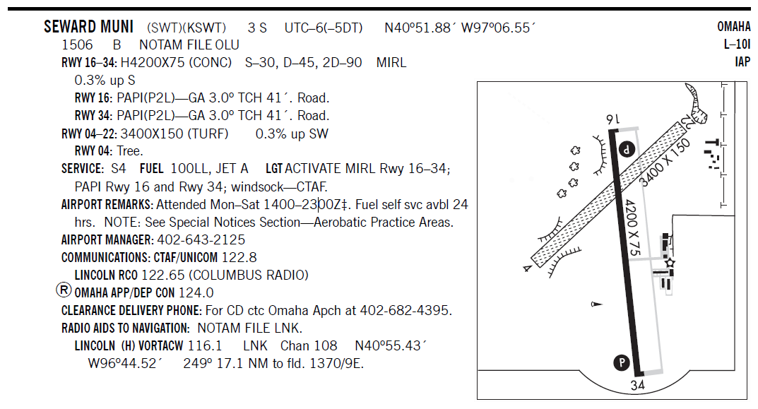

Editorial credit: FAA Chart Supplement

1. Explain how to enter a standard traffic pattern when the airplane is on the downwind side and when it is on the upwind side.
2. What advantages does an ADS-B air traffic control environment have over a traditional radar-based structure?