1. Which of the following is a reason why a pilot would use Google Earth or Bing Maps when planning a flight? (3.A.1)
2. To determine runway length
3. For weather conditions
4. For situational awareness
5. All of the above
6. Why would a commercial airplane land at a reliever airport? (3.A.1)
7. The arrival time is much earlier than expected.
8. A larger ground crew is needed for maintenance.
9. It needs to be replaced with another airplane.
10. Too much congestion at the destination airport.
11. According to Federal Aviation Regulations, what has the following definition?

“An area on land or water that is used or intended to be used for the landing and takeoff of aircraft and includes its buildings and facilities, if any.” (3.A.1)

1. Terminal
2. Airport
3. Runway
4. None of these
5. What does the diagram show? (3.A.2)

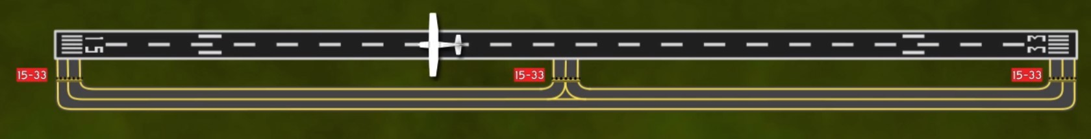

Editorial credit: ERAUSpecialVFR

1. An airplane on runway 33
2. An airplane on runway 15
3. An airplane on taxiway 33
4. An airplane on taxiway 15
5. What do the 6 white stripes indicate? (3.A.2)

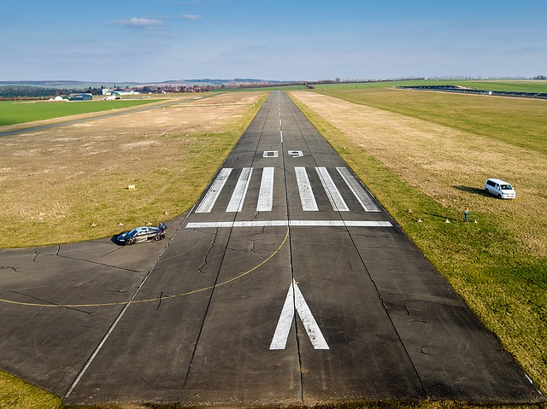

1. Landing threshold
2. Touchdown zone
3. Aiming point
4. Centerline stripes
5. What are the colors of the VASI lights when a pilot’s runway approach is too high? (3.A.3)
6. Near VASI lights are red and far VASI lights are white.
7. Near VASI lights are white and far VASI lights are red.
8. Near and far VASI lights are both red.
9. Near and far VASI lights are both white.
10. What rotating light helps pilots locate airports at night? (3.A.3)
11. Blue omnidirectional lights
12. Light tower
13. Airport beacon
14. Light gun
15. Why is it necessary to have defined traffic patterns and procedures? (3.A.4)
16. Standardized, consistent patterns increase predictability and allow pilots to operate with the same basic set of expectations.
17. A shared understanding of patterns helps pilots know where to look for other aircraft, and how to predict their actions.
18. Increased pilot awareness helps reduce potential for conflicts and midair collisions.
19. All of the above
20. Traffic patterns usually contain only left turns. (3.A.4)
21. True
22. False

**Use the diagram to answer Questions 10-11.**

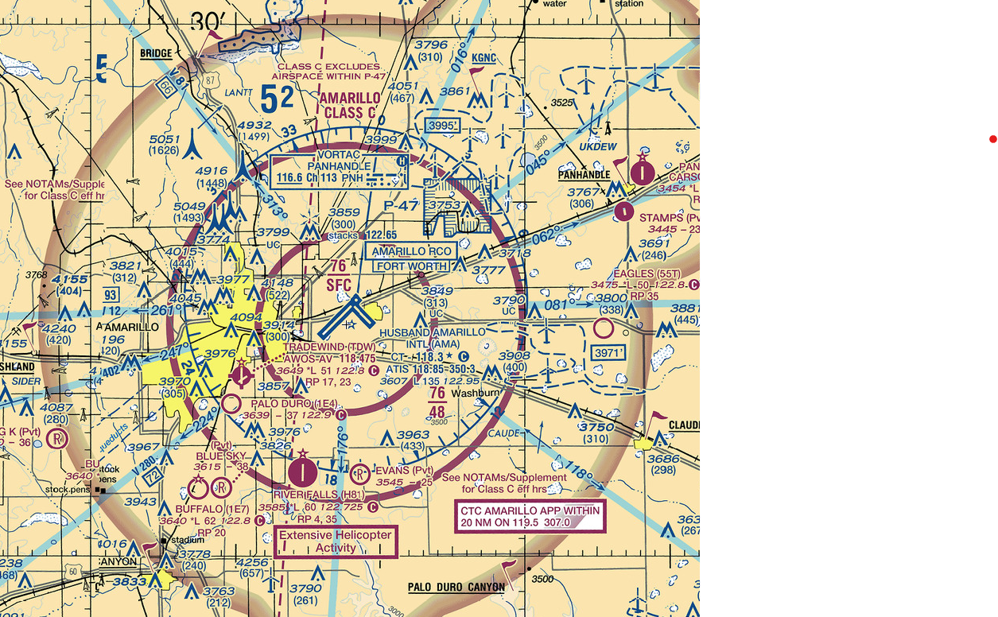

Editorial credit: FAA Sectional Chart

1. What is the name and type of airspace associated with (surrounding) the blue-outlined towered airport at the center of the image? (3.A.5)
2. Amarillo Intl; KAMA
3. Texas; Class C
4. Tradewind; Class B
5. Husband Amarillo International; Class C
6. What frequency would a pilot use to obtain the latest weather observation at the blue-outlined towered airport at the center of the image? (3.A.5)
7. 118.5 MHz
8. 122.95 MHz
9. 118.85 MHz
10. 118.475 MHz
11. An ATC radar facility issues the following advisory to a pilot during a local flight: “TRAFFIC 2 O’CLOCK, 7 MILES, NORTHBOUND….” Where should the pilot look for this traffic? (3.A.6)
12. Between directly ahead and 90° to the left
13. Between directly ahead and 90° to the right
14. Between 90° to the right and 180° to the right
15. Between 90° to the left and 180° to the left
16. What transponder code indicates lost communication or failed radios? (3.A.6)
17. 7700
18. 1200
19. 7600
20. 7777
21. What are the 3 elements of communication? Select 3 correct answers. (3.A.5)
22. Licenses
23. Equipment
24. Airspace
25. Frequency
26. Procedures
27. Who is the final authority in the decision to accept or decline any land and hold short (LAHSO) clearance? (3.A.7)
28. Second-in-Command (SIC)
29. Flight Service Station (FSS)
30. Pilot-in-Command (PIC)
31. Air Traffic Control (ATC)
32. As defined by the FAA, a hotspot is a__________. (3.A.7)
33. location on an airport movement area with a history of potential risk of collision or runway incursion, and where heightened attention by pilots is necessary
34. region of airspace where communication can be lost or interrupted, and where pilots should use alternate forms of communication
35. location on an airport non-movement area where most of the communication with air traffic control occurs
36. region of airspace with a history of midair collisions, and where heightened attention by pilots is necessary
37. What response should a pilot give when receiving this message from ATC? (3.A.7)

**“Skyhawk 54321, Cleared to land 16 right, hold short of runway 09 for departing traffic.”**

1. “Message received by Skyhawk 54321, will proceed with landing.”
2. “Message received. We will land 16 right, and will hold short of runway 09.”
3. “Skyhawk 54321 cleared to land 16 right, hold short of runway 09.”
4. “Skyhawk 54321 will land 16, and will hold short of runway 09.”
5. What do most midairs have in common? (3.A.8)
6. They happen close to an airport, at high altitudes, and during the day.
7. They happen close to an airport, at low altitudes, and during the day.
8. They happen far from an airport, at high altitudes, and during the night.
9. They happen far from an airport, at low altitudes, and during the night.
10. How should a pilot scan the sky while looking out of their window? (3.A.8)
11. Scan slowly from 12 o’clock to 6 o’clock and then from 11 o’clock to 7 o’clock.
12. Look ahead but scan from left to right every 60 seconds.
13. Look ahead but scan in 10° increments from right to left every 60 seconds.
14. Scan slowly in 10° segments from 10 o’clock to 2 o’clock.
15. Which of the following are ways that a pilot can avoid wake turbulence? Select three answers. (3.A.8)

1. When taking off, wait 2 to 5 minutes for the vortices of a departing large aircraft to dissipate.
2. Take off after the liftoff point of larger airplanes.
3. Remain slightly upwind when following a larger aircraft.
4. Stay above the altitude of the leading airplane.
5. Land after the touchdown point of a large aircraft landing ahead of you.
6. Fly below the final approach glidepath of a landing large aircraft.
7. Explain the similarities and differences between towered and nontowered airports. (3.A.1)

At towered and nontowered airports, pilots must follow standard procedures according to FAA publications. Traffic patterns are the same at towered and nontowered airports.

At nontowered airports, pilots must announce their intentions to other traffic in the area on the designated common traffic advisory (CTAF) frequency. A Common Traffic Advisory Frequency (CTAF) is always used at nontowered airports and used at towered airports only when a tower is not in operation.

Towered airports have an operating control tower, while nontowered airports do not. Only towered airports have air traffic controllers. At towered airports, pilots must maintain two-way radio communication with ATC and both acknowledge and comply with their instructions.

1. A runway has a magnetic heading of 154 degrees. What is the runway name? Explain how you found the answer. (3.A.2)

The magnetic heading is always rounded to the nearest ten, so 154 rounds to 150. All leading or trailing 0s are removed, so 150 becomes 15. The runway is named using each digit separately. So, runway 15 is read “runway one five.”

1. Use the diagram to locate and name the different kinds of lighting available at Seward Municipal Airport, and explain how they are activated. (3.A.3)

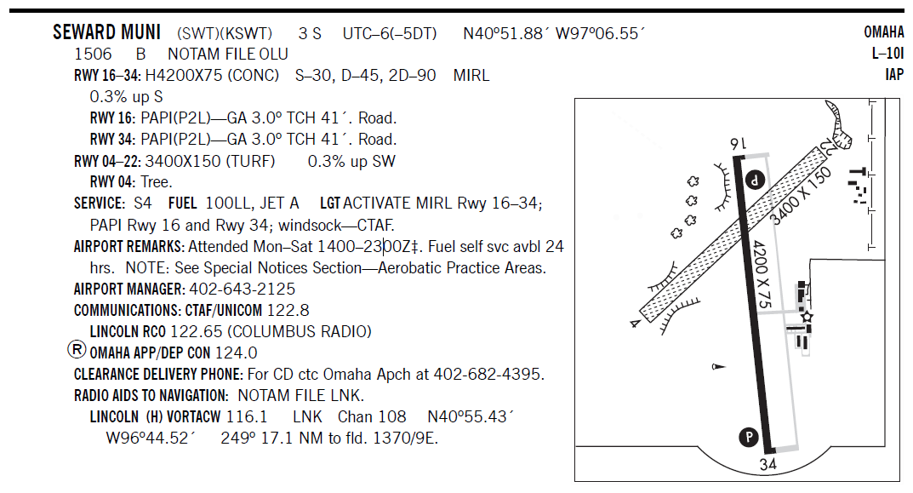

Editorial credit: FAA Chart Supplement

The “B” in the second line shows that a rotating beacon light is available. Medium intensity lights (MIRL) are present on runways 16-34. PAPI lights are present on runways 16 and 34. The SERVICE line indicates that lighting for the MIRL, PAPI, and windsock is activated by using the CTAF frequency. The procedure would be to “key” or “click” the communication radio’s transmit button (on the microphone or yoke) seven times. From AIM section 2-1-9:

*Suggested use is to always initially key the mike 7 times; this assures that all controlled lights are turned on to the maximum available intensity. If desired, adjustment can then be made, where the capability is provided, to a lower intensity (or the REIL turned off) by keying 5 and/or 3 times.*

MIRL systems have three intensities (Advisory Circular 150/5340-30H, page 10), so a student may respond that keying the mike three or five times will activate the lights.

1. Explain how to enter a standard traffic pattern when the airplane is on the downwind side and when it is on the upwind side. (3.A.4)

Standard traffic patterns involve only left turns. When an airplane is on the downwind side, it is positioned well to enter the traffic pattern at a 45-degree angle. When an airplane is on the upwind side, it needs to position itself so that it can enter on the downwind side at a 45-degree angle. To achieve this, the pilot should cross over midfield at least 500 feet above pattern altitude (normally 1,500 feet agl). When well clear of the pattern—approximately two miles—descend to pattern altitude, then turn to enter at 45 degrees to the downwind leg at midfield. Because large and turbine aircraft fly 1,500-foot-agl patterns, crossing 500 feet above the single-engine pattern altitude might place you in conflict with traffic. If large or turbine aircraft are operating into your airport, 2,000 feet agl is a safer crossing altitude.

1. What advantages does an ADS-B air traffic control environment have over a traditional radar-based structure? (3.A.6)

ADS-B has greater precision because it is satellite-based: GPS is used to determine aircraft position. Unlike radar-based systems, ADS-B involves hundreds of ground stations, so ATC can see much more airspace than they can with a radar-based system. Students might say, “Coverage is much greater.” ADS-B is not affected by interference such as rain, mountains, buildings, and birds that can interfere with radar signals. Range, altitude, and location of an aircraft are rarely limiting factors with ADS-B, while radar-based systems may have aircraft fly beyond their range, fly at an altitude which puts them in a radar’s blind spot, or are simply in an area with no radar coverage.

The ADS-B system also allows pilots to see other aircraft in their vicinity on cockpit displays. This helps pilots see and avoid traffic in places where they may not have had radar coverage or ATC services to help them in the past.

Another benefit with ADS-B systems is that pilots may obtain weather information on cockpit displays. Weather radar images, METARs, TAFs, airmets, sigmets, TFRs, and NOTAMS are some of the common products available to pilots using FIS-B.