Name ___________________________________________

Class ___________________________________________

Use the aeronautical chart excerpt below to answer Questions 1-5.

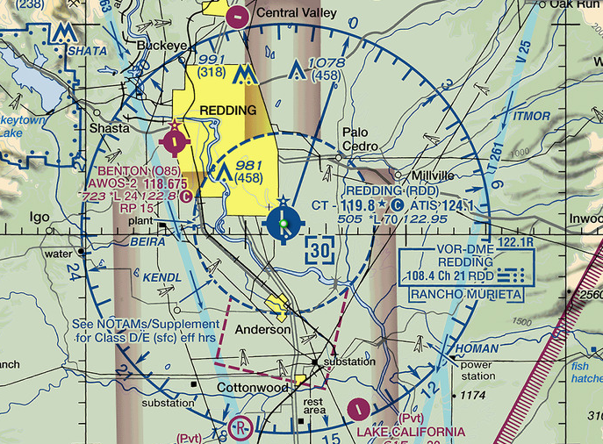

- What is the Redding Airport ATIS frequency?

- 124.1
- 119.8
- 122.1
- 108.4

- What is the longest runway length at Redding Airport?

- 5,050 feet
- 9,810 feet
- 3,000 feet
- 7,000 feet

- What is the elevation of the Redding Airport?

- 505 feet
- 119.8 feet
- 300 feet
- 70 feet

- What do the “tick marks” around the Redding Airport runway circle indicate?

- The air traffic control tower is not in operation from 6:00 p.m. to 6:00 a.m.
- One “tick mark” represents 1,000 feet of runway elevation.
- Services are available Monday through Friday from 10:00 a.m. to 4:00 p.m.
- Helicopters are not allowed to land at the airport.

- What is the height, in MSL, of the obstruction between the Redding and Benton airports?

- 458 feet
- 981 feet
- 1,078 feet
- 458 feet

Use the aeronautical chart excerpt below to answer Questions 6-10.

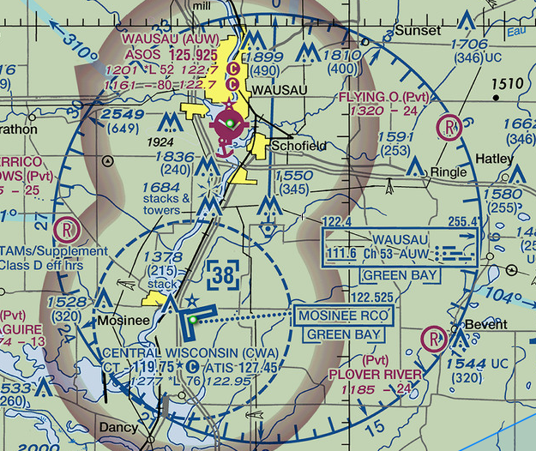

- There is a rotating or flashing beacon for which airports?

- Wausau Airport only
- Central Wisconsin Airport only
- Both airports
- Neither airport

- Which airport(s) are towered?

- Wausau Airport only
- Central Wisconsin Airport only
- Both airports
- Neither airport

- Which airport(s) have hard-surfaced runways?

- Wausau Airport only
- Central Wisconsin Airport only
- Both airports
- Neither airport

- Which airport(s) have a seaplane base?

- Wausau Airport only
- Central Wisconsin Airport only
- Both airports
- Neither airport

- Which airport(s) have glider activity?

- Wausau Airport only
- Central Wisconsin Airport only
- Both airports
- Neither airport

Use the aeronautical chart excerpt below to answer Questions 11-12.

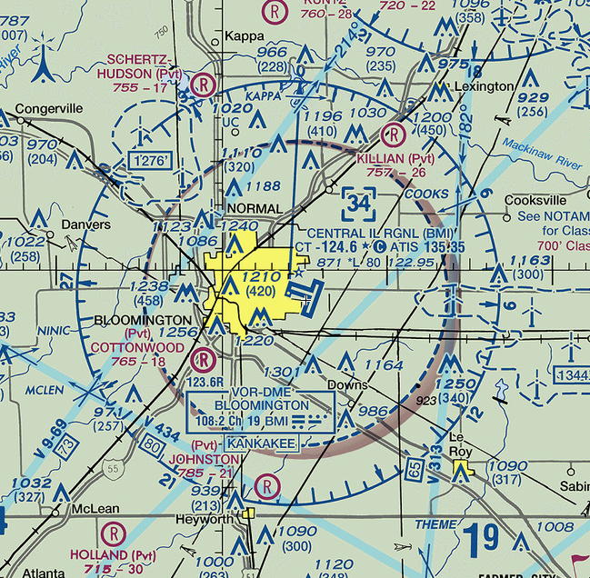

- Which of these types of airspace is shown?

- Class A
- Class B
- Class C
- Class D

- What is the MSL ceiling of the airspace?

- 60,000 feet
- 8,000 feet
- 3,400 feet
- 1,210 feet

Use the aeronautical chart excerpt below to answer Questions 13-15.

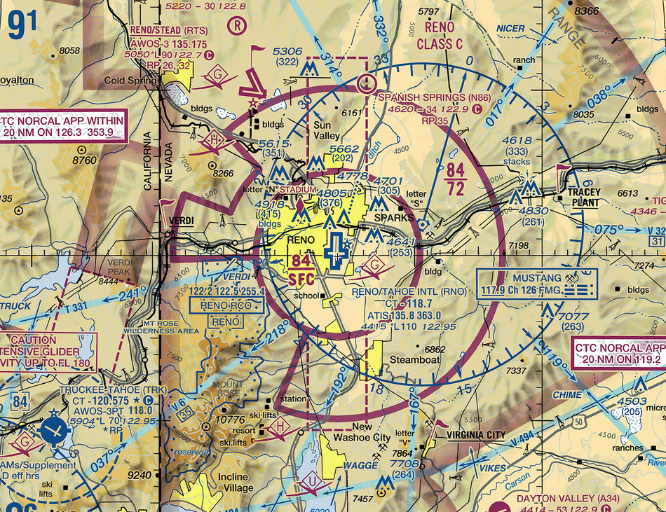

- What type of airspace is associated with the Reno/Tahoe International Airport?

- Class A
- Class B
- Class C
- Class D

- What could be a reason for the cutout on the southwest region of the airspace around the Reno/Tahoe International Airport?

- To avoid a region of rapidly rising terrain
- To avoid glider activity
- To avoid a water landing
- To avoid descending too close to the runway

- What are the floor and ceiling altitudes (in MSL) of the shelf portion (outer ring) of the airspace around the Reno/Tahoe International Airport?

- 7,200 feet and 8,400 feet
- Ground and 7,200 feet
- Ground and 8,400 feet
- 2,500 feet and 8,400 feet

Use the aeronautical chart excerpt below to answer Questions 16-18.

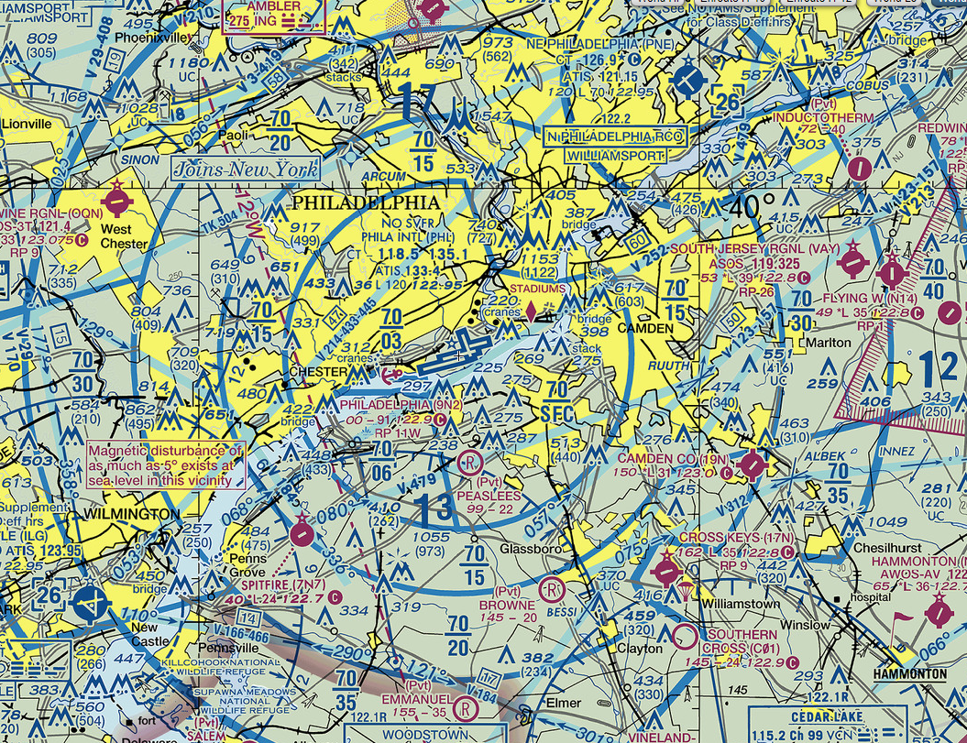

- What type of airspace is depicted around Philadelphia International Airport (KPHL)?

- Class A
- Class B
- Class C
- Class D

- What are the floor and ceiling heights (MSL) of the ring of airspace that overlies South Jersey Regional Airport (east-northeast of KPHL)?

- Surface to 10,000 feet
- Surface to 7,000 feet
- 4,000 feet to 7,000 feet
- 3,000 feet to 7,000 feet

- What must occur before a pilot can land at Cross Keys Airport (17N), located to the southeast of KPHL?

- Two-way radio communication with controllers must be established.
- The pilot must hear the words “cleared to enter” the airspace surrounding the airport.
- No communication is necessary, but only if the pilot remains below 2,000 ft MSL.
- No communication is required by regulation, though the pilot should monitor the CTAF.

Use the aeronautical chart to answer Questions 19-20.

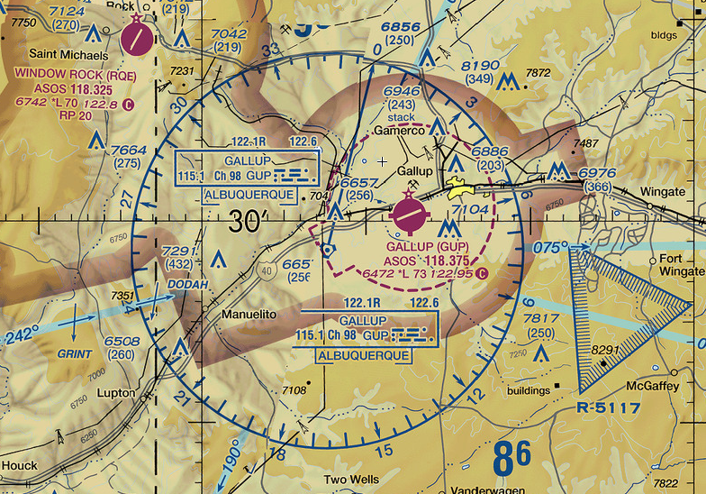

- The triangular region of airspace southeast of Gallup Airport (KGUP) is __________.

- Class G airspace
- an abandoned airport
- a radio tower
- restricted airspace

- Which statement is true about KROE and KGUP?

- Both airports have automated weather observation systems.
- Both are at the same elevation.
- Both airports share a CTAF.
- Both have right traffic patterns.

- In which airspace is the visibility requirement the greatest?

- Class C between 2,500 and 4,000 feet AGL
- Class D from the surface up to 2,500 feet MSL
- Class E above 10,000 feet MSL
- Class B at any altitude

- A pilot’s radios have become inoperative while approaching Class C airspace. Is this a problem? Explain your thinking and recommend a course of action for the pilot.

Questions 23-26 refer to the aeronautical chart excerpt below and the following scenario:

You are a private pilot planning a short flight from the Akron/Jesson Airport (K9G3) to the Greater Rochester International Airport (KROC). After takeoff on Runway 7, you climb in the traffic pattern and depart the pattern southeast so you can follow a highway eastbound toward KROC. The route you plan to follow is indicated on the chart below.

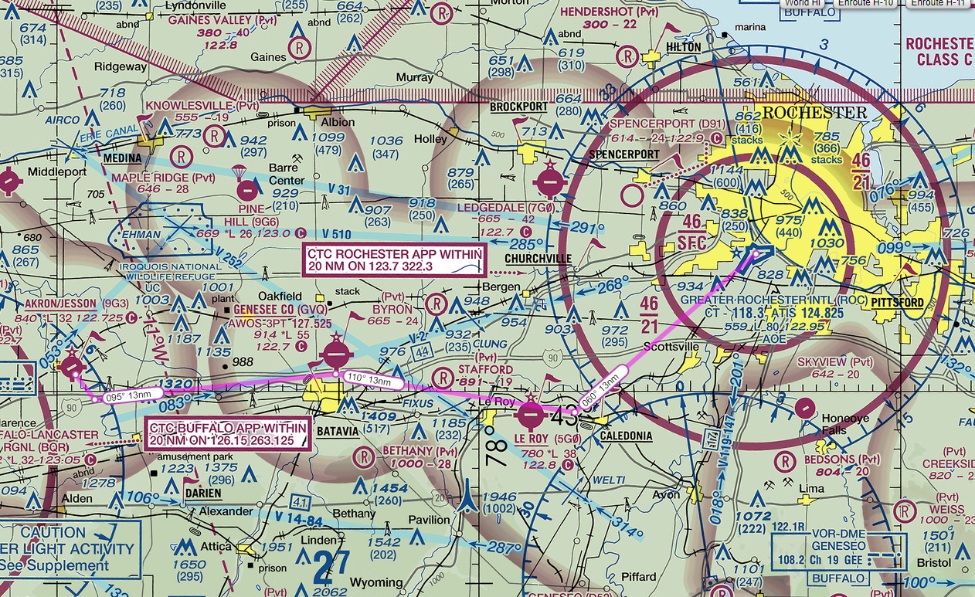

- You are just passing the Stafford Airport and headed toward the Le Roy (5G0) Airport. At what altitude would you overfly the airport and why?

- Rochester Approach asked you to fly a heading of 060° at Caledonia. Explain how you would know you are at Caledonia?

- After turning to 060° at Caledonia, Rochester Approach told you to expect a straight-in approach to Runway 4. If you flew directly from Caledonia to the runway, what potential hazard would you face?

- List the following Greater Rochester International Airport radio frequencies:

ATIS:

Rochester Approach:

KROC Tower:

