Use the aeronautical chart excerpt below to answer Questions 1-5.

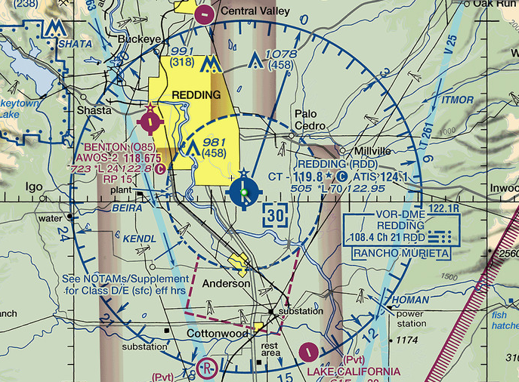

- What is the Redding Airport ATIS frequency? (4.A.1)

- 124.1
- 119.8
- 122.1
- 108.4

- What is the longest runway length at Redding Airport? (4.A.1)

- 5,050 feet
- 9,810 feet
- 3,000 feet
- 7,000 feet

- What is the elevation of the Redding Airport? (4.A.1)

- 505 feet
- 119.8 feet
- 300 feet
- 70 feet

- What do the “tick marks” around the Redding Airport runway circle indicate? (4.A.1)

- The air traffic control tower is not in operation from 6:00 p.m. to 6:00 a.m.
- One “tick mark” represents 1,000 feet of runway elevation.
- Services are available Monday through Friday from 10:00 a.m. to 4:00 p.m.
- Helicopters are not allowed to land at the airport.

- What is the height, in MSL, of the obstruction between the Redding and Benton airports? (4.A.1)

- 458 feet
- 981 feet
- 1,078 feet
- 458 feet

Use the aeronautical chart excerpt below to answer Questions 6-10.

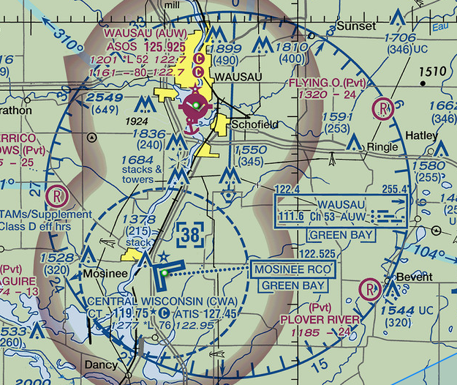

- There is a rotating or flashing beacon for which airports? (4.A.1)

- Wausau Airport only
- Central Wisconsin Airport only
- Both airports
- Neither airport

- Which airport(s) are towered? (4.A.1)

- Wausau Airport only
- Central Wisconsin Airport only
- Both airports
- Neither airport

- Which airport(s) have hard-surfaced runways? (4.A.1)

- Wausau Airport only
- Central Wisconsin Airport only
- Both airports
- Neither airport

- Which airport(s) have a seaplane base? (4.A.1)

- Wausau Airport only
- Central Wisconsin Airport only
- Both airports
- Neither airport

- Which airport(s) have glider activity? (4.A.1)

- Wausau Airport only
- Central Wisconsin Airport only
- Both airports
- Neither airport

Use the aeronautical chart excerpt below to answer Questions 11-12.

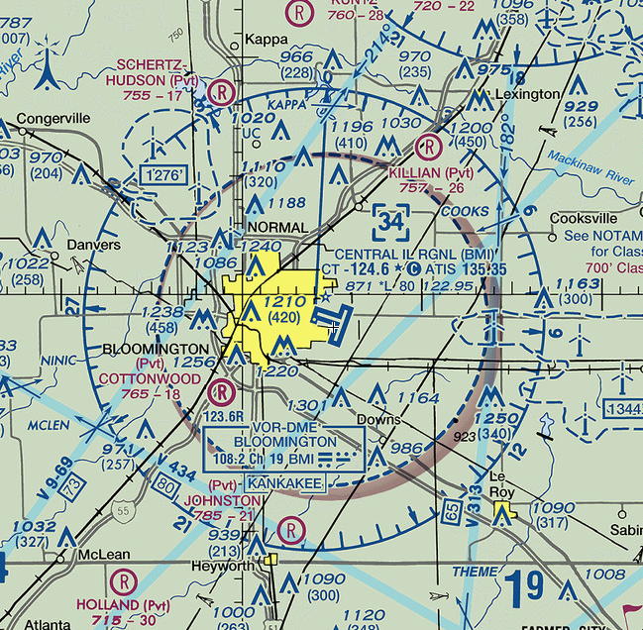

- Which of these types of airspace is shown? (4.A.2)

- Class A
- Class B
- Class C
- Class D

- What is the MSL ceiling of the airspace? (4.A.2)

- 60,000 feet
- 8,000 feet
- 3,400 feet
- 1,210 feet

Use the aeronautical chart excerpt below to answer Questions 13-15.

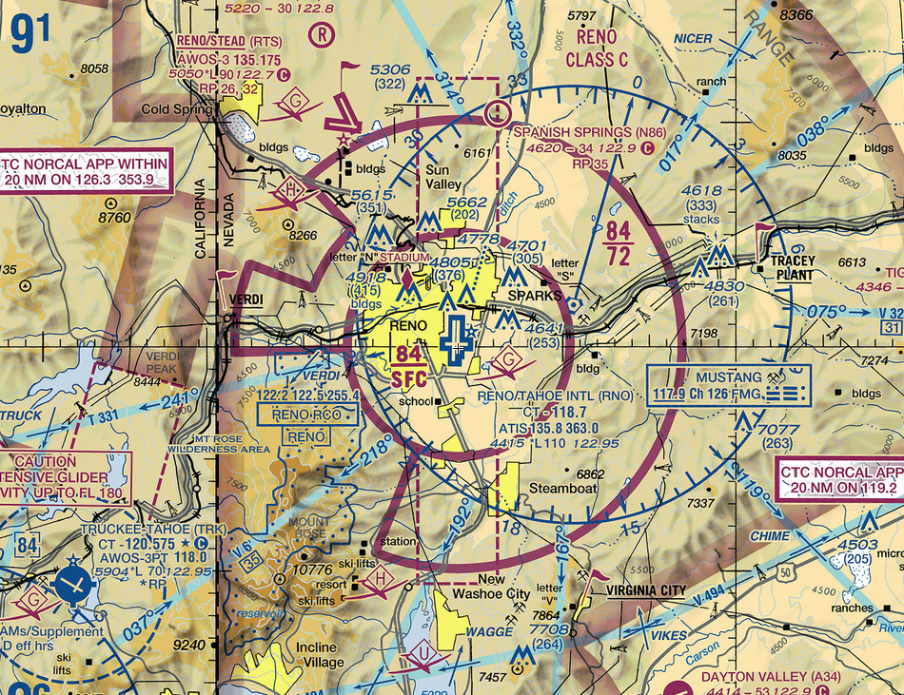

- What type of airspace is associated with the Reno/Tahoe International Airport? (4.A.2)

- Class A
- Class B
- Class C
- Class D

- What could be a reason for the cutout on the southwest region of the airspace around the Reno/Tahoe International Airport? (4.A.2)

- To avoid a region of rapidly rising terrain
- To avoid glider activity
- To avoid a water landing
- To avoid descending too close to the runway

- What are the floor and ceiling altitudes (in MSL) of the shelf portion (outer ring) of the airspace around the Reno/Tahoe International Airport? (4.A.2)

- 7,200 feet and 8,400 feet
- Ground and 7,200 feet
- Ground and 8,400 feet
- 2,500 feet and 8,400 feet

Use the aeronautical chart excerpt below to answer Questions 16-18.

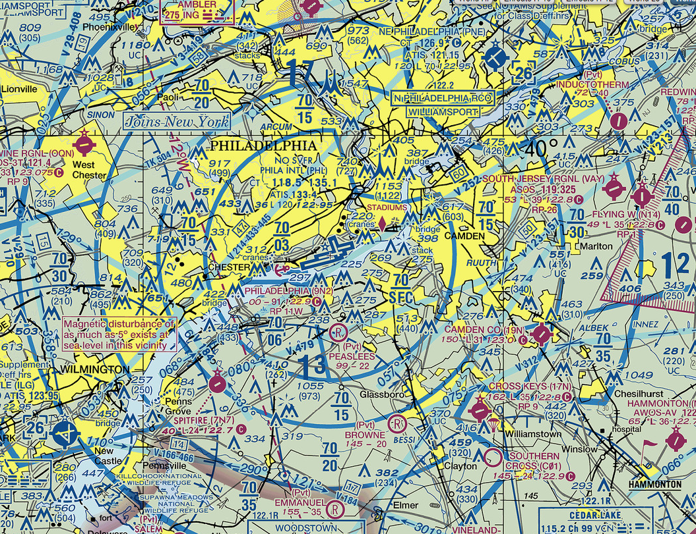

- What type of airspace is depicted around Philadelphia International Airport (KPHL)? (4.A.2)

- Class A
- Class B
- Class C
- Class D

- What are the floor and ceiling heights (MSL) of the ring of airspace that overlies South Jersey Regional Airport (east-northeast of KPHL)? (4.A.2)

- Surface to 10,000 feet
- Surface to 7,000 feet
- 4,000 feet to 7,000 feet
- 3,000 feet to 7,000 feet

- What must occur before a pilot can land at Cross Keys Airport (17N), located to the southeast of KPHL? (4.A.2)

- Two-way radio communication with controllers must be established.
- The pilot must hear the words “cleared to enter” the airspace surrounding the airport.
- No communication is necessary, but only if the pilot remains below 2,000 ft MSL.
- No communication is required by regulation, though the pilot should monitor the CTAF.

Use the aeronautical chart to answer Questions 19-20.

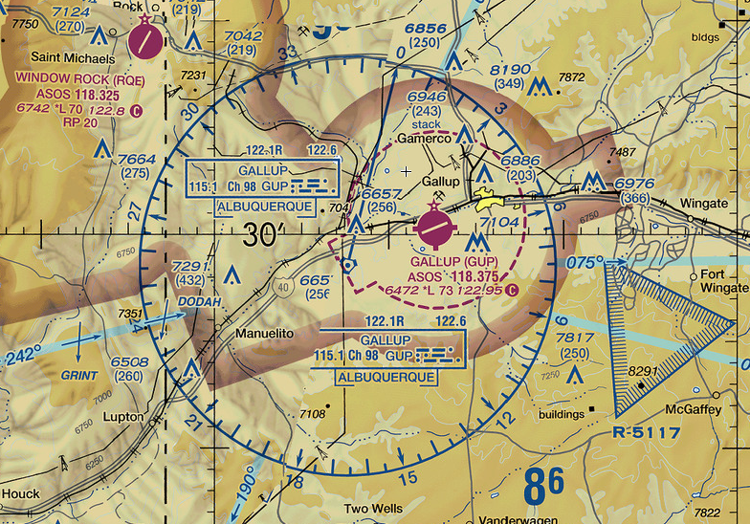

- The triangular region of airspace southeast of Gallup Airport (KGUP) is __________. (4.A.2)

- Class G airspace
- an abandoned airport
- a radio tower
- restricted airspace

- Which statement is true about KROE and KGUP? (4.A.2)

- Both airports have automated weather observation systems.
- Both are at the same elevation.
- Both airports share a CTAF.
- Both have right traffic patterns.

- In which airspace is the visibility requirement the greatest? (4.A.2)

- Class C between 2,500 and 4,000 feet AGL
- Class D from the surface up to 2,500 feet MSL
- Class E above 10,000 feet MSL
- Class B at any altitude

- A pilot’s radios have become inoperative while approaching Class C airspace. Is this a problem? Explain your thinking and recommend a course of action for the pilot. (4.A.2)

This may or may not be a problem. A student’s answer needs to effectively explain why they chose one answer or another.

For example, because entering Class C airspace requires two-way radio contact, the pilot should not enter the airspace. If there is no urgent need to land at the Class C airport, then the pilot should try to find a nontowered airport, where communications with ATC are not a requirement.

Additionally, if the student’s answer indicates this is a problem or an emergency, then the answer should include a course of action that includes entering 7600 into the transponder and/or following light gun signals from the control tower. For example, a student may create a scenario where the only option is to land at the large Class C airport because of runway length or fire/rescue services.

Questions 23-26 refer to the aeronautical chart excerpt below and the following scenario:

You are a private pilot planning a short flight from the Akron/Jesson Airport (K9G3) to the Greater Rochester International Airport (KROC). After takeoff on Runway 7, you climb in the traffic pattern and depart the pattern southeast so you can follow a highway eastbound toward KROC. The route you plan to follow is indicated on the chart below.

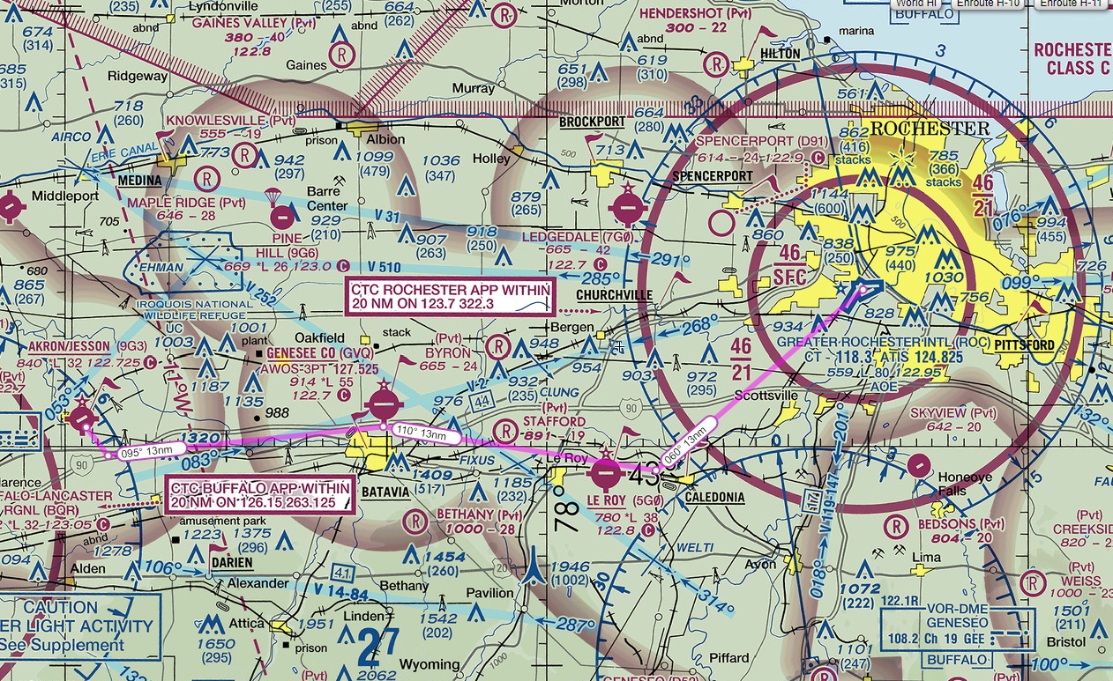

- You are just passing the Stafford Airport and headed toward the Le Roy (5G0) Airport. At what altitude would you overfly the airport and why? (4.A.1)

The objective is for the student to be above the traffic patterns of airports along the route of flight. The traffic pattern altitude at the Le Roy Airport is 1,800 feet MSL, so an answer that gives an altitude above this altitude would be an appropriate answer. Additionally, because of the “why” portion of the question, a student’s answer should give some evidence that they recognize the height of the 5G0 traffic pattern is 1,800 feet MSL.

- Rochester Approach asked you to fly a heading of 060° at Caledonia. Explain how you would know you are at Caledonia? (4.A.1)

The pilot should have noticed passing over KGVQ, since the route of flight passes slightly north of the airport, and Caledonia is just ahead. Caledonia should be identifiable because of the town and the racetrack on the south side of a railway line. Students may also note that the flags and underlined names of the landmarks mean that they are VFR checkpoints.

- After turning to 060° at Caledonia, Rochester Approach told you to expect a straight-in approach to Runway 4. If you flew directly from Caledonia to the runway, what potential hazard would you face? (4.A.1)

There is an obstruction with a top at 934 feet MSL to the west of the final approach leg of Runway 4. You will want to be cautious about your altitude and position as you descend to the runway so that you remain a safe distance away from the tower.

- List the following Greater Rochester International Airport radio frequencies: (4.A.1)

ATIS: 124.825 MHz

Rochester Approach: 123.7 MHz

KROC Tower: 118.3 MHz

