**Name ___________________________________________**

Class ___________________________________________

**­­­**

1. The FAA classifies a small UAS (sUAS) as any system that has a UAV with a takeoff weight of less than ____________.
2. .55 pounds.
3. 55 pounds.
4. 55.5 pounds.
5. 555 pounds.
6. An aircraft with aft center of gravity will ______.
7. roll counterclockwise
8. pitch up
9. roll clockwise
10. yaw to the right
11. What applications do sUAS have in today’s world? Select all that apply.
12. Inspecting assets such as bridges and pipelines.
13. Inspecting airplanes as they take off and land.
14. Performing search and rescue missions.
15. Lifting heavy machinery.
16. How does a fixed-wing drone differ from a multirotor drone?
17. Fixed-wing drones have a much greater endurance than multirotor drones.
18. Multirotor drones need lots of room for takeoff and landing.
19. Fixed-wing drones can utilize vertical thrust, which requires more power.
20. Multirotor drones use longitudinal thrust or thrust along the long axis of the craft.
21. How can a remote pilot find the center of gravity on a UAV? Select all that apply.
22. By dividing the total moment by the total weight.
23. By attaching extra weights to the UAV and conducting test flights.
24. Through experimentation by hanging the UAV from a line until it is balanced.
25. By upgrading propeller motors for a more stable flight.
26. Quadcopters, hexacopters, and octocopters are types of_________.
27. fixed-wing UAS
28. FAA-sanctioned UAS
29. multirotor UAS
30. single-rotor UAS
31. Which of the following statements about flight controllers is true? Select all that apply.
32. They are required for fixed-wing UAS.
33. They always rely on GPS.
34. They make micro adjustments to compensate for air disturbances.
35. They translate inputs from the pilot to outputs at each motor.
36. What function does a rudder perform on a fixed-wing UAV?
37. It controls overbanking tendency.
38. It controls roll.
39. It controls yaw.
40. It controls pitch.
41. Part 107 stresses that the PIC is responsible for____________. Select all that apply.
42. personally repairing any faulty UAS components
43. safe UAS operations
44. obtaining preflight checklists from other UAS pilots
45. preflight familiarization and inspection of a UAS
46. When can a non-certificated member of a crew manipulate the controls of an sUAS?
47. When the crew member is under the direct supervision of a certificated PIC.
48. When the crew member is studying to take the FAA aeronautical knowledge test.
49. When the crew member is under the direct supervision of a visual observer.
50. When the crew member is flying the sUAS below 100 feet.

1. The FAA requires a minimum crew of a PIC and a visual observer at all times.
2. True
3. False
4. After receiving a Part 107 remote pilot certificate with an sUAS rating, how often must you take a recurrent knowledge exam?
5. Every 6 months.
6. Every 12 months.
7. Every 24 months.
8. Every 36 months.

1. When might it be acceptable for a pilot in command to lose visual line of sight of a UAV? Select all that apply.
2. When a crewmember maintains visual line of sight and is in communication with the PIC.
3. If an in-flight emergency requires urgent, prompt action.
4. To talk to a law enforcement officer.
5. After obtaining a Part 107 waiver to fly beyond visual line of sight.

1. The required distance a remote pilot must maintain from clouds is
2. 400 feet below and 3 SM horizontally.
3. 500 feet below and 2,000 feet horizontally.
4. 1,000 feet below and 1 SM horizontally.
5. 1,000 feet below and 2,000 feet horizontally.
6. According to FAR Part 107, sUAS cannot be flown __________.
7. when visibility is no less than 4 statute miles
8. beyond a ground speed of 100 mph
9. at an altitude above 300 feet AGL
10. 3,000 feet horizontally from clouds

1. When must an sUAS accident be reported to the FAA within 10 days? Select all that apply.
2. If damage to property other than the sUAS exceeds $500.
3. If the incident occurs within five miles of an airport.
4. If a serious injury or loss of consciousness occurs.
5. If a flyaway occurs in a national park and the sUAS is damaged.

1. The ability to maintain powered UAV flight is affected by________. Select all that apply.
2. density altitude
3. lunar gravitational force
4. weight and balance
5. gimbal orientation

1. The majority of airspace below 500 feet AGL is _______ airspace.
2. Class A
3. Class C
4. Class D
5. Class G

1. What weather resources should sUAS pilots use to build a complete weather picture? Select all that apply.
2. visual observations, weather reports, and forecasts
3. www.1800wxbrief.com
4. Flight Service at 1-800-wxbrief
5. www.aviationweather.gov
6. A commercially certificated remote UAS pilot is required to _______.
7. only follow FAA regulations
8. only follow FAA regulations and state laws
9. ignore local laws and use their best judgment
10. follow FAA regulations as well state and local laws

1. To calculate the rough distance in SM from a lightning strike, count the_________.
2. seconds between when the lightning is seen and thunder is heard, and divide by 5
3. seconds between when the lightning is seen and thunder is heard, and divide by 10
4. minutes between when the lightning is seen and thunder is heard, and divide by 5
5. seconds between when the lightning is seen and thunder is heard, and multiply by 10

1. What are some examples of covered data? Select all that apply.
2. Photos or videos of state parks and national landmarks.
3. License plates.
4. Landscape photos with homes in the distance.
5. Full-face photographic images.

1. FAR Part 107 states that during an emergency _______________.
2. a remote pilot is permitted to deviate from any part of 14 CFR Part 107
3. a remote pilot does not yield right of way to approaching aircraft
4. a remote pilot must immediately contact local authorities
5. a remote pilot should always continue to operate within the requirements of 14 CFR Part 107

1. How and when does fog form?
2. Fog forms when air warms.
3. Fog forms when moisture evaporates from existing warm air.
4. Fog forms when air cools to its dew point.
5. Fog forms when air cools to 5ºF above its dew point.

1. What new technologies entered the UAS landscape in the 1990s that stimulated investment in the UAS industry? Select all that apply.
2. GPS navigation technology.
3. Miniaturized avionics.
4. Lightweight plastic polymers.
5. Digital electronics.

1. Adding weight to a UAV can result in________. Select all that apply.
2. loss of control
3. an increase in lift
4. unsafe flying conditions
5. the elimination of center of gravity

1. Which of the following are true about components of fixed-wing UAS? Select all that apply.
2. Wings generate lift.
3. Wings generate thrust.
4. Propellers generate lift.
5. Propellers generate thrust.

Use the load factor chart to answer question 28.

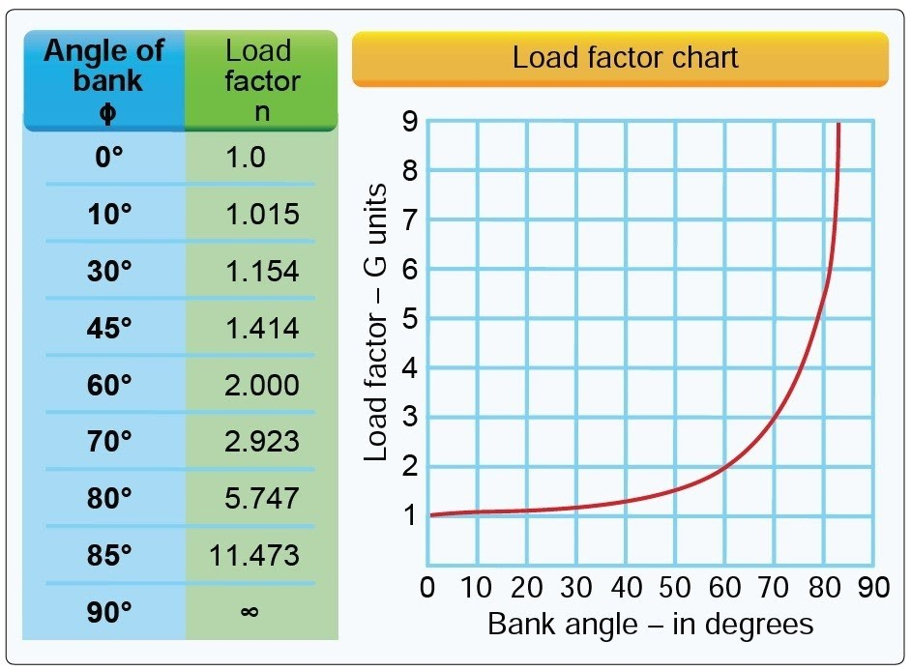

Editorial credit: Airman Knowledge Testing Supplement

1. How much weight would the propellers of a 30-pound UAV need to support if it entered a 45º bank angle?
2. 63.63 lbs.
3. 34.62 oz.
4. 42.42 lbs.
5. 34.62 lbs.

1. What is the minimum thrust-to-weight ratio a PIC will want in order to ensure adequate UAV performance under normal conditions?
2. 1:1 thrust-to-weight ratio
3. 2:1 thrust-to-weight ratio
4. 3:1 thrust-to-weight ratio
5. 4:1 thrust-to-weight ratio

Use the following formula: (*W* × 2) ÷ *E* = *L* to answer question 30.

*W* = Total Weight

*E* = # of Engines/Motors

*L* = Lift/thrust needed per engine or motor

Note: For increased safety, round up to the nearest pound.

1. If a hexacopter weighs 22 lbs., how much thrust would a single engine or motor need to support?
2. 6 lbs.
3. 7 lbs.
4. 8 lbs.
5. 9 lbs.

1. When is a person not allowed to serve as remote PIC, manipulator of sUAS controls, VO, or any other crew member? Select all that apply.
2. If they have consumed an alcoholic beverage in the preceding 8 hours.
3. If blood alcohol concentration is 0.02% or greater.
4. If they have consumed an alcoholic beverage in the preceding 12 hours.
5. If they are using a drug that affects their physical or mental capabilities.

1. Which of these situations might arise if the stabilization and GPS systems of an sUAS fail? Select all that apply.
2. Changing wind conditions could cause instability.
3. The PIC would have to use an autopilot system to retrieve the UAV.
4. The Return to Home function would be inoperative.
5. The UAV would be more responsive with greater aerodynamic ability.

1. Low Altitude Authorization and Notification Capability (LAANC), allows remote pilots to __________.
2. access controlled airspace at or above 400 feet
3. access controlled airspace at or below 400 feet
4. conduct flights over people and moving vehicles
5. conduct flights at night

1. What requirements must a person meet to become an FAA-certificated remote pilot?  
   Select all that apply.
2. Pass the FAA aeronautical knowledge test.
3. Fly only within community-based safety guidelines.
4. Obtain an FAA remote pilot certificate from the FAA prior to operations.
5. Read, speak, write, and understand English language.
6. A UAV propeller with a crack in it does not to be replaced.
7. True
8. False

1. Which operation would not require a remote pilot to hold a commercial certificate?
2. A worker uses a drone to survey a construction site for their employer.
3. A biker uses a drone to video tricks they intend to show their friends later.
4. A realtor uses a drone to photograph a home to list it for sale in a local paper.
5. A professional photographer uses a drone to take pictures at an outdoor wedding.
6. What roles could members of an sUAS crew have? Select all that apply.
7. Pilot in command.
8. Air traffic controller.
9. Visual observer.
10. Mission commander.

1. A LiPo battery_______. Select all that apply.
2. requires little to no care and maintenance
3. should be stored at 40 percent charge capacity when not being used
4. used in freezing temperatures can result in abrupt power loss to a UAV
5. can safely be stored at a temperature of 60°C

1. If a visual observer informs the PIC that the UAV is approaching a tree at 12 o’clock, where is the tree?
2. Forward relative to the direction the UAV is facing.
3. Forward relative to the direction the PIC is flying.
4. The direction the UAV is facing relative to the sun.
5. The direction of true north.

1. If an sUAS operation to record video of climbers on Mount Everest, which of these physiological conditions is most likely to affect the crew? Select all that apply.
2. Hypoxia.
3. Spatial disorientation.
4. The bends.
5. Hypothermia.

1. Which of these is not an appropriate resource for a safe sUAS operation?
2. FAA navigational and sectional charts.
3. Taxiway diagram.
4. Weather forecasts and conditions.
5. Radios with airplane frequencies.

1. What are the three priorities of manned aircraft that also apply to piloting a UAS?
2. Compensate, navigate, and relegate.
3. Mitigate, relegate, and communicate.
4. Aviate, navigate, and communicate.
5. Formulate, arbitrate, and operate.

1. When can an sUAS be operated from a moving land vehicle? Select all that apply.
2. When visual line of sight is maintained.
3. When the vehicle is in Class B airspace.
4. When the vehicle is in a sparsely populated area.
5. When the driver assumes the role of PIC.

1. FAR Part 107 states that after an emergency _______________.
2. the remote pilot must submit a written report to the FAA within 24 hours
3. the remote pilot must report the emergency if asked to do so by the FAA
4. the remote pilot must report the emergency to the FAA within 24 hours
5. the remote pilot must contact the National Transportation Safety Board

1. In aviation, what is the PAVE checklist?
2. Pilot, Avionics, Vehicle, and External factors.
3. Pilot, Aircraft, enVironment, and External pressures.
4. Position, Aircraft, Visibility, and Environment.
5. Pilot, Aircraft, oVercast, and Environment.

1. A PIC’s control inputs have no effect on the UAV being flown. The UAV then flies to a hover over its takeoff point and lands, which of these situations may have occurred?
2. The UAV batteries are below 50% charge.
3. The GCS controls have been reversed.
4. The UAV underwent a flyaway.
5. A lost link may have occurred, and the Return to Home failsafe protocol has been triggered.

1. Which of the following is considered a hazardous attitude by the FAA? Select all that apply.
2. Overconfidence.
3. Anti-authority.
4. Machismo.
5. Decision paralysis.
6. How do multicopter UAVs compensate for torque to maintain stability? Select all that apply.
7. By having all the propellers turn clockwise.
8. By having half the propellers turn clockwise and half turn counterclockwise.
9. By using variable pitch propellers.
10. By having all the propellers turn counterclockwise.

1. Range sensors or sonar modules help UAVs to___________. Select all that apply.
2. determine altitude AGL
3. calculate GPS coordinates
4. avoid obstacles
5. take thermal images
6. Your sUAS crew has been hired to conduct power line inspections. A section of the power lines you need to inspect runs behind 15 houses. Which of these actions shows that the team is using voluntary best practices concerning privacy in their sUAS operation?
7. Your team performed the operation without any advance notice being given to the residents.
8. Your team put flyers informing the residents of the time and day that the inspection operation would take place.
9. Your team ensured that the UAV did not climb above 400 feet AGL.
10. Your team was careful to maintain visual line of sight with the UAV throughout the operation.